Development of Hydrogen Gas Pipe Sizing Equations, Graphs, and Tables for Hydrogen Domestic Systems

Standards Research

Development of Hydrogen Gas Pipe Sizing Equations, Graphs, and Tables for Hydrogen Domestic Systems

Authors
Frank Bos, Dynaflow Research Group Inc.
Mick Bouman, Dynaflow Research Group Inc.
Thijs Krijger, Dynaflow Research Group Inc.
Mark Groen, Dynaflow Research Group Inc.
Sean de Noronha, Dynaflow Research Group Inc.
Project Advisory Panel
To be confirmed by CSA Group.
Pam Marvinney, CSA Group (Project Manager)
Acknowledgements
To be completed.
Financial Support
To be completed.
Disclaimer
This will be completed by CSA Group Standards Research.
Copyright
This will be completed by CSA Group Standards Research.

Table of Contents
Executive Summary 5
1 Introduction 7
1.1 Problem Statement and Research Need 7
1.2 Scope and Objectives 7
1.3 Report Structure 8
1.4 Key Concepts and Terminology 8
2 Methods 9
2.1 Data Collection and Literature Review Approach 9
2.2 Analytical Framework 10
2.3 Computational Fluid Dynamics Methodology 10
2.4 Sensitivity Analysis Approach 10
2.5 Standards Cross-Referencing Methodology 10
3 Results and Discussion 11
3.1 Physical and Chemical Properties of Hydrogen 11
3.1.1 Reference Conditions and Ideal-Gas Behavior 11
3.1.2 Property Comparison with Reference Natural Gas 11
3.1.3 Three Ratios that Drive Sizing 12
3.1.4 Sonic Velocity and Mach Number 14
3.2 Existing Hydrogen Pilot Projects and Lessons Learned 14
3.2.1 HyDeploy 15
3.2.2 Australian Hydrogen Centre 15
3.2.3 Dutch and German Hydrogen Neighborhood Conversions 15
3.2.4 THyGA 16
3.2.5 U.S. HyBlend (NREL/Sandia) 16
3.3 Standards and Codes Review 17
3.3.1 Overview of Applicable Standards 17
3.3.2 Comparative Analysis and Cross-Reference Matrix 19
3.4 Key Operating Parameters for Domestic Hydrogen Systems 21
3.4.1 Volumetric Flow Rate Increase 22
3.4.2 Pressure Drop Comparison 22
3.4.3 Velocity Limits and Momentum Flux 23
3.4.4 Noise and Acoustic Power 23
3.4.5 Effect of Elevated Supply Pressure 24
3.4.6 Corrugated Stainless Steel Tubing (CSST) 25
3.4.7 Effect of Pipe Upsizing 26
3.5 Equation and Model Development 26
3.5.1 Evaluation of Existing Pipe Sizing Equations 27
3.5.2 Development of Hydrogen-Specific Equations 33
3.5.3 Hydrogen Sizing Equations and Applicability 38
3.6 Graph and Table Development 43
3.6.1 Applicability of CSA/ANSI LC 1 Graphing Methodology 43
3.6.2 Hydrogen Sizing Graphs and Tables 46
3.6.3 Designer-Ready Tools for Standards Inclusion 52
3.7 Sensitivity Analysis 52
3.7.1 Identification of Critical Input Parameters 52
3.7.2 Uncertainty and Robustness Analysis 54
3.7.3 Parameter Ranking and Design Guidance 55
3.8 Model Validation and Recommendations for Laboratory Testing 57
3.8.1 Critical Tests for Domestic-Scale Piping 58
3.8.2 Measurement Parameters and Acceptance Criteria 59
3.8.3 Prioritized Test Matrix and Instrumentation 60
4 Integrated Gap Analysis and Recommendations 60
4.1 Integrated Analysis 61
4.2 Identified Gaps and Misalignments 61
4.3 Recommendations for Standards Development 62
5 Conclusions 62
References 63
Appendix A Standards Cross-Reference Matrix 65
Appendix B Hydrogen Sizing Equations – Detailed Derivations 72
B.1 Identifying the friction law 72
B.2 Eliminating f and Re 73
B.3 Parameter definitions 74
B.4 Flow and energy conversions 74
B.5 Sensitivity of the back-calculated friction factor to the assumed diameter 74
B.6 Back-calculated friction factors plotted over Re for CSA/ANSI LC 1:23 75
Appendix C Sensitivity Analysis – Supplementary Data 76
Appendix D Laboratory Test Plan – Detailed Specifications 77
D.1 Instrumentation 77
D.2 Test arrangement and test points 77
D.3 Hydrogen safety 78

Executive Summary
This report examines whether the pipe-sizing methods embedded in the North American fuel-gas installation codes can be carried over to 100% hydrogen domestic service below 10 psig (69 kPa gauge), and develops replacements where they cannot. It covers the four governing documents (CSA B149.1, the International Fuel Gas Code (IFGC), NFPA 54, and the corrugated stainless steel tubing (CSST) product standard CSA/ANSI LC 1), rigid piping from ½-inch through 2-inch nominal pipe size, and the CSST sizes of CSA/ANSI LC 1, for pure hydrogen.
Three hydrogen properties drive every sizing consequence. First, hydrogen carries about one-third of the energy of natural gas per unit volume, so an appliance needs roughly 3.1 times the volumetric flow to deliver the same energy input. Second, hydrogen has about 12% of the density of natural gas. Third, its Reynolds number, which determines whether flow is laminar or turbulent, is approximately half that of the natural-gas value under equivalent energy delivery conditions. The Reynolds number ratio matters most: it pushes domestic hydrogen operating points into the laminar and transitional range, where the published sizing methods were never calibrated. At equal energy input the pressure drop rises by roughly 11% to 26% before friction-factor changes, and flow-generated fitting noise rises by roughly 5 to 7 dB. Both return to the natural-gas baseline with a one-step pipe upsize. Raising supply pressure to approximately 4.5 psig removes the noise increase alone on the HHV basis, within the 5 psig indoor cap of the U.S. codes; on the LHV basis the required 6.1 psig exceeds the cap. International pilot programs have demonstrated that hydrogen can be delivered and used safely in homes; however, none have published the pressure-drop data required to validate sizing tables. Consequently, sizing must be based on first principles calculations.
The three installation codes all use the same pipe-sizing equation, called Polyflo, to calculate pipe capacity at a given pressure drop for various pipe lengths and diameters. However, the codes publish the formula without explaining where it comes from. This study shows the mathematical derivation of the formula and demonstrates that all of its coefficients originate from a single assumption about how friction varies with flow. With that identification, the published tables can be reproduced exactly, and the equation can be evaluated for any gas. However, its underlying friction law agrees with actual (Moody) pipe-friction behavior only for Reynolds numbers between 4,000 and 10,000. Below the transition, it over-predicts capacity, even for natural gas at the lowest pressure schedules, by 33% on average across the table entries falling in the laminar-flow regime; hydrogen lies even deeper within that region. The codes provide two gas-correction routes: density multipliers tabulated down to a relative density of 0.35, or direct use of the natural-gas tables below 0.70. Neither reaches hydrogen’s relative density of 0.0696, so sizing hydrogen piping with these methods means extrapolating far outside their validated range.
For non-corrugated piping, Moody friction including the laminar-flow regime serves as the reference, and hydrogen tables on this basis are presented for the most-used residential schedule, with the flow regime marked cell by cell. Against the reference, two sizing options keep the existing equation. The first uses the laminar law f = 64/Re below Re = 1,361, where it crosses the Polyflo line, and the published equation above it; by calculation it can give up to about 6% more capacity than Moody friction near the transition. The second shifts the Polyflo friction law upward by a single factor of 1.18, which makes it conservative relative to Moody friction for steel, copper and plastic pipe. Neither option needs a roughness value. For CSST no sizing equation exists in the public domain: the published capacities are certification-fitted curves, and the measured data follow a laminar branch joined to a size-dependent plateau that no published friction model reproduces. A CFD model of the smallest size reproduces the laminar branch of the measurements but not the plateau, so the trend is not confirmed by an independent method. Hydrogen CSST capacities therefore require new flow testing within the CSA/ANSI LC 1 framework. A test program using natural gas, nitrogen or helium as surrogate gases is recommended to complete the validation of both routes; the tests are set out in §3.8 and the recommendations for each standard in §4.3.

Introduction
The prospect of converting domestic gas distribution to 100% hydrogen raises a basic engineering question: can the pipe-sizing methods embedded in North American installation codes be carried over, and where they cannot, what replaces them? This report answers that question for 100% hydrogen in domestic service. It traces where the published sizing methods come from, tests them against the Reynolds numbers hydrogen actually occupies, develops hydrogen sizing tables for non-corrugated pipe, examines how sensitive those results are to their inputs, and sets out the laboratory testing needed to confirm them. It closes with a gap analysis of the governing standards and recommendations for their development.

Problem Statement and Research Need
The sizing tables in CSA B149.1, IFGC and NFPA 54 were developed for natural gas. Although the codes provide correction methods for gases with lower relative densities, these methods do not extend to hydrogen, whose relative density (0.0696) lies well outside the tabulated range. Consequently, the use of these corrections for hydrogen requires extrapolation beyond their intended domain of application. For corrugated stainless steel tubing, no sizing equation exists in the public domain, and the applicable product standard excludes hydrogen entirely. Whether the existing methods remain valid for hydrogen, and what should replace them where they do not, has not previously been established from first principles.

Scope and Objectives
The study covers domestic hydrogen systems operating below 10 psig (69 kPa gauge). Within that envelope, the scope comprises:
- the four governing North American documents: CSA B149.1, CSA/ANSI LC 1, the International Fuel Gas Code (IFGC) and NFPA 54 (Figure 1);
- rigid smooth-bore piping from ½-inch through 2-inch nominal pipe size (NPS) in steel;
- corrugated stainless steel tubing (CSST) in the sizes listed in CSA/ANSI LC 1;
- supply pressures from 0.25 psig (7 inches water column, the standard North American natural-gas delivery pressure) to 10 psig (69 kPa gauge); and
- pure hydrogen only; hydrogen–natural gas blends are not treated in this report.
The objectives are to establish where the published sizing methods come from and whether they remain valid for hydrogen, to develop hydrogen-specific sizing on a physics basis where they do not, to present the results as graphs and tables in the format of the existing schedules, and to define the testing needed to complete validation. Execution of laboratory testing is outside the scope of this study, as are material compatibility and hydrogen embrittlement; for material qualification the reader is referred to ASME B31.12 [37] and Sandia Report SAND2021-12478 [38].
Figure 1 positions the four documents: three installation codes that prescribe how fuel-gas piping is sized and installed, and one product standard that certifies CSST products and assigns their flow-capacity ratings.
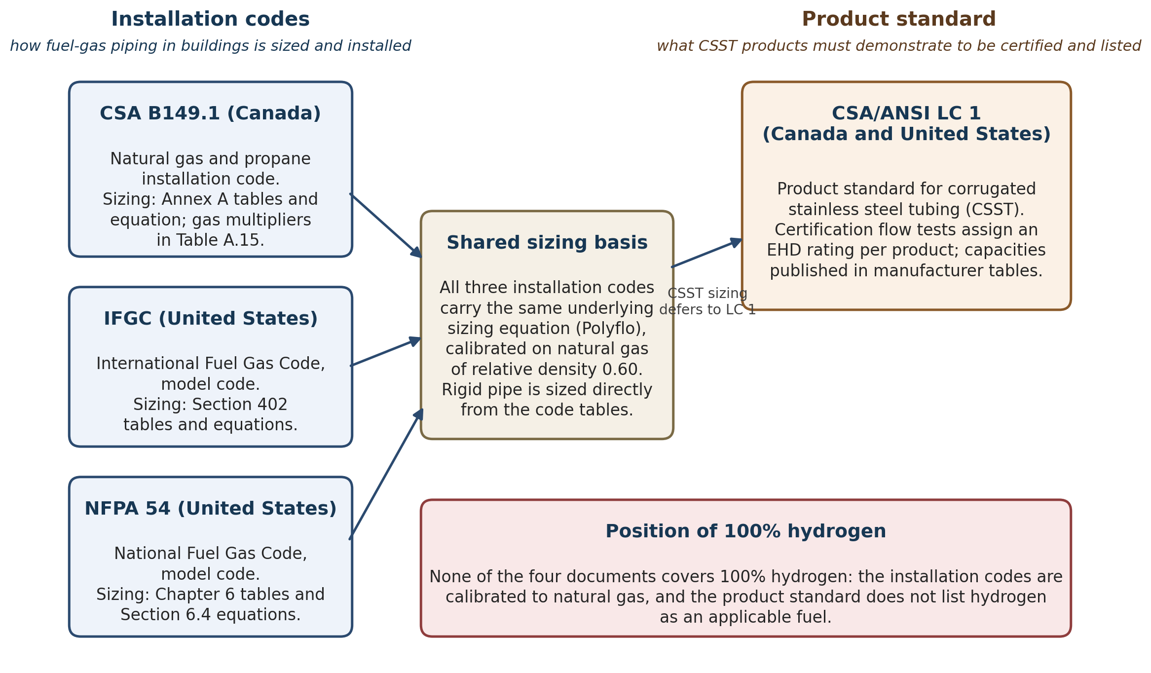
Figure 1 – The four governing North American documents and what each governs. The three installation codes share one underlying sizing basis; the product standard certifies CSST products and assigns the Equivalent hydraulic diameter (EHD) flow-capacity ratings the installation codes rely on for CSST.

Report Structure
Chapter 2 summarizes the methods. Chapter 3 contains the results: hydrogen properties (§3.1), pilot-project evidence (§3.2), the standards review (§3.3), operating parameters (§3.4), equation and model development (§3.5), hydrogen sizing graphs and tables (§3.6), sensitivity analysis and the resulting sizing options (§3.7), and model validation with the recommended laboratory tests (§3.8). Chapter 4 brings these results together in a gap analysis of the governing standards and recommendations for their development, and Chapter 5 states the conclusions. Appendices A to D hold the standards cross-reference matrix, the equation derivations, supplementary sensitivity data and the detailed laboratory test plan. The key concepts and terminology used throughout the report are presented in §1.4.

Key Concepts and Terminology
The following terms are used throughout this report. They are defined here so that the technical discussion is accessible to readers who are less familiar with gas-flow terminology; brief reminders are also given at first use in the text.
- Sonic velocity (speed of sound): the speed at which sound, and hence any pressure disturbance, travels through the gas.
- Mach number: the ratio of the gas velocity in the pipe to the sonic velocity; below a Mach number of about 0.3, velocity-induced compressibility effects are commonly small enough for a low-Mach treatment, although gas density may still vary with pressure and is retained in the gas-flow equation.
- Choked flow: the condition in which the gas reaches sonic velocity at a restriction, which caps the achievable flow rate.
- Compressibility factor (Z): a measure of how far a real gas deviates from ideal-gas behavior; Z = 1 for an ideal gas.
- Superexpansibility factor (Y): the equivalent correction used in North American sizing equations.
- Relative density (specific gravity, SG): the density of the gas relative to air (air = 1).
- Higher and lower heating value (HHV, LHV): the energy released per unit volume of gas burned, with (HHV) or without (LHV) the heat recovered from condensing the water vapor formed in combustion.
- Wobbe index: the heating value divided by the square root of relative density; gases with the same Wobbe index deliver the same energy through a given orifice at the same pressure.
- Reynolds number (Re): a dimensionless ratio of inertial to viscous forces that determines whether flow is laminar, transitional, or turbulent.
- Friction factor (f): the dimensionless coefficient that sets how much pressure a pipe run loses at a given flow; used here in the Darcy convention.
- Momentum flux (ρv²): the product of gas density and the square of velocity, a measure of the mechanical force the flowing gas exerts on bends and fittings; also used as an erosion and mechanical-loading screening quantity.
- Aeroacoustic noise: noise generated by the gas flow itself, mainly at elbows, tees, valves, and other fittings.
- Water column (W.C.): a pressure unit; 7 inches W.C. is approximately 0.25 psig, the standard North American natural-gas delivery pressure.
- Equivalent hydraulic diameter (EHD): the empirical flow-capacity index assigned to corrugated stainless steel tubing (CSST) under CSA/ANSI LC 1.
- Standard increment (pipe upsizing): moving to the next larger nominal pipe size (NPS) in the standard series, for example from NPS ½ to NPS ¾.

Methods
The study combines four methods: review of literature and pilot-program evidence; primary-text analysis of the governing standards; first-principles hydraulic analysis, in which the published sizing equations are re-derived and their friction basis is tested against the General Flow Equation under Moody friction; and computational verification, in which every published sizing table is regenerated cell by cell and compared with the flow-equation result. The subsections below describe each in turn.

Data Collection and Literature Review Approach
Property data for hydrogen and the reference natural gas were reconciled across the NIST WebBook [1], ISO/TR 15916 [4] and the H2Tools compilation [5] (§3.1). Pilot-program evidence was collected from the published reports of the HyDeploy [7], [8], Hy4Heat [9], H21 [10], Australian Hydrogen Centre [11]–[14], HyDelta [15], H2Direkt [16], THyGA [18] and HyBlend [19] programs (§3.2), with attention restricted to findings relevant to pipe sizing: pressure drop, velocity and flow regime. The four governing standards were analyzed from their primary texts, clause by clause where sizing is concerned (§3.3 and Appendix A). Manufacturer data for CSST were assembled from four sources: one documented flow-capacity test program and three published sizing-table sets, approximately 5,500 capacity data points in all (§3.5.2). No public measurements of hydrogen flow in domestic piping were identified in the reviewed sources; that absence shapes the validation recommendations of §3.8.

Analytical Framework
The analytical framework is first-principles pipe hydraulics. The published sizing equations are re-derived from the General Flow Equation to expose the friction closure (i.e., the mathematical relationship specifying how the friction factor varies with Reynolds number) they embed (§3.5.1); that closure is tested against Moody friction, represented by the Churchill correlation, over the Reynolds-number range each gas actually occupies; and the decision to retain, recalibrate or replace an equation follows from where the closure holds. Compressibility is screened at the outset and found not to govern within the domestic scope of this project, pressures below 10 psig (69 kPa gauge); the basis for that screening is given in §3.1.4. The flow is therefore treated as effectively incompressible throughout, with gas density still scaled with absolute pressure where the high-pressure equation form applies (§3.1).

Computational Fluid Dynamics Methodology
Computational fluid dynamics (CFD) has a supporting role in this study: examining the internal flow structure of corrugated tubing, where the equivalent-diameter and equivalent-roughness questions of §3.5.2 cannot be resolved from published data alone. The model is a streamwise-periodic unit cell of five corrugations of the EHD 13 geometry profile, the same profile that defines the volume-equivalent diameter D_{eff} in §3.5.2, solved with OpenFOAM. The flow is driven to a set mean velocity, and the Reynolds number on the D_{eff} basis covers 250 to about 12,900. Turbulence is represented by the transient k-ω SST model, with a laminar model run alongside it up to Re = 1,500 as a check. Natural gas is the base case, and hydrogen is run at Re = 500 and 950 to test whether the friction factor depends on the gas at matched Reynolds number. The CFD results support, but do not replace, the flow-test program recommended in §3.8, and are reported there.

Sensitivity Analysis Approach
The sensitivity analysis of §3.7 changes one input at a time from a hydrogen baseline at the low-pressure schedule of CSA B149.1:25 Table A.1, and records the change in capacity and in the share of cells that fall in the laminar region. The inputs varied are the pipe roughness, the fitting allowance factor, the hydrogen viscosity, the heating-value basis and the pressure schedule, which sets both the supply pressure and the allowable pressure drop. Run length and pipe size are the axes of every sizing table, so their effect is read from the tables of §3.5.3 and §3.6.2 rather than varied separately. Appliance demand is not an input to a capacity table, since the table returns the capacity a pipe can carry for any demand. In-pipe velocity is reported alongside, since it follows from the flow rather than entering the friction factor, and the inputs are then ranked by their influence on hydrogen sizing.

Standards Cross-Referencing Methodology
Each sizing-relevant clause of CSA B149.1, the IFGC, NFPA 54 and CSA/ANSI LC 1 was extracted from the primary text and mapped against its counterparts in the other documents, producing the cross-reference matrix of Appendix A. The rows cover scope and applicable fuels, sizing equations and tables, gas-property corrections, pressure envelopes, velocity provisions and the treatment of CSST. The gaps and misalignments identified in the matrix feed the analysis of §3.3.2.

Results and Discussion
This chapter contains the technical results of the study. It opens with the properties of hydrogen that drive every sizing consequence (§3.1), reviews what existing pilot projects do and do not demonstrate (§3.2), establishes what the applicable standards prescribe (§3.3), and examines the operating parameters that govern domestic systems (§3.4). On that basis, §3.5 develops the equation and model analysis (where the published methods come from, where they are valid, and what replaces them where they are not), and §3.6 turns that analysis into hydrogen sizing graphs and tables. Sensitivity analysis and the resulting sizing options follow in §3.7, and model validation and laboratory testing in §3.8.

Physical and Chemical Properties of Hydrogen
This section establishes the property values on which every sizing result in this report rests. It fixes the reference conditions first, then compares hydrogen with the reference natural gas property by property, draws out the three ratios that drive sizing, and closes with sonic velocity and the Mach number.

Reference Conditions and Ideal-Gas Behavior
Property values for pure hydrogen at the domestic reference state of 60 °F (15.6 °C) and 14.7 psia (101.325 kPa), at 7 inches of water column (7 in. W.C.) (≈ 0.25 psig / 1.74 kPa gauge), and at 2 psig (≈ 13.8 kPa gauge) are reconciled across the NIST Webbook [1] (Leachman et al. 2009 equation of state [2]), ISO/TR 15916:2015 [4], and the H2Tools comparative-properties compilation [5]. Within the operating range considered in this research, hydrogen exhibits near-ideal gas behavior: the compressibility factor Z, which measures the deviation of a real gas from ideal-gas behavior (Z = 1 for an ideal gas), remains at or above 0.9994 throughout, corresponding to deviations from ideal-gas behavior of less than 0.1%. When pipe sizes are calculated using actual in-pipe conditions, hydrogen density must still be scaled with absolute pressure, because the gas becomes denser as pressure increases: hydrogen is about 13.6% denser at 2 psig, and about 68% denser at 10 psig, than at atmospheric pressure, so the high-pressure (P₁² − P₂²) form of the sizing equation given in the installation codes (IFGC and NFPA 54; see §3.3) must be used where the pressure drop is not small relative to absolute pressure.

Property Comparison with Reference Natural Gas
Table 1 summarizes properties most relevant to domestic pipe sizing for pure hydrogen and reference natural gas. Natural gas is treated as a representative North American code-design gas rather than as pure methane. For this analysis, the reference natural gas is assumed to have a specific gravity of 0.60 and a gross heating value (HHV) of 1,000 Btu/scf, consistent with the calibration basis used in North American natural-gas pipe-sizing tables (see §3.3). Actual delivered natural gas varies with composition and location (U.S. delivered natural-gas heat content has been reported around 1036–1037 Btu/ft³ in recent EIA annual data), so where project-specific gas composition or utility tariff heating value is available, those values should be used for final calculations. All values are stated at 60 °F (15 °C) and 14.7 psia (101.325 kPa) unless otherwise noted; imperial values are given first with metric equivalents in brackets.
Property | Units | H₂ | Reference natural gas | H₂ / NG ratio | Pipe-sizing significance
Density, ρ | lb/ft³ (kg/m³) | 0.00531 (0.0851) | 0.0458 (0.734) | 0.116 | Hydrogen is significantly less dense than the reference natural gas, having only about 11.6% of its density.
Vapor specific gravity (relative to air, air = 1) | — | 0.0696 | 0.60 | 0.116 | Confirms hydrogen is far outside the SG range used in North American NG multiplier tables.
Dynamic viscosity, μ | lb/(ft·s) (μPa·s) | 5.9 × 10⁻⁶ (8.8) | 8.1 × 10⁻⁶ (12.0) | 0.73 | Hydrogen has lower dynamic viscosity than NG, but the density reduction dominates Reynolds-number behavior.
Kinematic viscosity, ν | ft²/s (m²/s) | 1.12 × 10⁻³ (1.04 × 10⁻⁴) | 1.76 × 10⁻⁴ (1.63 × 10⁻⁵) | 6.36 | Hydrogen’s kinematic viscosity is much higher, resulting in lower Reynolds numbers at equal velocity.
ρ/μ ratio (relative to NG) | — | 0.159 × NG | 1.00 | 0.159 | At equal velocity and pipe diameter, hydrogen Reynolds number is only about 16% of NG.
Speed of sound | ft/s (m/s) | ≈ 4300 (≈ 1300) | ≈ 1350–1450 (≈ 410–440) | ≈ 3.0 | Hydrogen Mach number remains low at domestic velocities.
Compressibility / superexpansibility | — | Z ≈ 1.000 at domestic pressures | Y ≈ 0.9992 in IFGC/NFPA table basis | approx. equal | Compressibility-factor corrections are small, but density still scales with absolute pressure.
Lower heating value, LHV | Btu/scf (MJ/m³) | ≈ 274 (≈ 10.2) | ≈ 900 (≈ 33.5) for nominal 1000 Btu/scf gross NG | 0.30 | Equal useful heat input requires roughly 3.3 times hydrogen volumetric flow on an LHV basis.
Higher heating value, HHV | Btu/scf (MJ/m³) | ≈ 324 (≈ 12.1) | 1000 (37.26) nominal design gas | 0.324 | Equal gross heat input requires roughly 3.1 times hydrogen volumetric flow on an HHV/code-table basis.
Lower Wobbe index | Btu/scf | ≈ 1039 | ≈ 1162 if NG LHV = 900 Btu/scf | 0.89 | Useful if discussing net-energy interchangeability.
Higher Wobbe index | Btu/scf | ≈ 1228 | ≈ 1291 if NG HHV = 1000 Btu/scf | 0.95 | More consistent with North American gross-heating-value appliance/input conventions.
Table 1 – Thermophysical and combustion properties of hydrogen and reference natural gas at 60 °F (15.6 °C) and 14.7 psia (101.325 kPa). Reference natural gas basis: SG = 0.60, nominal HHV = 1000 Btu/scf. Hydrogen density, viscosity, and specific-gravity values are consistent with the H2Tools comparative-properties data [5] (NTP defined as 20 °C and 1 atm), adjusted to the 60 °F basis where relevant. The distinction between LHV and HHV is kept explicit because H2Tools defines LHV as excluding the latent heat of water condensation and HHV as including it. Sources: NIST Webbook [1] (Leachman et al. 2009 [2]), ISO/TR 15916:2015 [4], H2Tools Comparative Properties [5].

Three Ratios that Drive Sizing
Two quantities carry the central argument of this report: the Reynolds number and the friction factor. The Reynolds number expresses the ratio of inertial to viscous forces in the flow: Re = ρvD/μ, where ρ is the gas density in lb/ft³ (kg/m³), v the mean velocity in ft/s (m/s), D the inside diameter in ft (m), and μ the dynamic viscosity in lb/(ft·s) (Pa·s). For a given pipe and gas, the Reynolds number rises in direct proportion to the flow rate (Figure 2, panel a). Low Reynolds numbers give laminar flow, in which the gas moves in ordered layers; high Reynolds numbers give turbulent flow; between about Re = 2,300 and Re = 4,000 the flow is transitional.
The friction factor behaves differently in each regime (Figure 2, panel b). In laminar flow it falls steeply as flow rises, following f = 64/Re regardless of pipe roughness. In the transitional regime, the friction factor is not governed by an exact physical law; measured values scatter within a band bounded by the laminar and turbulent limits. In turbulent flow it is nearly independent of flow and is set mainly by the wall roughness. Pressure loss scales with f·v², so which regime a pipe operates in decides how its capacity responds to pipe size and pressure, and a sizing method calibrated in one regime cannot be assumed to hold in another. This single point drives most of the hydrogen-specific findings of this report, because hydrogen operates at about half the Reynolds number of natural gas at equal energy delivery (§3.1).
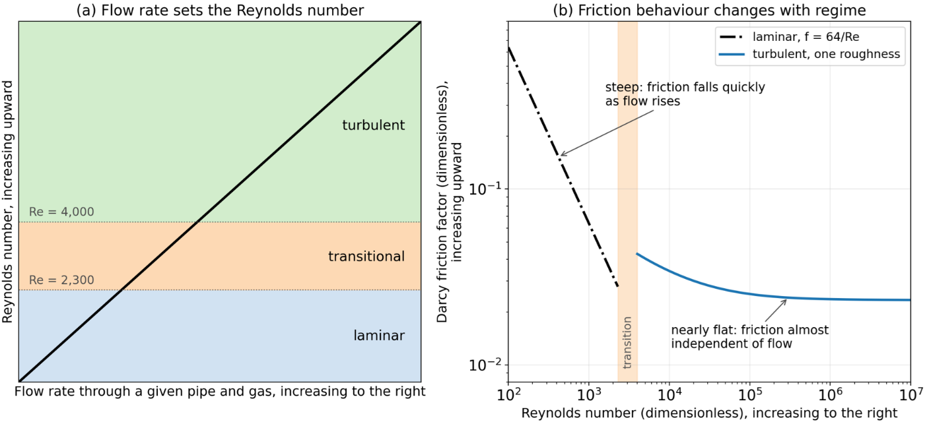
Figure 2 – The Reynolds number and the friction factor. (a) For a given pipe and gas the Reynolds number rises in proportion to the flow rate, moving the operating point through the laminar, transitional and turbulent regimes. (b) The Darcy friction factor falls steeply with Reynolds number in laminar flow (f = 64/Re) and is nearly flat in turbulent flow; the transition lies between Re = 2,300 and Re = 4,000.
Three ratios drive the sizing considerations. First, at the same pressure and temperature, hydrogen has approximately 11.6% of the density of the reference natural gas, making it roughly one-eighth to one-ninth as dense. Second, hydrogen’s dynamic viscosity is approximately 73% of the reference natural-gas value, so the ρ/μ ratio, governing Reynolds number at the same velocity, is only about 15.9% of the natural-gas value. Third, hydrogen has a much lower energy content per unit volume than natural gas, so an appliance requires a higher gas flow rate to deliver the same amount of energy. Based on the nominal reference-gas values in Table 1, the required hydrogen flow rate is approximately 3.1 times that of natural gas on an HHV basis (1,000/324 = 3.09) and approximately 3.3 times on an LHV basis (900/274 = 3.28). When both the Reynolds-number and volumetric-flow effects are considered, hydrogen Reynolds numbers are approximately 49% - 52% of those for natural-gas, at the same appliance input before accounting for diameter, roughness, and local fitting effects. At domestic loads and small NPS sizes, some operating points may fall within the laminar/transitional regime. Figure 3 traces the three ratios through to their operating consequences.
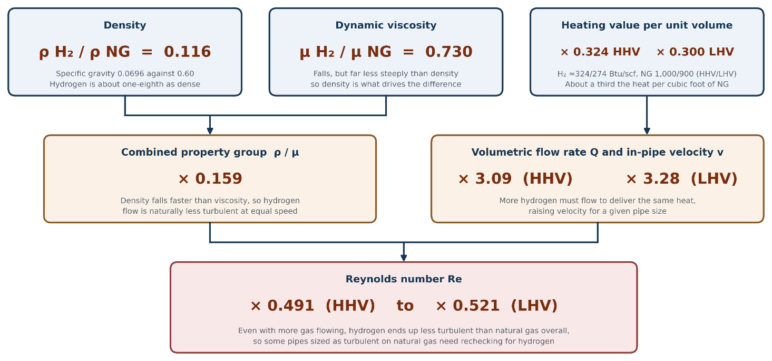
Figure 3 – The three property ratios for 100% hydrogen relative to the reference natural gas, and what they produce at equal appliance energy input in the same pipe. Property ratios are from Table 1; the Reynolds-number ratio is on the Annex A viscosity basis (§3.5).

Sonic Velocity and Mach Number
Hydrogen’s sonic velocity (the speed at which sound, and hence any pressure disturbance, travels through the gas) at domestic conditions is approximately 4,300 ft/s (1,300 m/s), compared with approximately 1,350 to 1,450 ft/s (410 to 440 m/s) for reference natural gas. The Mach number (the ratio of the gas velocity in the pipe to the sonic velocity) stays below 0.3 at any in-pipe velocity below about 1,280 ft/s (390 m/s). The highest hydrogen velocity in runs of 30 ft (9 m) or longer at the pressure schedules within the scope of this project is about 980 ft/s (300 m/s), a Mach number of 0.23. Mach numbers below 0.3 are the standard criterion for negligible compressibility effects, so hydrogen stays under it. Choked flow (the condition in which the gas reaches sonic velocity at a restriction, which caps the achievable flow rate) is therefore not a sizing constraint. In-pipe velocity is still screened in practice, for noise and erosion rather than for compressibility; the applicable screening values are treated with the other operating parameters in §3.4.3.

Existing Hydrogen Pilot Projects and Lessons Learned
International pilot-project evidence indicates that 100% hydrogen domestic service is feasible in selected controlled demonstrations, but this evidence does not by itself validate the North American domestic-piping sizing tables. The distinction matters because the two claims rest on different evidence: the pilot projects demonstrate operational feasibility (hydrogen, at each program’s blend share or purity, was delivered and used safely in the homes concerned), whereas validating the sizing tables would require measured pressure-drop and flow data for the specific pipe sizes, materials, and configurations those tables cover, and such data were generally not published by the pilot programs. Five programs are reviewed in this section: HyDeploy (UK), the Australian Hydrogen Centre, the Dutch and German hydrogen neighborhood conversions, the European appliance-testing program THyGA (Testing Hydrogen Admixture for Gas Applications), and the U.S. HyBlend initiative led by the National Renewable Energy Laboratory (NREL) and Sandia National Laboratories. Each project is summarized below, with attention restricted to findings relevant to pipe sizing, pressure drop, velocity, and flow regime. Findings related to appliance certification, leakage, embrittlement, odorization, and public acceptance are also addressed in these projects but are outside the primary focus of this review.

HyDeploy
The UK HyDeploy program illustrates the staged British transition from 20% hydrogen blends toward 100% hydrogen service. HyDeploy [7] (Keele University campus, 2019–2021) and HyDeploy2 [8] (Winlaton, Gateshead) delivered up to 20% hydrogen blends through existing low-pressure polyethylene and steel distribution piping without modification to customer-side installations. The companion programs Hy4Heat [9] (UK BEIS, 2019–2022) and H21 [10] (Northern Gas Networks, Leeds City Gate and Phase 2) progressed the evidence base toward 100% hydrogen in the domestic envelope by qualifying appliances, joints, components, and service tees for hydrogen service. The Hy4Heat work reported domestic appliance operating envelopes consistent with up to 75 mbar gauge (≈ 1.1 psig) and observed an increased volumetric flow at the meter on hydrogen of approximately a factor of three. Hy4Heat as a program is appliance- and safety-case work rather than a hydraulic revalidation of the UK Pole-type customer pipe-sizing tables (the UK domestic sizing tables, of the same lineage as the North American sizing equations reviewed in §3.5), and the present report does not treat its outputs as a Pole-type-table (i.e.,….) revalidation. None of the UK programs reviewed published pressure-drop or velocity measurements at the customer-piping level at a resolution sufficient to revalidate the Pole-type tables for hydrogen; their published outputs focus on safety case, materials, and appliance certification rather than on hydraulic recharacterization.

Australian Hydrogen Centre
The Australian Hydrogen Centre (AHC) was a research consortium that operated from 2019 to 2023. Led by Australian Gas Networks and partners, the initiative was funded by the Australian Renewable Energy Agency (ARENA), the South Australian Government, and the Victorian Government. AHC completed six feasibility studies examining both 10% hydrogen blending [13], [14] and the conversion of gas distribution networks to 100% hydrogen. Of these, the 100% hydrogen Victoria Feasibility Study [11] and 100% hydrogen South Australia Feasibility Study [12] (ARENA Knowledge Bank, 2023) are the most directly relevant to domestic piping. The studies reported that converting existing high-density polyethylene (PE-HD) gas distribution networks to 100 % hydrogen is technically feasible. However, the reports provided limited information on residential piping hydraulics, as they focus primarily on the feasibility, economics, and risks of hydrogen conversion at the distribution-network level.

Dutch and German Hydrogen Neighborhood Conversions
The Dutch HyDelta program [15] (Phases 1–3, 2021–2024) and the Stad aan ’t Haringvliet residential conversion project produced the most directly relevant European evidence on customer-side piping. HyDelta reported that, for the same energy demand, 100% hydrogen requires approximately three times the volumetric flow of G-gas (the low-calorific Groningen-quality natural gas distributed in the Netherlands), because the required flow scales with the inverse ratio of the lower heating values, confirming that meter and trunk-line sizing must accommodate that increase at equal energy demand. The Stedin-operated Stad aan ’t Haringvliet conversion reported leak-tight customer-side operation under monitored field conditions. The German H2Direkt project [16] (Hohenwart, Bavaria; energy supplier Energie Südbayern, network operator Bayernets) operated a residential hydrogen distribution loop using PE-HD service piping. However, interior piping material and per-segment leak-tightness details for H2Direkt are not reported in the reviewed sources at a level of detail that allows independent confirmation; therefore, that information is treated here as project-summary information rather than verified measurement. None of the Dutch or German neighborhood conversion projects published a recharacterization of NEN 1078 or DVGW G 655 sizing tables (the Dutch and German domestic gas-installation sizing standards, respectively) against hydrogen flow data. The Belgian KU Leuven BatHyBuild inventory [17] (2021) catalogues earlier Dutch demonstrations (Ameland (2007–2011), Rozenburg (2014), and Hoogeveen (2020)) which helps inform the network-scale picture though they predate the domestic-piping-specific work of HyDelta.

THyGA
The EU-funded THyGA program [18] (2020–2022; coordinator Engie Laborelec) conducted a hydrogen-tolerance test campaign on approximately 100 domestic and small commercial appliances originally designed and certified for natural gas, with the publicly available test-program report (THyGA deliverable D2.5) indicating a primary focus on hydrogen blends below 30 vol% with additional tests up to 60 vol%; broader 100% hydrogen appliance coverage was not in scope across the full appliance set. THyGA showed that appliances rated to the existing European installation envelope (typically 20 to 75 mbar gauge, i.e. 0.3 to 1.1 psig) continued to deliver the rated useful heat output on the tested hydrogen blends with adjusted volumetric flow. This provides evidence that appliances can operate on hydrogen blends, but it does not validate the hydraulic performance of customer piping. THyGA did not measure pressure drop or gas velocity in customer piping, and its results cannot be used to confirm that the same pressure-drop allowance used for natural gas is also appropriate for hydrogen.

U.S. HyBlend (NREL/Sandia)
HyBlend (2020–present) and its successor BlendPATH [19] are the U.S. Department of Energy (DOE) techno-economic and hydraulic modeling initiatives led by NREL and Sandia National Laboratories, with industry partners including the Canadian utility ATCO [20] (Fort Saskatchewan Hydrogen Home, Alberta), Enbridge [21] (Markham hydrogen blending station, Ontario), SoCalGas [22], and the New York State Energy Research and Development Authority (NYSERDA) [23]. HyBlend has published transient and steady-state hydraulic modeling studies of hydrogen blends and 100% hydrogen across a range of distribution-system geometries. However, the published per-segment outputs focus on transmission and high-pressure distribution systems rather than ≤ 10 psig customer piping envelope. As a result, HyBlend/BlendPATH and the associated utility-partner demonstration projects are treated here as background and modeling context rather than as validation of domestic sizing tables. The ATCO Fort Saskatchewan Hydrogen Home is publicly described as a residential blended-gas demonstration (with initial public information indicating a hydrogen blend of approximately 5% in the supplied network) and provides a Canadian residential analog. However, no public per-segment pressure-drop data at a level of detail sufficient to recalibrate the CSA B149.1:25 Annex A tables were identified in the reviewed source set.
The pilot literature reviewed above emphasizes safety, appliance certification, and public acceptance rather than domestic-piping hydraulic data. Therefore, the sizing tables should be derived primarily from first-principles hydraulics anchored on the property data in §3.1, with pilot evidence providing operational confirmation rather than primary calibration. Table 2 condenses what each program demonstrates and what it does not.
Program | Hydrogen share | System layer | Evidence relevant to pipe sizing | Public pressure-drop data for sizing-table validation
HyDeploy, HyDeploy2, Hy4Heat, H21 (UK) | Blends up to 20% delivered; 100% program work on appliances and components | Low-pressure distribution networks; appliance and component qualification | Blend delivery through existing polyethylene and steel low-pressure networks without customer-side modification; appliance envelopes to 75 mbar (1.1 psig); volumetric flow at the meter up by about a factor of three on hydrogen | None identified in the reviewed public sources
Australian Hydrogen Centre (AU) | 10% blend and 100% conversion feasibility studies | PE-HD distribution networks | 100% conversion of PE-HD distribution networks reported technically feasible; limited information on residential piping hydraulics | None identified in the reviewed public sources
HyDelta, Stad aan ’t Haringvliet, H2Direkt (NL, DE) | 100% | Distribution and residential service; customer-side operation | Approximately three times the volumetric flow at equal energy demand (LHV basis); leak-tight customer-side operation under monitored field conditions | None identified in the reviewed public sources
THyGA (EU) | Blends, mainly below 30 vol% (tests up to 60 vol%) | Domestic and small commercial appliances | Rated useful heat output maintained on tested blends with adjusted volumetric flow; customer-piping hydraulics not measured | None identified in the reviewed public sources
HyBlend, BlendPATH (US) | Blends and 100%, modeling | Transmission and high-pressure distribution | Steady-state and transient hydraulic modeling; Canadian residential analog (ATCO, approximately 5% blend) | None identified in the reviewed public sources
Table 2 – Pilot-program evidence and its relevance to domestic pipe sizing, condensing §3.2.1 to §3.2.5. The last column records whether pressure-drop data sufficient to validate domestic sizing tables were identified in the reviewed public sources.

Standards and Codes Review
This subsection evaluates existing standards, codes, and regulations relevant to the design of domestic hydrogen gas piping in North America. The primary clause-by-clause analysis uses CSA B149.1:25 [32], the 2021 International Fuel Gas Code [33], the 2015 edition of NFPA 54 [34], and CSA/ANSI LC 1:23 / CSA 6.26:23 [35]. Other editions are cited only where a specific comparison or later change is identified. The clause-by-clause cross-reference matrix supporting this comparison is presented in Appendix A.

Overview of Applicable Standards
The standards relevant to domestic piping below 10 psig are summarized in Table 3; they span Canadian, US, European, UK, Australian and international instruments. The fifteen entries are listed so that the four standards examined in §3.3.2 can be positioned against the wider international set.
The four standards in the scope of the present report (CSA B149.1:25 [32], the IFGC [33], NFPA 54 [34] and CSA/ANSI LC 1 [35]) are the focus of the detailed clause-by-clause analysis presented in §3.3.2 and Appendix A. The additional standards listed in Table 3 are included for situational awareness, on the basis of their published scope and high-level positioning within the international hydrogen domestic-piping context. Their primary texts have not been consulted in detail for this review, and the cells of Table 3 that describe them reflect publicly available scope information rather than direct extraction from the standard itself.
Standard / edition | Region | Scope for 100% H₂ domestic | Sizing method | CSST treated?
CSA B149.1:20 / :25 [32] | Canada | NG/LP fuel scope; the 2025 version adds H₂–NG blend clauses (e.g. 6.3.2–6.3.5); 100% hydrogen is outside B149.1 fuel scope and is addressed separately by CAN/BNQ 1784 and by hydrogen-specific piping standards such as ASME B31.12 | Pole / Spitzglass-type tables (Annex A); SG = 0.60 | Via CSA/ANSI LC 1 reference
CAN/BNQ 1784-000:2022 [36] | Canada | Residential and light-commercial 100% H₂; ≤ 500 kPa | Canadian regulatory anchor for 100% H₂; piping design delegated to ASME B31.12 | Per Bureau de normalisation du Québec (BNQ) Clause 7.4.1.5, gaseous-hydrogen piping design is delegated to ASME B31.12; no LC 1 compliance expectation has been confirmed against the BNQ text in this study
CSA/ANSI LC 1:23 / CSA 6.26:23 [35] | NA | CSST product standard; NG/LP to ≤ 5 psig; H₂ not listed | EHD method; manufacturer tables on air/CH₄ | Central; EHD lab-derived on NG/air
IFGC 2021 / 2024 §402 [33] | US | NG and LP fuel scope; SG = 0.60 sizing basis with low-pressure (< 1.5 psig) and high-pressure (≥ 1.5 psig) equation forms in §402.4; sizing tables span < 2 psig up to 5 psig inlet cases; indoor maximum operating pressure capped at 5 psig per §402.7 (with listed exceptions). Gaseous-hydrogen systems are treated separately in IFGC Chapter 7; §402 does not provide 100% hydrogen sizing tables | Low-P Eq. 4-1 (Spitzglass-LP); High-P Eq. 4-2 (Spitzglass-HP); Cr, Y factors | Accepts CSST listed to LC 1 / 6.26
NFPA 54 (2015 / 2024) [34] | US | NG and LP fuel scope; hydrogen fuel-gas systems are excluded from NFPA 54 (scope/commentary), with hydrogen systems addressed by hydrogen-specific codes such as NFPA 2 and storage provisions handled by NFPA 55 as applicable | §6.4.1 Spitzglass-LP form with embedded Cr, Y | Via LC 1 reference
ASME B31.12-2023 [37] | US (referenced by CAN/BNQ 1784-000:2022 [36]) | US hydrogen piping and pipeline standard; all pressure ranges | Darcy–Weisbach-based hydrogen piping framework | Not addressed
ISO/TR 15916:2015 [4] | International | H₂ safety basics; non-prescriptive; property data + hazards | Informative only | Not addressed
CSA Z662-23 [42] | Canada | H₂ and H₂-blend pipelines (transmission/distribution); not domestic | Pipeline design framework; defers to B149.1 / BNQ 1784 for interior piping | N/A (pipeline scope)
DVGW G 655:2025 [43] | Germany | Hydrogen-readiness framework for German installations | Property/Wobbe-based framework for domestic hydrogen sizing | Via EN 15266
DVGW G 260:2021 [44] / G 600 (TRGI 2018) [45] | Germany | Gas quality (G 260); installation (TRGI) | German gas-quality and installation framework for hydrogen service | Via EN 15266
NEN 1078:2024 [46] + NPR 3378-3:2025 [47] | NL | Dutch building gas installations standard with hydrogen added in 2024; NPR 3378-3 dimensions pipework for natural gas, propane and hydrogen | Graph-method pipe dimensioning for natural gas, propane and hydrogen (NPR 3378-3) | Via EN 15266
IGEM/H/2 Ed 2 [48] + IGEM/UP/1B Ed 4 [49] + IGEM/H/3 Ed 2 [50] | UK | UK domestic, small-installation, and industrial/commercial hydrogen standards | UK domestic hydrogen installation framework | Via EN 15266 reference
EN 15266:2024 [51] / UNE-EN 15266:2025 [52] | EU | European CSST product standard for building gas installations | EHD-based capacity tables; hydrogen not within default scope | Central; CSST product standard
AS/NZS 5601.1:2022 [53] | AU/NZ | Australia/NZ gas installation standard; hydrogen via performance-based design | Standard NG/LP tables; not hydrogen-calibrated | Via LC 1 / EN 15266 equivalents
EIGA Doc 121/14 [54] | EU (industry) | Industrial H₂ piping and safety guidance; informative for domestic | Industrial hydrogen piping guidance; no domestic sizing | Not addressed
Table 3 – Standards relevant to domestic piping below 10 psig. Bolded standards in the text above (CAN/BNQ 1784-000:2022, ASME B31.12-2023, DVGW G 655:2024, NEN 1078:2024 / NPR 3378-3:2025, and IGEM/H/2 Edition 2) are those directly relevant to 100% hydrogen service; among them, ASME B31.12 covers hydrogen piping and pipelines more broadly rather than being specifically a domestic gas installation code. Context-row scope descriptions for the remaining standards are drawn from publicly available scope information and have not been verified against each standard’s full text in this study.
Selection of the native sizing form for this study is addressed in §3.5 and is informed by the four governing North American standards rather than by the European sizing instruments listed in Table 3.

Comparative Analysis and Cross-Reference Matrix
The four standards examined in this study (CSA B149.1, the International Fuel Gas Code, NFPA 54, and the corrugated-stainless-steel-tubing product standard CSA/ANSI LC 1) fall into two categories. The first three are domestic-installation codes that prescribe how to size fuel-gas piping. The fourth, CSA/ANSI LC 1, is a product standard that provides the Equivalent Hydraulic Diameter (EHD) values used by the installation codes when sizing CSST systems. Appendix A contains the full clause-by-clause comparison; the discussion here focuses on the broader conclusions from that comparison.
The three installation codes (CSA B149.1, the IFGC and NFPA 54) rest on the same underlying sizing equation, called Polyflo, examined in detail in §3.5.1. In both its low-pressure and high-pressure forms, that equation was calibrated against natural gas with a relative density of 0.60. The gas properties enter through a single constant (C_{r}), and the superexpansibility factor (Y) remains approximately equal to 1.0 at residential conditions. The three codes differ in presentation and in the maximum pressure permitted for piping installed indoors (the IFGC and NFPA 54 cap this indoor piping pressure at 5 psig, subject to listed exceptions, while the CSA B149.1:25 tabulated range extends higher than 5 psig), but all three derive from the same natural-gas calibration. For gases other than the 0.60 design gas, each code provides a correction route, and the routes differ. CSA B149.1:25 (Clause 6.3.6) makes the relative-density multipliers of its Table A.15 mandatory, with tabulated values spanning relative densities 0.35 to 2.10 and a direction in Annex A.2.6 to take the next higher tabulated value for a gas between entries. NFPA 54 (Annex B.3.4) and the IFGC (Appendix A102.4) instead state that gas with a relative density of 0.70 or less may be sized directly from the natural-gas tables, with gravity-factor multipliers applied only above 0.70.

Two consequences follow for the non-corrugated pipe installation codes. First, the gas-correction routes do not explicitly extend to hydrogen. Hydrogen’s relative density of 0.0696 lies at about one fifth of the lowest value tabulated in CSA B149.1:25 Table A.15; application of the next-higher rule in Annex A.2.6 therefore results in a multiplier of 1.31, corresponding to a gas with a relative density of 0.35. The relationship underlying the table is the square root ratio of relative densities of natural gas and the target gas: √(0.60/S). This expression yields a value of 2.94 for hydrogen, so the next-higher rule returns a multiplier under half of what the table's own underlying relationship would assign, and CSA B149.1's standard correction procedure cannot be relied on for hydrogen without modification. The IFGC and NFPA 54 codes take a different approach, treating gases with a relative density of 0.70 or less within the same category for sizing purposes. Since hydrogen has a relative density of 0.00696, the applicable provisions direct users to the standard natural gas sizing tables without additional adjustment. These provisions were developed for conventional fuel gases and do not specifically address the unique density and volumetric energy characteristics of hydrogen. Both the Canadian and U.S. installation code approaches provide sizing methods intended for conventional gaseous fuels. Because hydrogen exhibits physical properties that differ significantly from those of natural gas, additional consideration of hydrogen's lower density and lower volumetric energy content may be warranted. Hydrogen-specific sizing methodologies can provide a means of addressing these characteristics.

Second, the gas-property constant within the sizing equation must be calculated from first principles Using hydrogen’s density and viscosity, C_{r} is calculated as 0.0935, compared with 0.6094 for natural gas (§3.5.2). In addition, the flow regime must be evaluated at each load point, as hydrogen may operate in the laminar or transitional flow range under conditions where natural gas would typically remain turbulent.
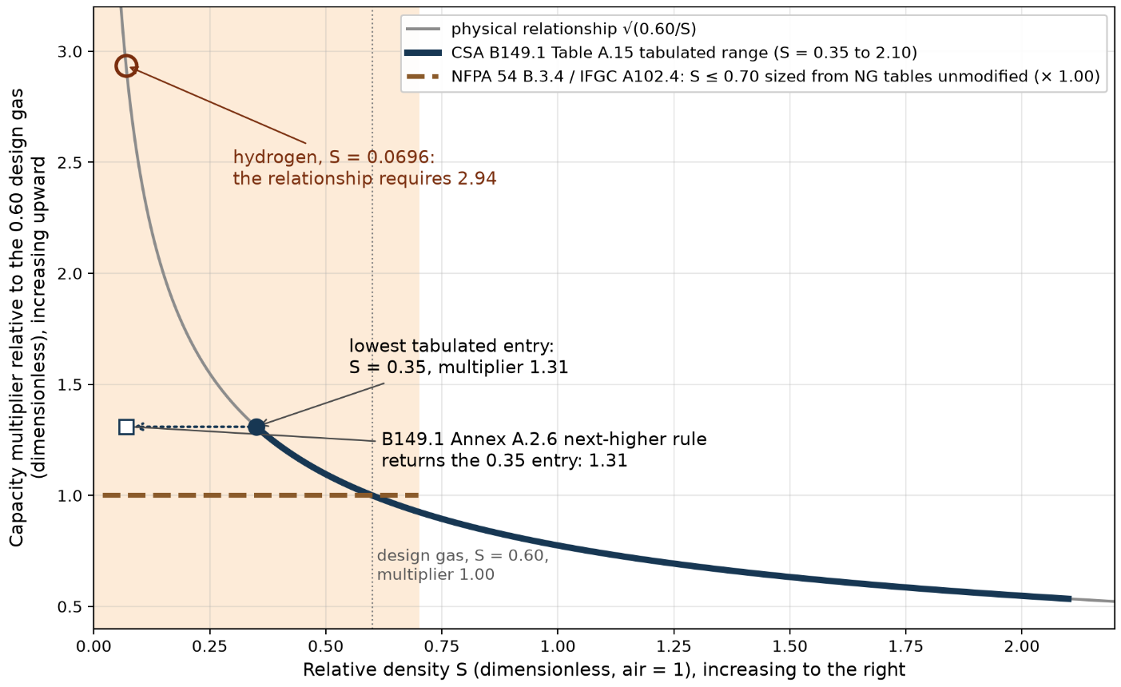
Figure 4 – Gas-correction routes of the installation codes against relative density. The physical multiplier follows √(0.60/S). CSA B149.1:25 Table A.15 tabulates it from S = 0.35 to 2.10, and the Annex A.2.6 next-higher rule returns the 0.35 entry (1.31) for any lighter gas, where hydrogen at S = 0.0696 requires 2.94. NFPA 54 (Annex B.3.4) and the IFGC (Appendix A102.4) send gas at S ≤ 0.70 to the natural-gas tables unmodified. Every route ends before it reaches hydrogen; clause citations in Appendix A.
For corrugated tubing, CSA/ANSI LC 1 operates differently. Rather than providing a sizing equation, it certifies each CSST product by flow test. The manufacturer measures flow capacity over a prescribed set of pipe lengths and pressure conditions and fits a single smooth curve through the measurements. LC 1 tabulates minimum required capacities for each EHD rating, and the product is assigned the largest EHD rating for which its fitted curve meets or exceeds every one of that rating’s tabulated minimums. The tabulated capacities are minimum requirements based on natural gas of relative density 0.60, so a certified product’s measured capacity sits at or above the table values for its rating. How the fit is constructed, and what it means for hydrogen requalification, is taken up in §3.5.1 and §3.5.2.
A further consequence follows for CSST specifically. The applicable-fuels clause of LC 1 does not list hydrogen and the EHD ratings are based on certification testing and acceptance tables developed for gas with relative density of 0.60. As a result, their direct applicability to hydrogen requires further consideration. Hydrogen CSST capacities may therefore need to be established through hydrogen-specific or surrogate-gas certification within the LC 1 framework rather than by applying a property-based multiplier to the existing ratings.
Taken together, the three installation codes and the LC 1 product standard leave an identified gap for 100% hydrogen domestic piping below 10 psig. The equation form is available, but its gas-property constant is calibrated to natural gas; the generic correction routes of the codes extend only to a relative density 0.35 or direct users to an unmodified natural-gas table below 0.70; and the empirical EHD ratings of the product standard are tied to the certification gas. Addressing this gap requires verifying the friction behavior over the Reynolds-number range hydrogen actually occupies, and qualifying CSST within the LC 1 framework. That is the work program of §3.5 and §3.6. The clause citations supporting this subsection are collected in Appendix A.

Key Operating Parameters for Domestic Hydrogen Systems
Pipe sizing for hydrogen conversion depends on a small set of operating parameters. These parameters determine whether an existing installation can safely accommodate hydrogen and whether it can operate within the pressure, velocity and noise limits specified by the codes and good engineering practice. They also determine which code requirements each fix triggers (for example, raising supply pressure above 5 psig requires welded joints under IFGC §402.7 and NFPA 54 §5.5.1, while a pipe upsize does not). This section examines those parameters in turn:
- the volumetric flow rate required for equal energy delivery (§3.4.1);
- the pressure drop relative to natural gas at that flow (§3.4.2);
- in-pipe velocity and momentum flux (§3.4.3);
- aeroacoustic (flow-generated) noise at fittings and valves (§3.4.4);
- the influence of elevated supply pressure (§3.4.5);
- the hydraulic behavior of corrugated stainless steel tubing (§3.4.6); and
- the effect of upsizing the pipe by one standard increment (§3.4.7).
First-principles direction is taken from the property values of §3.1 and from the code provisions reviewed in §3.3. Figure 5 sets these parameters in a single causal chain, and marks which of them each of the two mitigations, a one-step pipe upsize and raising supply pressure, acts on. Same appliance, same pipe: hydrogen needs about three times the gas flow of natural gas, and a one-step pipe upsize offsets what the flow does to pressure drop and noise.
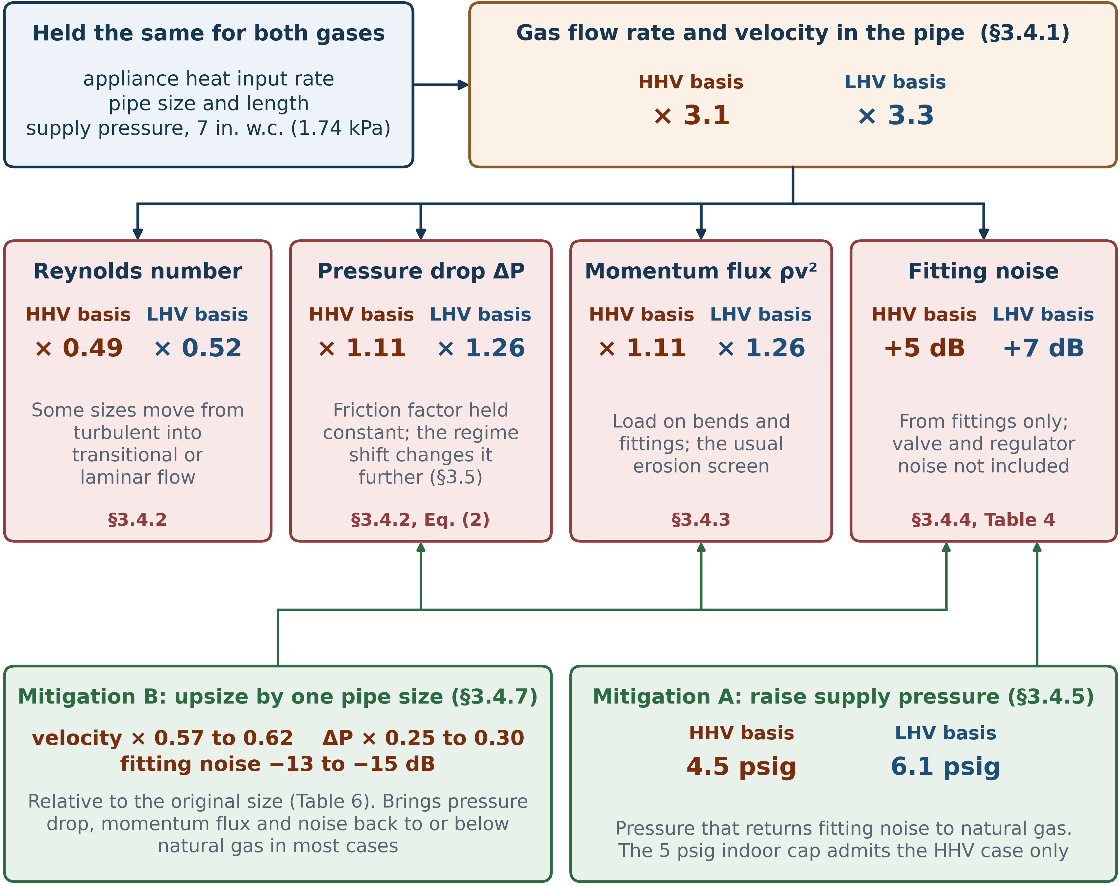
Figure 5 – Equal appliance energy input traced through to the operating consequences of §3.4 and the two mitigations available. Each value is hydrogen relative to natural gas, except Mitigation B, and labeled with its heating-value basis. The pressure-drop ratio holds the friction factor constant (§3.4.2), and the noise figures cover the fitting dipole component only (§3.4.4). CSST whistling is a separate acoustic risk that neither mitigation addresses (§3.4.6).

Volumetric Flow Rate Increase
Hydrogen’s lower volumetric heating value drives the required increase in hydrogen volumetric flow. Based on the reference natural-gas basis adopted in §3.1, an appliance specified at a fixed useful heat-input rate requires a hydrogen standard volumetric flow rate equal to the natural-gas standard volumetric flow rate multiplied by the inverse ratio of the heating values. Based on the higher heating value (HHV) convention commonly used in North American appliance input ratings and fuel gas codes, the energy-content ratio is approximately: HHV_{NG} / HHV_{H2} = 1000 Btu/scf / 324 Btu/scf ≈ 3.1. On an LHV basis, the corresponding ratio is LHV_{NG} / LHV_{H2} ≈ 900 Btu/scf / 274 Btu/scf ≈ 3.3 (heating values per Table 1). This means that, on a volumetric basis, approximately 3.1 times more hydrogen flow is required than natural gas on an HHV basis, or about 3.3 times more on an LHV basis, to deliver the same energy input. This increase in flow propagates upstream from the appliance through the branch lines, trunk line, and meter, and is the principal reason that existing sizing-table capacities need to be reevaluated for 100% hydrogen at every domestic pipe size. Where utility-tariff or composition-specific natural-gas heating values are available, those should be substituted for the nominal reference values in final calculations.

Pressure Drop Comparison
The Darcy–Weisbach pressure drop provides the basis for comparing hydrogen and reference natural gas at equal heat-input demand:
$ΔP = f \left(\frac{L}{D}\right) \left(\frac{1}{2}ρv^{2}\right)$ (1)
where ΔP is the pressure drop in psi (Pa), f the Darcy friction factor (dimensionless), L the pipe length in ft (m), D the inside diameter in ft (m), ρ the gas density in lb/ft³ (kg/m³), and v the mean velocity in ft/s (m/s). This equation provides the basis for the comparison below.
The flow increase of §3.4.1 raises the gas velocity by a factor of approximately 3.1 (HHV basis) to 3.3 (LHV basis), while the density ratio (ρ_{H2}/ρ_{NG}) of approximately 0.116 reduces effect of the increased velocity on the ½ρv² term (dynamic pressure) . The friction factor f also changes, because the hydrogen Reynolds number at equal heat-input demand is approximately half the natural-gas value (§3.1). As a result, some domestic pipe sizes that operate in the turbulent flow regime on natural gas may shift into the transitional or laminar regime when carrying hydrogen. Therefore, the flow regime should be evaluated at each load point.
Assuming the friction factor remains unchanged, the Darcy–Weisbach relationship predicts a hydrogen pressure drop approximately 11% higher than that of natural gas on the HHV basis, and approximately 26% higher on the LHV basis. The pressure-drop ratio is proportional to the density ratio multiplied by the square of the velocity ratio:
$\frac{{ΔP}_{H2}}{{ΔP}_{NG}} ∝ \left(\frac{ρ_{H2}}{ρ_{NG}}\right)×{\left(\frac{v_{H2}}{v_{NG}}\right)}^{2}$
$= 0.116×{3.1}^{2} ≈ 1.11 \text{(HHV basis) or }0.116×{3.3}^{2} ≈ 1.26 \text{(LHV basis)}$ (2)
All ratios in Equation (2) are dimensionless; the subscripts denote hydrogen and reference natural gas at equal appliance energy input in the same pipe. The property and flow ratios are as established in §3.1 and §3.4.1. The Reynolds-number shift introduces a friction-factor correction whose direction and magnitude depend on diameter, roughness and load. For the nominal pipe size (NPS) ½ through NPS 2 range investigated here, the resulting correction is reported as a modeling result for the cases analyzed rather than as a general rule. The friction-factor treatment itself is developed in §3.5.

Velocity Limits and Momentum Flux
None of the three North American installation codes prescribes a numerical velocity limit for natural-gas piping: mean-velocity caps are absent from CSA B149.1, IFGC §402 and NFPA 54 §6.4 alike (Appendix A, row 15). The velocity limits most often quoted, 20 m/s (66 ft/s) and 40 m/s (131 ft/s), come from natural-gas distribution mains: IGEM/TD/3 advises keeping velocity to 20 m/s where dust may be carried and allows up to 40 m/s in filtered systems and polyethylene networks [55]. These limits address dust entrainment and erosion in mains rather than any property of the gas, and no equivalent limit has yet been set for hydrogen; a U.K. network project was set up in 2022 to establish one [56]. Industrial hydrogen pipeline guidance sets no velocity restriction for hydrogen beyond economics, while warning of erosion at valves where the flow approaches sonic velocity [54]. Any velocity limit applied to hydrogen in domestic piping should therefore be cited and applied as engineering practice rather than as a code requirement. For hydrogen, the more useful screening quantity is the momentum flux ρv², in lbf/ft² (Pa): it measures the mechanical load the flowing gas exerts on bends and fittings and is the customary erosion screen. Under the equal-friction-factor assumption of §3.4.2, the momentum-flux ratio is equivalent to the pressure drop ratio derived there, and evaluates to the same 1.11 (HHV basis) and 1.26 (LHV basis). Switching to hydrogen therefore raises the momentum flux by roughly 11% to 26% at equal appliance energy input, and any hydrogen-specific velocity criterion should be tied to ρv² rather than to velocity alone if the natural-gas erosion-screening envelope is to be preserved. Noise scales with higher powers of velocity and is treated separately in §3.4.4.

Noise and Acoustic Power
The first-order aeroacoustic screening indicates that the fitting-generated component could be approximately 5 dB higher on the higher-heating-value basis and 7 dB higher on the lower-heating-value basis for hydrogen at equal appliance energy input, unless velocity is reduced. These values are not predictions of total installed-system noise. The theoretical basis is as follows. Aeroacoustic noise in gas piping is conventionally treated through the Lighthill acoustic analogy (Lighthill 1952 [24]), which decomposes turbulence-generated noise into monopole, dipole, and quadrupole source terms. Monopole sources are mass-flow-fluctuation driven and are important at valves and regulators; dipole sources are pressure-fluctuation driven and are important at elbows, tees, and fittings, scaling broadly with v⁶/c³; quadrupole sources arise from Reynolds-stress fluctuations in turbulent flow and scale with v⁸/c⁵. For hydrogen at equal appliance input on the reference-natural-gas basis adopted in §3.1, the Lighthill dipole intensity ratio is approximately 3.5 on the higher-heating-value basis and 5.2 on the lower-heating-value basis:
$\frac{I_{H2}}{I_{NG}} = \left(\frac{ρ_{H2}}{ρ_{NG}}\right) × {\left(\frac{v_{H2}}{v_{NG}}\right)}^{6} × {\left(\frac{c_{NG}}{c_{H2}}\right)}^{3} ≈ 3.5 \text{(HHV basis) or } ≈ 5.2 \text{(LHV basis)}$ (3)
In Equation (3), I is the acoustic intensity and ρ, v and c are the gas density, in-pipe velocity and sonic velocity of each gas; all three ratios are dimensionless, so any consistent unit system may be used. Reported as a sound power level using the intensity/power dB convention (10·log₁₀), these correspond to approximately +5 dB on the HHV basis and approximately +7 dB on the LHV basis. Valve and regulator monopole noise is component-specific (orifice geometry, lift, pressure ratio, trim type) and cannot be derived from gas-property ratios alone; it is not quantified here and should be obtained from manufacturer noise predictions or based on tests for the specific valve/regulator selected. Quadrupole noise at straight pipe is negligible at domestic velocities. The literature on piping aeroacoustics (Norton and Karczub [25], Goldstein [26], the VDI 3733 framework [27]) supplies the scaling laws.
Quantity (equal appliance energy input, reference-NG basis) | HHV basis | LHV basis
Velocity ratio v_H₂ / v_NG (same pipe) | ≈ 3.1 | ≈ 3.3
Lighthill dipole intensity ratio I_H₂ / I_NG | ≈ 3.5 | ≈ 5.2
Fitting-generated sound power level change | ≈ +5 dB | ≈ +7 dB
Table 4 – First-order aeroacoustic screening estimates for 100% hydrogen relative to reference natural gas at equal appliance energy input (derivations in the text above).

Effect of Elevated Supply Pressure
Raising the supply pressure is examined here as a preliminary check of whether that pressure increase can bring the modelled fitting-noise component back towards the natural-gas baseline. The calculation returns the natural-gas baseline at approximately 4.5 psig on the higher-heating-value basis and 6.1 psig on the lower-heating-value basis, compared with 7 in. w.c. (approximately 0.25 psig). The U.S. installation codes generally limit indoor operating pressure to 5 psig, subject to listed exceptions (IFGC §402.7 and NFPA 54 §5.5.1). At constant standard-volume energy demand, increasing absolute pressure raises density and reduces actual velocity. The sixth-power velocity scaling then gives a large calculated reduction in the fitting component. This result does not include regulator or valve noise, CSST whistling, structure-borne sound, or room acoustics. The higher-heating-value result lies below the general 5-psig limit, while the lower-heating-value result lies above it.
Figure 6 plots the fitting-noise level against hydrogen supply pressure, relative to the natural-gas baseline at 7 in. w.c., a fixed reference point rather than natural-gas noise plotted against pressure, since only hydrogen's supply pressure varies in this figure. At equal appliance energy input and the same low supply pressure as natural gas, hydrogen starts out louder, +5.4 dB on the HHV basis and +7.1 dB on the LHV basis. Raising the hydrogen supply pressure lowers this excess, since velocity falls for the same standard-volume flow and noise scales with the sixth power of velocity. The curve crosses the natural-gas baseline at 4.5 psig on the HHV basis, within the 5-psig indoor cap, and at 6.1 psig on the LHV basis, above the cap. Table 5 summarizes the two equalization points against the indoor pressure cap.

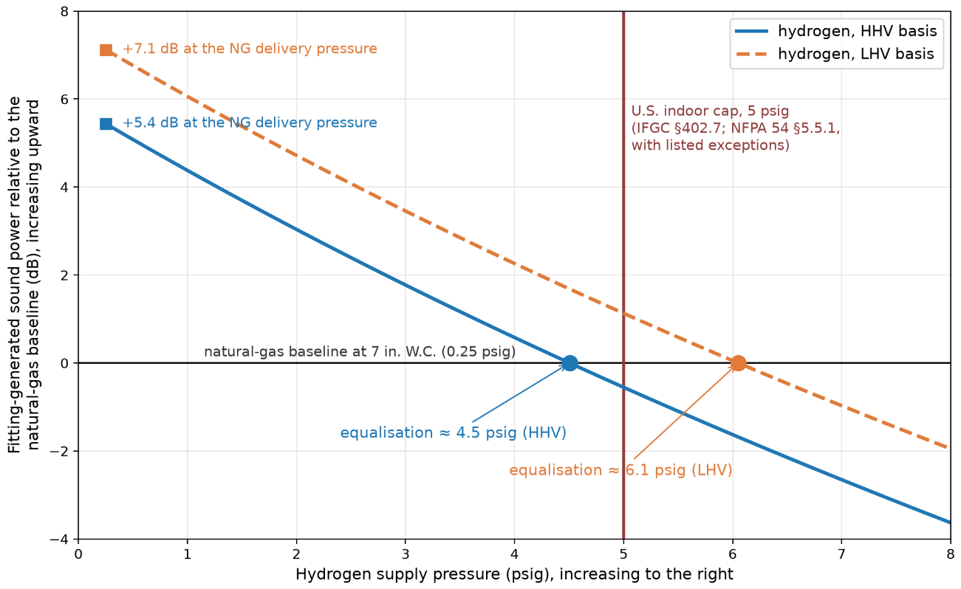
Figure 6 – Fitting-generated sound power for 100% hydrogen relative to the natural-gas baseline at 7 in. W.C. (0.25 psig), against hydrogen supply pressure. Dipole scaling of §3.4.4 with intensity falling as the inverse fifth power of absolute pressure at fixed standard-volumetric duty; baseline intensity ratios 3.5 (HHV) and 5.2 (LHV). Equalization with the natural-gas baseline at approximately 4.5 psig (HHV) and 6.1 psig (LHV); the U.S. indoor cap is 5 psig (IFGC §402.7; NFPA 54 §5.5.1, with listed exceptions), so LHV-basis equalization lies above the cap.
Quantity (equal appliance energy input, reference-NG basis) | HHV basis | LHV basis
Supply pressure at which fitting noise equalizes with the NG baseline at 7 in. W.C. (0.25 psig) | ≈ 4.5 psig | ≈ 6.1 psig
Indoor maximum operating pressure cap (IFGC §402.7; NFPA 54 §5.5.1) | 5 psig | 5 psig
Equalisation feasible within existing indoor cap | Yes | No, above the cap
Table 5 – Elevated-supply-pressure results: equalization pressures for fitting-generated noise against the North American indoor pressure cap.

Corrugated Stainless Steel Tubing (CSST)
The main findings for CSST are twofold: first, its published flow capacities (the EHD values) are calibrated for natural gas and are not directly transferable to hydrogen, so hydrogen-specific certification testing would be required; second, CSST carries a specific tonal-noise (“whistling”) risk whose onset velocity depends on the speed of sound in the gas, which is roughly three times higher for hydrogen than for natural gas. The analytical background is as follows. Corrugated stainless steel tubing (CSST) presents a non-circular, periodic geometry whose hydraulic behavior is not captured by the Moody friction factor for smooth pipe [28]. Three complementary analytical approaches appear in the literature. (i) The equivalent-roughness approach treats the corrugations as a uniform sand-grain roughness, ε, calibrated against measured ΔP versus Q data; this yields a single Colebrook-friction-factor input [29] that reproduces the test data within experimental uncertainty but loses the geometric content of the corrugation pitch. (ii) Idelchik’s expansion-contraction approach [30] treats each corrugation as a sudden enlargement followed by a sudden contraction, with discrete loss coefficients K_{e} and K_{m} summed over the tubing length; this preserves the geometric content but requires per-tubing K-factor data. (iii) The CSA/ANSI LC 1 equivalent hydraulic diameter (EHD) approach defined in Clause 5.10.3.2 of LC 1:23 / CSA 6.26:23 [35] fits measured ΔP-vs-Q test data with a power-law regression y = a·xᵇ constrained to a correlation factor of at least 0.99, and assigns a single EHD label per tubing line.
The LC 1:23 EHD method is calibrated against natural gas at specific gravity 0.60 (Tables 1 a, 1 b, and 1 c of LC 1:23 set the acceptance criteria at three discrete pressure / pressure-drop pairs, each “based on 0.60 specific gravity gas”) and the standard does not list 100% hydrogen as an applicable fuel gas (LC 1:23 Clause 1.6). No public-domain revalidation data for the EHD labels under 100% hydrogen were identified in the reviewed source set, and the manufacturer test programs that underpin the existing EHD values were conducted with air or natural gas, not hydrogen. A separate acoustic risk specific to CSST is “whistling”, which is better framed as a Strouhal/acoustic lock-in phenomenon in the corrugations and end restrictions: tonal noise is generated when shear-layer oscillations across the corrugations lock onto an acoustic mode of the tubing or fitting. Reported Strouhal numbers for corrugated-pipe whistling fall in the range of approximately 0.25–0.5, with the onset velocity therefore depending on corrugation pitch, tubing-line size, fitting geometry, and the gas sound speed (which is roughly 3× higher for hydrogen than for natural gas, see Table 1). Momentum flux ρv² acts only as a coarse screening factor for this mechanism rather than as the governing parameter. The whistling risk is documented in CSST manufacturer literature [31]. The certification basis of the EHD method is described in §3.3.2 and §3.5.1, and Appendix A row 11 records it at primary-source resolution.

Effect of Pipe Upsizing
In summary, increasing the pipe by one nominal size restores the hydrogen pressure drop, momentum flux, and fitting-noise contribution to at or below the natural-gas baseline in most domestic cases, and the effect is strongest for the smaller sizes (NPS ½ through NPS 1). The supporting reasoning follows. Upsizing the nominal pipe size by one standard increment (e.g., NPS ½ to NPS ¾, NPS ¾ to NPS 1, or NPS 1 to NPS 1¼) reduces the mean velocity in proportion to D⁻² at fixed actual volumetric flow and reduces the Darcy–Weisbach pressure drop in proportion to f L Q² / D⁵ for a given pipe family, before friction-factor changes. The D⁻⁵ scaling means that one-step upsizing is materially more effective at reducing ΔP than at reducing v alone. For hydrogen at equal appliance input on the reference-NG basis used in §3.4.1–§3.4.4, a one-step upsizing brings the pressure-drop ratio, the momentum flux ρv², and the dipole-noise contribution back to within or below the natural-gas baseline at the original size, with the precise effect depending on the original diameter and the length of the run. The effect is most pronounced in the smaller-diameter range (NPS ½ through NPS 1) and diminishes for the larger NPS 1¼ through NPS 2 sizes, where the baseline velocity is already low.
A compact diameter-ratio screening table for representative NPS ½ → ¾, ¾ → 1, and 1 → 1¼ increments is given in Table 6. The standard pipe-size increments are tabulated in CSA B149.1:25 Annex A, IFGC §402.4, and NFPA 54 Chapter 6; CSST sizes warrant separate treatment because the EHD increments are manufacturer-specific and do not map onto NPS series. Table 6 shows that a single one-step upsize is a substantial change: velocity drops to roughly 0.57 to 0.62 of its original value, pressure drop falls to roughly a quarter to a third of the original, and fitting noise drops by 13 to 15 dB across the three increments shown. The effect is largest at the smallest sizes, NPS ½ to NPS ¾, where the diameter increases proportionally the most
One-step size increase (Schedule 40 inside diameters) | Velocity and ΔP after upsizing (× original) | Fitting-noise change
NPS ½ to NPS ¾ (0.622 in to 0.824 in) | v × 0.57; ΔP × 0.25 | ≈ −15 dB
NPS ¾ to NPS 1 (0.824 in to 1.049 in) | v × 0.62; ΔP × 0.30 | ≈ −13 dB
NPS 1 to NPS 1¼ (1.049 in to 1.380 in) | v × 0.58; ΔP × 0.25 | ≈ −14 dB
Table 6 – Effect of one-step pipe upsizing at fixed actual volumetric flow: velocity scales with the diameter ratio squared, pressure drop with the fifth power, and dipole noise with the twelfth power (before friction-factor changes).

Equation and Model Development
This subsection presents the assessment, development, and validation of pipe sizing equations for hydrogen flow in domestic piping systems. The approach taken is not to adapt the Polyflo equation directly to hydrogen's properties, but first to establish precisely what physical assumption Polyflo embeds, and then to test that assumption against the Reynolds-number range hydrogen actually occupies. An equation calibrated to a specific flow regime cannot be assumed valid outside it. The evaluation is carried out separately for non-corrugated steel pipes and for CSST, which reach different conclusions.
All Reynolds numbers in this chapter are evaluated with μ_{NG} = 1.2 × 10⁻⁵ Pa·s (the viscosity value embedded in the C_{r} definition of the codes under review) and μ_{H2} = 8.76 × 10⁻⁶ Pa·s, giving Re_{H2} ≈ 0.49 × Re_{NG} at equal energy delivery. A first-principles property refinement (μ_{NG} = 1.105 × 10⁻⁵ Pa·s) lowers the ratio to 0.45 and changes no conclusion of this chapter.

Evaluation of Existing Pipe Sizing Equations
Domestic pipe sizing of non-corrugated steel pipes and tubing in CSA B149.1, the IFGC and NFPA 54 rests on the Polyflo equation. §3.3 established that its gas-property constant is calibrated to natural gas and that the codes’ own correction routes do not extend to hydrogen. Therefore, whether hydrogen tables can be produced in the published format depends on whether this equation can be recalibrated from first principles. That requires establishing what physical assumption its published constants embed, which is the purpose of this subsection. The equation is given in Annex A.3.5 of CSA B149.1:25 in low-pressure (below 1.5 psig (10.3 kPa)) form as
$Q = K_{2} · D^{2.623} · {\left[\frac{ΔH}{Cr · L · F}\right]}^{0.541} · \left(b · z\right)$ (4)
and in high-pressure (at or above 1.5 psig (10.3 kPa)) form as
$Q = K_{1} · D^{2.623} · {\left[\frac{\left(P_{1}^{2} - P_{2}^{2}\right) · Y}{Cr · L · F}\right]}^{0.541} · \left(b · z\right)$ (5)
Equations (4) and (5) return the thermal capacity Q in MBtu/h (kW). The low-pressure form, Equation (4), works in the pressure drop ΔH, expressed in inches water column (kPa), and applies where the pressure drop is small against the absolute pressure. The high-pressure form, Equation (5), works in the difference of squared absolute pressures P₁² − P₂², in psia² (kPa²), and applies at operating pressures of 1.5 psig (10.3 kPa) and above, per CSA B149.1:25 Annex A.3.5; below that, the low-pressure form of Equation (4) applies (§3.1). The remaining parameters are: D the inside diameter in in. (mm); L the pipe length in ft (m); F the fitting allowance factor (dimensionless), 1.2 for the low-pressure residential schedules and 1 for the elevated-pressure schedules of CSA B149.1:25 Annex A; Y the superexpansibility factor, a dimensionless correction for the expansion of the gas as pressure falls along the run, tabulated in the codes alongside the gas-property factor; it stays within 0.1% of 1.0 at domestic conditions (§3.1); b the higher heating value of the gas in Btu/ft³ (MJ/m³); and z a unit-conversion constant, 1 in imperial units and 0.2778 in SI (converting MJ/h to kW). The constants are K₁ = 2237 and K₂ = 2313 in imperial units (0.3576 and 0.1509 in SI). C_{r} = K₃·S·T_{f}·(μ/S)^{0.152} is the gas-property factor, collecting the relative density S (dimensionless, air = 1), the flowing gas temperature T_{f} in °R (K) and the dynamic viscosity μ in centipoise (0.012 cP for the design natural gas), with K₃ = 0.00354 in imperial units (0.006372 in SI). For the 0.60-relative-density design natural gas, C_{r} = 0.6094.
The exponents 2.623 and 0.541 are fixed constants and are published without derivation in the standards. Whether these constants remain valid for hydrogen cannot be assessed from Equations (4) and (5) as written, because nothing in them states what physical assumption produced them.
The general relationship between flow, geometry and pressure drop is the General Flow Equation (GFE), which in SI units is
$Q = 1.1494 × {10}^{-3} · \left(\frac{T_{b}}{P_{b}}\right) · {\left[\frac{\left(P_{1}^{2} - P_{2}^{2}\right)}{S · T_{f} · L · Z · f}\right]}^{0.5} · D^{2.5}$ (6)
where f is the Darcy friction factor (dimensionless), T_{b} and P_{b} the base temperature and pressure in °R (K) and psia (kPa), P₁ and P₂ the inlet and outlet absolute pressures in psia (kPa), S the relative density (dimensionless, air = 1), T_{f} the flowing gas temperature in °R (K), L the pipe length in ft (m), D the inside diameter in in. (mm), and Z the gas compressibility factor (dimensionless), established in §3.1 as at or above 0.9994 across the pressure range considered here. Evaluated in the SI units shown, the GFE returns the volumetric flow rate Q at base conditions in m³/day. The GFE cannot be evaluated until f is specified, and f depends on the flow itself: a closure, meaning a relation that supplies f, is what turns the GFE into a usable sizing equation. If Polyflo is the GFE under some particular friction closure, that closure can be identified by assuming a power-law form and matching exponents. Closing the GFE with the power-law friction assumption
$f = a_{0} · {Re}^{-n}$ (7)
and eliminating f and Re algebraically yields an expression for Q in which the exponent on the pressure term is 1/(2 - n) and the exponent on diameter is (5 - n)/(2 - n). Setting these equal to Polyflo's published values, 1/(2 − n) = 0.541 and (5 − n)/(2 − n) = 2.623. Both return n = 0.151571, and evaluating Equation (7) as a₀ = f · Re^{n} across Tables A.1-A.7 of CSA B149.1:25 Annex A gives a₀ = 0.140370 uniformly.
Written out, the result of the elimination is the Polyflo equation in General Flow Equation form:
$Q = {\left[1.1494×{10}^{-3}·\left(\frac{T_{b}}{P_{b}}\right)·a_{0}^{-1/2}·{\left(\frac{1250·S·P_{b}}{27·π·R_{air}·T_{b}·μ}\right)}^{n/2}\right]}^{α}·{\left(\frac{\left(P_{1}^{2} - P_{2}^{2}\right)}{S·T_{f}·L·F}\right)}^{α/2}·D_{mm}^{α(2.5 - n/2)}$ (8)
where α = 2/(2 − n), a₀ and n are the friction-law constants of Equation (7) (a₀ = 0.140370, n = 0.151571), and R_{air} is the specific gas constant of air. The full derivation and explanation of terms is given in Appendix B. The numerical constant is specific to SI inputs, and the equation is evaluated in SI units: Q returns in m³/day at base conditions; T_{b} and P_{b} are the base temperature and pressure in K and kPa; P₁ and P₂ the inlet and outlet absolute pressures in kPa; S the relative density (dimensionless, air = 1); μ the dynamic viscosity in Pa·s; T_{f} the flowing gas temperature in K; L the pipe length in m; F the fitting allowance factor (dimensionless, as in Equations (4) and (5)); and D the inside diameter in mm. Imperial inputs are converted to these units before evaluation. With n = 0.151571, α = 1.08200, and the exponents evaluate to the values in Table 7. They match the published Polyflo exponents exactly, confirming that this expression is the GFE-closed form of Polyflo.
Exponent | Expression | Value
Pressure term: α/2 | 1/(2-n) | 0.541
Diameter: α(2.5-n/2) | (5-n)/(2-n) | 2.623
Table 7 – Exponents obtained for the Polyflo equation in GFE-form for capacity calculation of non-corrugated steel pipes; exact matches with the published Polyflo exponents
This form carries the gas properties S and μ directly rather than through the lumped constant C_{r}, so the gas dependence is visible in one step rather than two. The two forms are algebraically the same, and the connection is the exponent: the 0.152 appearing inside C_{r} is n itself, the same parameter that generates the published exponents 0.541 and 2.623. All three constants in the published Polyflo equation are therefore expressions of the single value n = 0.151571. The equation is not gas-specific: it can be evaluated for any gas for which S and μ are known, and no other term changes. Unlike Equations (4) and (5), which return capacity in kW (MBtu/h in imperial units), this form returns the volumetric flow rate Q in m³/day, as the GFE does.
The gas-interchange multipliers of Table A.15 of CSA B149.1:25 Annex A are equivalent to √(S_{NG}/S_{gas}), and
correct for density alone. Rather than using the multiplier route, the relative density and viscosity of the target gas can be substituted directly into the C_{r} term that the published Polyflo equation already carries. Equation (8) shows this even more explicitly, with S and μ as direct inputs. Therefore, direct substitution of the target gas’s physical properties corrects for the differing viscosity as well as its differing density, whereas applying the multiplier corrects for density alone. The gap this leaves is visible inside the standard itself: applying the tabulated propane multiplier to the Annex A natural-gas capacities returns values 6.9% below the Annex B propane capacities at the same pressure schedule, uniformly at every cell. This is 6.9% below what Equation (8) gives directly from propane's own S and μ. That margin is conservative rather than a safety concern. The multiplier route under-predicts capacity relative to the direct calculation, so a pipe sized this way can carry more energy than its nominal rating, not less. The only practical consequence is a slightly larger pipe than strictly necessary. For hydrogen the two routes, i.e. direct substitution of hydrogen's own S and μ into the Polyflo equation, and the multiplier route, differ by about 6.5%. No CSA B149.1:25 multiplier is tabulated for hydrogen’s relative density (§3.3.2), but simply using the relationship √(S_{NG}/S_{gas}) for hydrogen and comparing the result against direct substitution is where the 6.5% comes from.
Polyflo is therefore the GFE with the power-law friction assumption of Equation (7), and its two published exponents are both expressions of the single parameter n = 0.151571. Using this value for n, Tables A.1 to A.7 of CSA B149.1:25 Annex A are reproduced exactly, in SI and in imperial units, proving that this relation is the basis of all published Polyflo tables. For the subsequent analyses, b) variants of the Tables are used (e.g., Table A.5 b) of CSA B149.1:25). Table 8 shows the friction factor the power-law closure of Equation (7) implies across the Reynolds range: a single monotonic power law, with no laminar branch and no roughness plateau, that crosses the laminar line f = 64/Re at Re = 1,361.
Reynolds number Re | Polyflo friction factor f | Laminar friction factor 64/Re | Polyflo relative to laminar
500 | 0.0547 | 0.1280 | 0.43
1,000 | 0.0493 | 0.0640 | 0.77
1,361 | 0.0470 | 0.0470 | 1.00
2,000 | 0.0444 | 0.0320 | 1.39
4,000 | 0.0399 | – | –
10,000 | 0.0348 | – | –
100,000 | 0.0245 | – | –
1,000,000 | 0.0173 | – | –
Table 8 – Polyflo friction factor f = 0.140370·Re^{−0.151571} against Reynolds number, with the laminar line 64/Re for comparison below the transition. The two laws cross at Re = 1,361; below the crossing Polyflo under-predicts friction and therefore over-predicts capacity.

With the exact equation by which the published tables were produced in hand, hydrogen’s properties can be substituted into it, and theoretical sizing tables for hydrogen service can be generated in the published format. The figure below gives a step-by-step guide for using the Polyflo equation, in the form of Equations (4), (5) and (8), for a gas other than natural gas, including the conversions between volumetric and thermal units and between SI and imperial unit systems.
The terms b and z are as defined in §3.5.1. In SI, b is in MJ/m³ and volumetric flow in m³/h, giving thermal capacity in kW; in imperial, b is in Btu/ft³ and volumetric flow in ft³/h, giving Btu/h, which is divided by 1000 to obtain MBtu/h. Values of b are on a higher heating value basis, taken as 1000 Btu/ft³ (37.26 MJ/m³) for natural gas and 324 Btu/ft³ (12.1 MJ/m³) for hydrogen. The natural gas value makes a capacity expressed in ft³/h numerically equal to the same capacity in MBtu/h. Hydrogen carries only 32.4% of the thermal power at the same volumetric flow, which is the origin of the factor of approximately 3.1 between hydrogen and natural gas volumetric flows at equal appliance input given in §3.4.1.
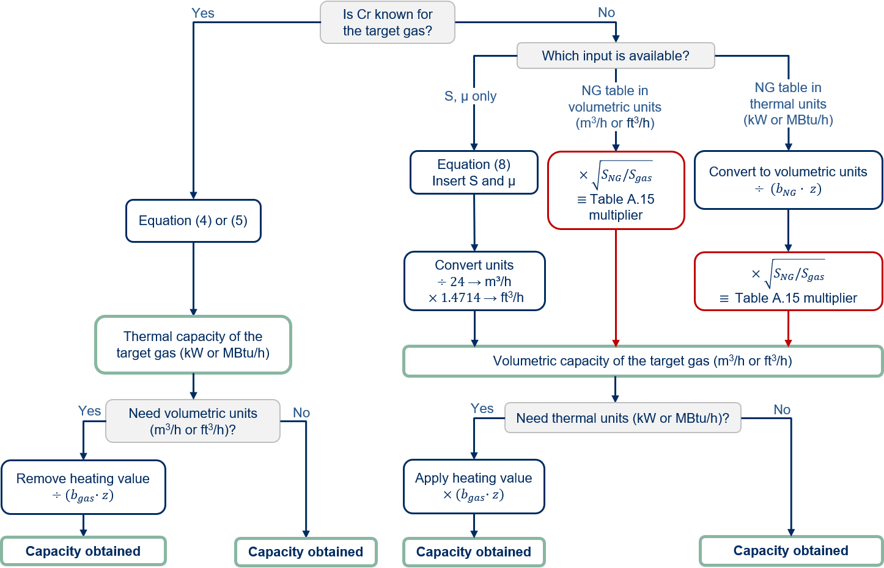
Figure 7 – Step-by-step guide for obtaining capacities for gases other than natural gas using the Polyflo equation in its various forms. Conversions between volumetric and thermal units, as well as SI and imperial unit systems are provided. The multiplier route does not appropriately correct for the viscosity.
It has not yet been established whether these hydrogen tables would be applicable to the actual behavior of hydrogen. The testable question is whether a friction factor falling as Re^{−0.151571} follows well-known pipe friction at the Reynolds numbers hydrogen actually occupies in domestic service.

Comparison Between Polyflo and Moody Friction for Smooth Pipes
It has been established that Polyflo uses a friction factor tied to the Reynolds number through the power law of Equation (7). The question is whether that law describes real pipe friction at the Reynolds numbers that matter for domestic service.
The reference description of pipe friction is the Moody representation, shown for the nine steel sizes (NPS ½, ¾, 1, 1¼, 1½, 2, 2½, 3, and 4) considered here in Figure 8 together with the Polyflo power law. In laminar flow, below Re = 2,300, the friction factor falls steeply as f = 64/Re, independent of pipe roughness. In turbulent flow, above Re = 4,000, it settles onto a family of curves, one per relative roughness, that flatten as the Reynolds number grows. Between the two lies a transition with no settled description. The Churchill correlation [40] describes this whole behavior, laminar branch included, as a single continuous function of the Reynolds number and the relative roughness:
$f = 8 · {\left[{\left(\frac{8}{Re}\right)}^{12} + \frac{1}{{\left(A + B\right)}^{1.5}}\right]}^{\frac{1}{12}}$ (9)
$A = {\left[2.457 \text{ln}\left(\frac{1}{{\left(\frac{7}{Re}\right)}^{0.9} + 0.27 · \frac{ε}{D}}\right)\right]}^{16}$ (10)
$B = {\left(\frac{37530}{Re}\right)}^{16}$ (11)
In Equations (9) to (11), Re is the Reynolds number (dimensionless), ε the equivalent sand-grain roughness in in. (mm), D the inside diameter in in. (mm), f the Darcy friction factor (dimensionless), and A and B intermediate dimensionless groups.
The Churchill correlation is a continuous description of pipe friction against Reynolds number across the laminar, transitional and turbulent regimes. That continuity is what matters here. The GFE must be solved by iteration, because Q depends on f and f depends on Q through the Reynolds number, and a single smooth friction function lets the sizing relations be evaluated continuously over the whole Reynolds range with stated accuracy. Churchill reproduces established turbulent friction values above Re = 4,000 and the laminar line f = 64/Re below Re = 2,300, within a single expression, which is sufficient for the capacity comparisons made here. In this report the GFE closed with the Churchill correlation is referred to as GFE-Churchill; it represents sizing on Moody friction.
Written out, GFE-Churchill is
Q=1.1494×10-3·TbPb·P12-P22S·Tf·L·F·fC0.5·D2.5, fC=fChurchillRe, ε/D (12)
where f_{C} is the Churchill friction factor of Equations (9) to (11), evaluated at the relative roughness ε/D and at the Reynolds number of the flow Q itself, from Equation (B.4), and the remaining symbols are as defined for Equations (6) and (8). Because f_{C} depends on Q through the Reynolds number, Equation (12) is solved by fixed-point iteration: starting from f_{C} = 0.02, Q and Re are evaluated, f_{C} is updated, and the steps are repeated until successive values of f_{C} agree to within 10⁻¹².
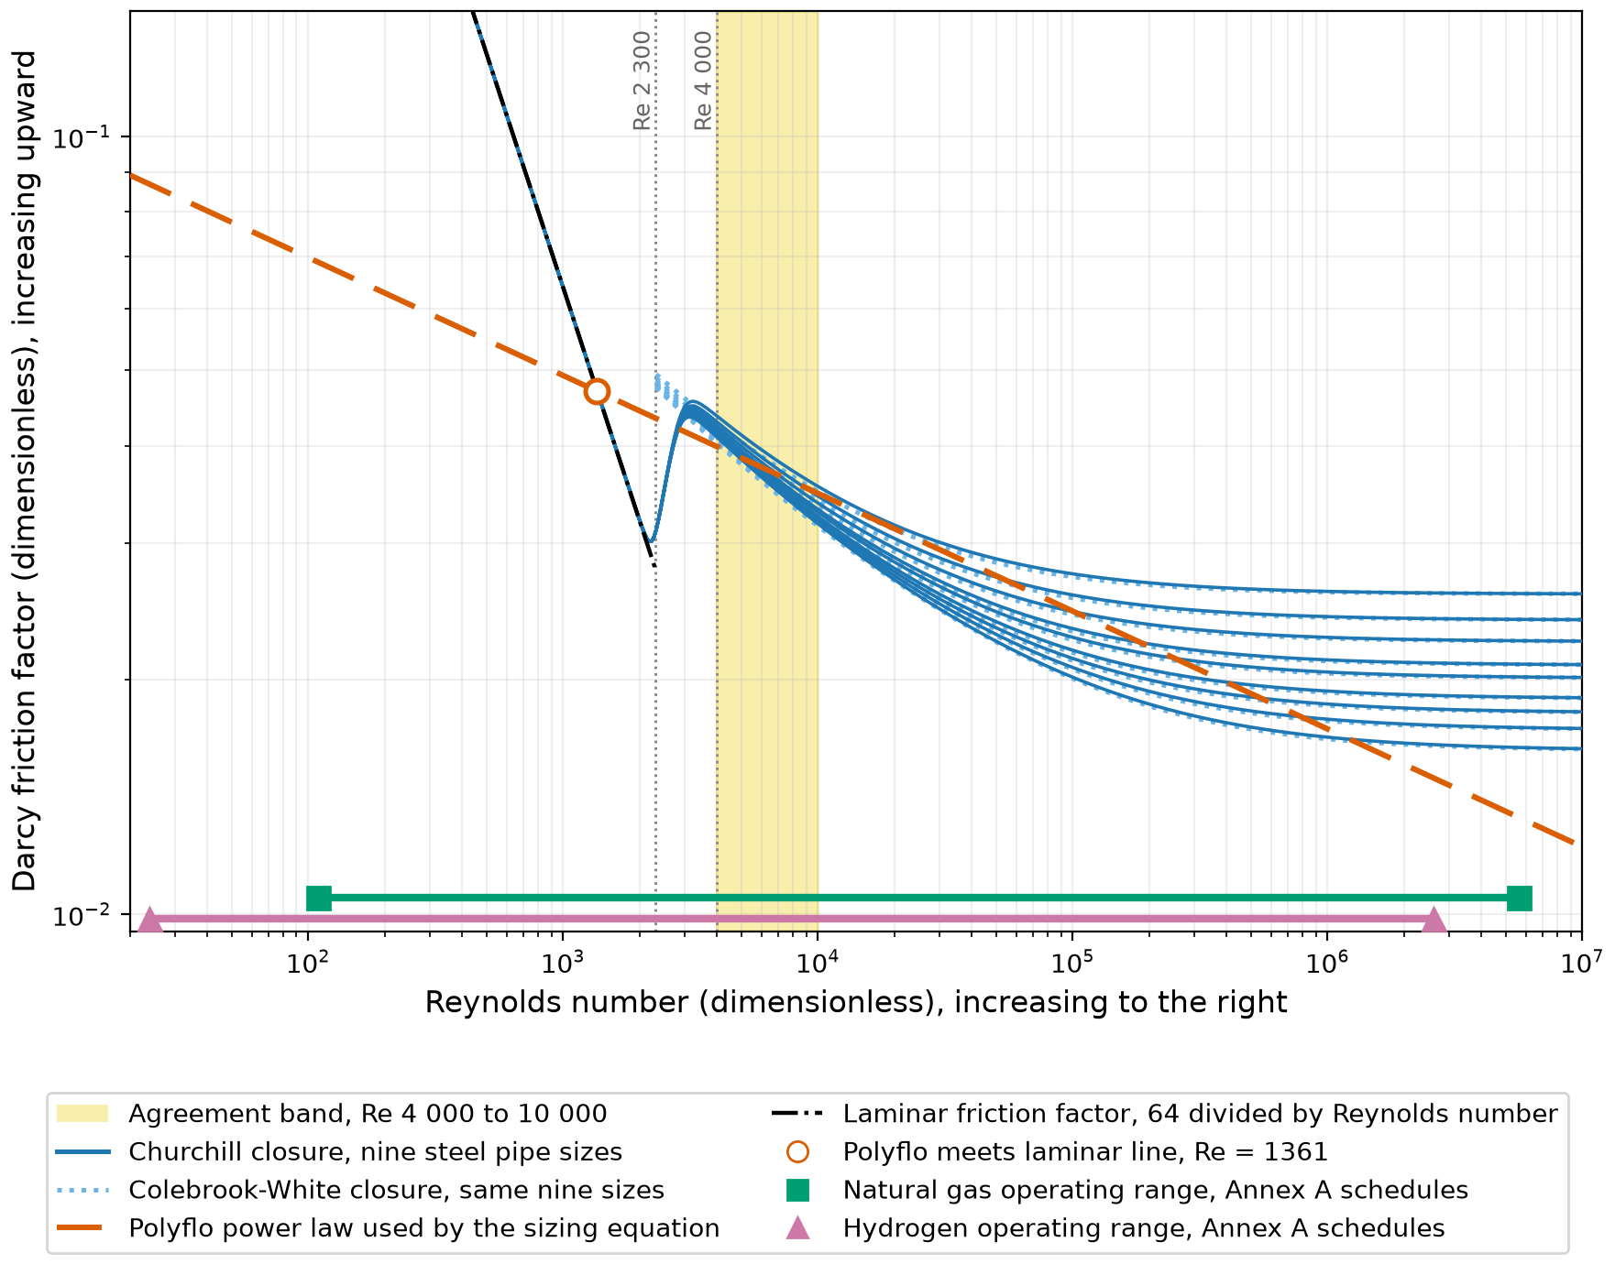
Figure 8 – Darcy friction factor versus Reynolds number: Churchill and Colebrook-White families for the nine steel sizes, the Polyflo power law, the laminar line f = 64/Re, and the Re = 4,000-10,000 agreement band. Operating spans of the published schedules for natural gas and hydrogen are indicated.
Figure 9 makes the comparison directly. For each of the nine steel sizes, the capacity from the GFE closed with the Polyflo power law is divided by the GFE-Churchill capacity at ε = 0.0018 in. (0.045 mm), the standard roughness for steel pipes [28], at fixed pressure drop and geometry. Natural gas is the baseline case, but the ratio itself is gas-independent: only the Reynolds number and the relative roughness enter it (§3.5.3). Below the crossing at Re = 1,361 the sizing equation over-predicts capacity, by a factor that reaches 6 at the lowest tabulated Reynolds numbers; between Re = 1,361 and the transition it under-predicts by up to about 23%; and from Re = 4,000 to 10,000 every size stays within 5% of the GFE-Churchill capacity. Above Re = 10,000 the curves fan out by roughness, and the smallest sizes drift back into over-prediction from Re near 9 × 10⁴. The objective here is to identify where the friction law underpinning Polyflo is a valid approximation, not to produce hydrogen-specific sizing guidance. Table 9 summarizes, for each Annex A pressure schedule, the fraction of operating points below Re = 4,000 and the root mean square (RMS) capacity difference between Polyflo and GFE-Churchill. The hydrogen columns are indicative only: they substitute hydrogen’s viscosity and relative density into an equation whose validity for hydrogen is the question under test.
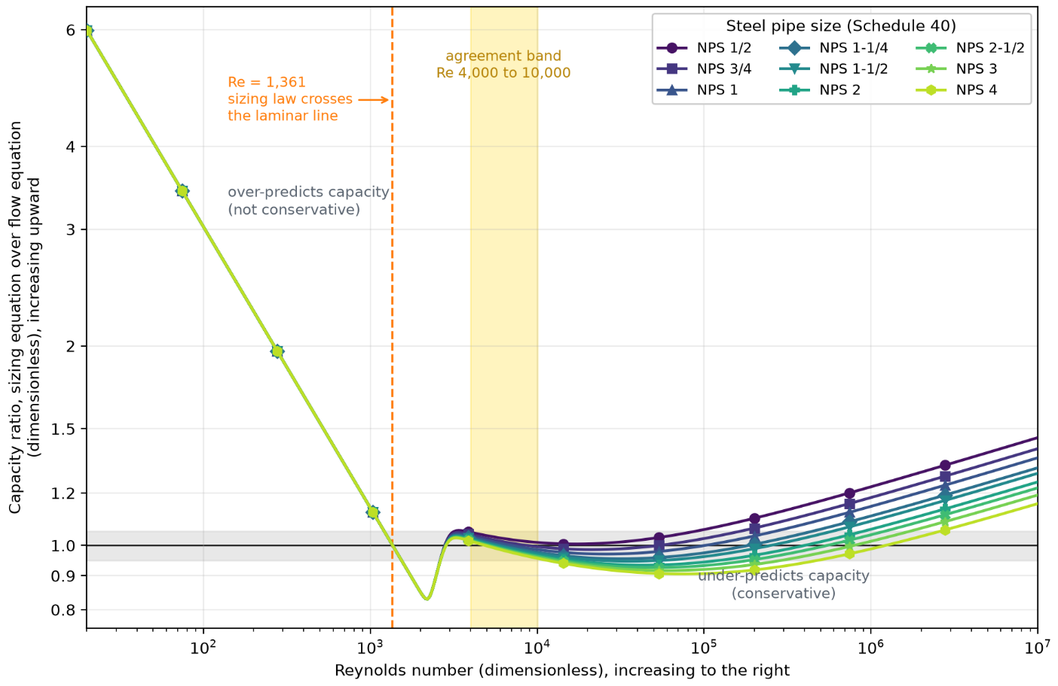
Figure 9 – Capacity ratio between the GFE closed with the Polyflo power law and the GFE closed with Churchill friction (ε = 0.0018 in. (0.045 mm)), at fixed pressure drop, against the GFE-Churchill Reynolds number. The ratio is gas-independent: only the Reynolds number and the relative roughness enter it. Values above 1.0 mean the sizing equation over-predicts capacity and is not conservative. The gray band marks ±5%; the yellow band marks Re = 4,000 to 10,000. Curves top to bottom at the right edge: NPS ½ to NPS 4.
Annex A table | Pressure schedule | NG: % points below Re = 4000 | NG: RMS deviation (%) | H2: % points below Re = 4000 | H2: RMS deviation (%)
A.1 | <1.75 kPa inlet, 125 Pa drop | 40.6 | 15.6 | 64.8 | 28.5
A.2 | 1.75-3.50 kPa inlet, 250 Pa drop | 29.9 | 11.1 | 53.3 | 21.7
A.3 | 14 kPa inlet, 7 kPa drop | 1.1 | 5.7 | 8.4 | 6.7
A.4 | 14 kPa inlet, 10 kPa drop | 0.4 | 5.4 | 6.1 | 6.7
A.5 | 34 kPa inlet, 17 kPa drop | 0 | 4.5 | 1.9 | 5.9
A.6 | 70 kPa inlet, 35 kPa drop | 0 | 3.9 | 0 | 5.1
A.7 | 140 kPa inlet, 70 kPa drop | 0 | 4.2 | 0 | 4.2
Table 9 – Fraction of operating points below Re = 4000 and RMS capacity deviation between Polyflo and GFE-Churchill, natural gas and hydrogen, non-corrugated Schedule 40 steel, Tables A.1-A.7 of CSA B149.1:25 Annex A. Hydrogen is purely indicative. Differences are computed from capacities rounded to whole kW as published, the same basis as Table 16.
At the pressure schedules of Tables A.1 and A.2, a substantial fraction of operating points falls below Re = 4000: 40.6% and 29.9% for natural gas, and 64.8% and 53.3% for hydrogen. The hydrogen fractions are larger because hydrogen operates at lower Reynolds numbers than natural gas at equal energy delivery. RMS deviations follow the same pattern: 15.6% and 11.1% for natural gas at Tables A.1 and A.2, and 28.5% and 21.7% for hydrogen. At the pressure schedules of Tables A.6 and A.7, all operating points are fully turbulent, and RMS deviations drop to around 5%. The schedules of Tables A.6 and A.7 sit at or above the 10 psig scope boundary of this study; they are retained in the comparison to bound the fully turbulent behavior of the sizing equation.
Figure 8 shows precisely why this is observed. The Polyflo power law intersects the laminar line f = 64/Re at Re = 1361, so operating points below this value carry the largest deviations. Above Re = 4000, the Polyflo friction curve follows the Moody turbulent curves closely up to Reynolds numbers of order 10⁶, which is why capacity deviations are small wherever flow is fully turbulent. Hence, Polyflo and Moody friction agree closely only in the turbulent regime. Back calculating a single pipe roughness ε from the capacities obtained using the Polyflo equations does not result in a single pipe roughness. The shape of the Polyflo friction law on logarithmic axes in Figure 8 explains why: the friction factor decreases monotonically, so each measurement yields a unique value of the roughness ε that decreases with increasing Reynolds number even at matched pipe diameter. The friction factor f never asymptotes to a single value in the fully turbulent region, as it does with Moody friction, so Polyflo cannot characterize a single pipe roughness.

CSST Pipe Sizing Tables Empirically Determined
The sizing basis of CSST differs fundamentally from that of non-corrugated steel tubing. CSST is sized under CSA/ANSI LC 1:23 using an empirically assigned EHD capacity index rather than a physical pipe dimension. Manufacturers conduct flow tests and fit the results to a power-law curve; the resulting capacities are compared against Tables 1 a) to 1 c) of CSA/ANSI LC 1:23 and the EHD value is assigned as the largest designation whose tabulated capacity the measured curve meets or exceeds. The primary data source for this evaluation is measured engineering flow data from a documented CSST flow-capacity test program conducted in 1996 by one manufacturer, Manufacturer C. Sizing tables from Manufacturer A, Manufacturer B and Manufacturer C are also consulted as a secondary check, giving approximately 5,500 published capacity data points across the four datasets. Since the sizing tables are not fully measured flow data, they are used for qualitative corroboration only. Forward-solving Polyflo at the published EHD dimensions and all known test conditions overpredicts Manufacturer C’s measurement data capacity on average by over 50% (overprediction range spanned 7% to 148%) across all pipe sizes and test conditions, with the largest deviations at small diameters and low pressure drops. Similarly, using Polyflo to back-calculate the inner diameter that would give the published capacity yields 5% to 30% smaller inner diameters than those published. The certification tables of CSA/ANSI LC 1:23 do not conform to Polyflo's friction law either. Polyflo is therefore not applicable to CSST. Two details of the certification basis matter for any hydrogen requalification. The fitted curve is a power law in pressure drop against flow (Clause 5.10.3.2 of LC 1:23 requires a correlation factor of at least 0.99), and the tabulated acceptance capacities include “losses for four 90° bends and two end fittings” (notes below Tables 1 a), 1 b) and 1 c) of LC 1:23). A hydrogen-specific EHD requalification must therefore reproduce both the curve-fit form and the baseline fitting allowance, not merely the headline capacity number.
Polyflo and the EHD certification basis accordingly support separate modeling pathways: a regime-valid pipe-friction formulation for non-corrugated pipe, and product-specific empirical characterization for CSST.

Development of Hydrogen-Specific Equations

Hydrogen Coefficient for Non-Corrugated Steel Pipe
For non-corrugated steel pipe a published sizing equation already exists, carried by CSA B149.1, the IFGC and NFPA 54 alike. C_{r} is the only gas-dependent term in Equations (4) and (5), and it is defined in terms of relative density, viscosity and temperature, so a value can be evaluated for any gas. For hydrogen it comes out at 0.0935 against 0.6094 for natural gas, and substituting it into those equations generates theoretical hydrogen sizing tables. Whether the result is valid is a separate question, taken up in §3.5.3.

Data Requirements for a CSST Closure
For CSST no equation exists to adapt: §3.5.1 establishes that Polyflo does not describe corrugated tubing at any size or condition. A closure for CSST must therefore be built from measured friction behavior. The subsections below establish which of the available data sources can support that, what the measured friction behavior is, and what class of closure that behavior supports.

Screening the Available CSST Data Sources
Establishing a replacement closure requires measured friction data. The Manufacturer C measurement dataset is a documented flow-capacity test program. The other three sources are published sizing tables whose method of generation is not stated. This section assesses whether those tabulated capacities were generated by calculation or by measurement, since only measured data is usable for a hydrogen closure Each of the other datasets can be tested for this by scaling the pressure drop and the length by the same factor. If a table entry was computed from a formula in ΔP/L, the published flow remains unchanged to the last digit under this scaling; a real measurement would not reproduce this identity exactly. The test shows that the published flow does remain unchanged to the last digit across large parts of the Manufacturer A, B and C sizing tables, and holds to different extents across the three. Manufacturer A satisfies the identity, Q(ΔP, L) = Q(k·ΔP, k·L) exactly at every cell; Manufacturer B satisfies it for 59% of its natural-gas pairs; Manufacturer C’s published sizing tables satisfy it at its two largest sizes while failing it at the four smallest. Where the identity holds, the tabulated value is purely formula output rather than a measurement, and fitting a friction model to it would characterize the formula rather than the tube. That covers the whole of Manufacturer A and part of the other two; the test below settles the remainder.
The same identity carries a second consequence. A capacity that depends only on ΔP/L is independent of the absolute pressure at which the drop occurs, so these tables return the same flow for a given drop whether it is taken at a few inches of water column or at 10 psi. Compressible flow does not behave this way. The driving term in Equation (6) is P1² - P2², which is identically 2·P_{avg}·ΔP where P_{avg} is the mean absolute pressure, so at fixed ΔP/L the capacity scales with the square root of P_{avg} rather than being independent of it. This follows from the density increase established in §3.1, where hydrogen is about 13.6% denser at 2 psig and about 68% denser at 10 psig than at atmospheric pressure, and where the (P1² - P2²) form is accordingly required wherever the pressure drop is not small relative to the absolute pressure; the elevated-pressure schedules in the CSST tables fall in exactly that range. A capacity expressed as a function of ΔP/L alone cannot represent this dependence. A single such law expressed across the full range of tabulated inlet pressures would need one exponent to hold at both the lowest and the highest pressures in that range; since the true capacity depends on the pressure level itself and not only on ΔP/L, that single exponent forces the fit low at one end of the range and high at the other rather than matching the whole range at once. These tables are therefore not derived from compressible pipe flow, on this basis alone and independently of any friction model. Fitting the generating relationship directly, in the form Q = C·D^{p}·(ΔP/L)^{q}, returns R² of 0.998 or better but a different pressure exponent for each EHD and a different exponent again across manufacturers at the same EHD, so no single equation is recovered from them either. The Manufacturer A, Manufacturer B and Manufacturer C sizing tables are therefore not suitable as a source of friction data. All quantitative work is restricted to Manufacturer C’s measurement data.

Friction Modeling Approaches Tested
A summary of each of the existing friction modeling approaches that have been tested on CSST is provided in Table 10. For each approach, the outcome is quoted against Manufacturer C's measurement data in every case, along with the reasons why the approach was not explored further. The capacity fits in Table 10 use the nominal bore D = EHD·25.4/32 mm, the diameter implied by the size index, so the roughness values they return are tied to that bore.
Approach | Outcome | Why set aside
Applying the Polyflo equation at published pipe dimensions and capacities per EHD | Forward-calculating with the published diameter yields a mean capacity overprediction above 50%, with individual cells from +7% to +148%. Back-calculating from the published capacity yields a smaller diameter than published for the same capacity. | Polyflo's friction law is found to be an approximation for turbulent non-corrugated-wall pipe flow and does not describe corrugated tubing at any size.
Back-calculate using Colebrook-White to obtain one roughness per EHD | ε/D that minimizes the capacity deviation over the piping lengths per EHD yields ε/D values that vary a factor of over 6x across four sizes. | Roughness should be a property of the tubing wall, not of the size. The 3/8-in, ½-in and ¾-in sizes exceed Colebrook-White's own validity limit of ε/D ≤ 0.05; only the 1-in size is within it.
Colebrook-White, single roughness across all sizes | ε/D can vary by a factor of about 20 and maintain under one percentage point of RMS capacity deviation. | Bore diameter and roughness cannot be separated; infinitely many combinations of the two produce similar RMS capacity deviation, so neither parameter is uniquely identifiable from the fit.
Churchill, ε/D set per EHD so the fully rough limit equals the measured plateau | Log-residual of 0.08 to 0.27 over the turbulent points but 0.50 to 0.61 over the laminar points | Reproduces the plateau by construction, but the transition from laminar produces a sharp minimum where the measured data shows a shallow one
Table 10 – CSST friction modeling approaches attempted, outcomes, and reasons for rejection.
It is established in Table 10 that back-calculating relative roughness using Colebrook-White from the diameter alone, fitting a roughness to minimize capacity deviation over the range does not work for Manufacturer C‘s measurement dataset. An estimate of relative corrugation height would help separate a genuine roughness effect from the bore-roughness ambiguity above. Manufacturer C’s inside and outside diameters are used directly, with corrugation height approximated as h = (OD − ID)/2; this simplification omits wall thickness, which is not published, and so overstates h slightly, making it a conservative check. Table 11 summarizes the resulting relative corrugation height h/D per EHD. These h/D are higher than Colebrook-White’s validity, which tops out at ε/D = 0.05, at every size. Corrugation height h is used here as a proxy for the equivalent sand-grain roughness ε; that is a modeling assumption, not an established equivalence.
EHD | Nominal Size | ID (in.) | OD (in.) | h (in.) | h/ID
13 | 3/8" | 0.39 | 0.51 | 0.060 | 0.154
18 | 1/2" | 0.57 | 0.70 | 0.065 | 0.114
23 | 3/4" | 0.75 | 0.93 | 0.090 | 0.120
31 | 1" | 1.04 | 1.23 | 0.095 | 0.091
39 | 1-1/4" | 1.38 | 1.57 | 0.095 | 0.069
62 | 2" | 2.07 | 2.30 | 0.115 | 0.056
Table 11 – Manufacturer C geometry and corrugation height ratio h/ID per EHD, h = (OD − ID)/2

Friction Behavior Back-Calculated from the Measured Data
To examine the friction behavior directly rather than through a candidate model, the Darcy friction factor is back-calculated from each Manufacturer C measurement using the Darcy-Weisbach equation evaluated at the arithmetic mean pressure,
$f = \frac{\left(\frac{ΔP}{L}\right) · D}{\frac{1}{2} · ρ_{avg} · V^{2}}$(13)
where ρ_{avg} is the gas density at the arithmetic mean pressure in lb/ft³ (kg/m³), computed as ρ_{avg} = S·P_{avg}/(R_{air}·T) with P_{avg} = (P₁ + P₂)/2 in psia (kPa absolute), R_{air} the specific gas constant of air in ft·lbf/(lb·°R) (J/(kg·K)), T the gas temperature in °R (K), V the mean velocity in ft/s (m/s), and the remaining symbols as defined for Equation (1). The arithmetic mean is the exact choice here rather than an approximation, since multiplying Equation (13) through by 2ρ_{avg} and substituting the mass flux G = ρV, which is constant along the pipe, returns the GFE. The back-calculated friction factor is therefore equivalent to inverting Equation (6), with no approximation introduced beyond neglect of the acceleration term, which reaches at most 1.5% of the friction term at the highest pressure drop in the dataset.
The back-calculated friction factors follow a consistent pattern across all four EHD sizes. Figure 10 shows that at the lowest Reynolds numbers, the data trend is moving toward the characteristic behavior expected for laminar flow. The agreement does not extend across the whole sub-transitional range: the measured points reach a minimum at roughly Re = 1200 to 1400 and rise from there. Above the transition the behavior departs somewhat from Moody friction, in that the friction factor does not fall with increasing Reynolds number as the turbulent Moody curves do, but instead levels off onto a plateau whose height depends on pipe size (median friction factor above Re = 4,000 of 0.28, 0.22, 0.22 and 0.14 for EHD 13, 18, 23 and 31). A friction factor that is flat or rising with Reynolds number is not consistent with turbulent flow in a fixed-roughness pipe, and is better read as the corrugation imposing an increasing drag loss that does not scale in the same way as wall shear. The mechanism is form drag. Flow separates at every corrugation, and with a fixed number of corrugations per unit length the loss follows the dynamic pressure and therefore the square of the velocity. Darcy-Weisbach defines f as that loss divided by ½ρV², so a loss of this kind leaves f independent of Reynolds number. Wall shear behaves this way only once a pipe is fully rough, which for commercial steel means Reynolds numbers of order 10⁵ to 10⁶; here the plateau arrives immediately above the transition.
Since EHD is a capacity index rather than a measured bore, these friction factors depend on the diameter assumed for each size. The bore of corrugated tubing varies along its length between corrugation root and crest, so no single published dimension represents the flow diameter. The volume-equivalent diameter is used for these friction factors, Deff=4·Ameanπ, where A_{mean} is the mean flow area over one corrugation pitch of the measured Manufacturer C profile. The same diameter defines the Reynolds number of the CFD model, so measured and simulated friction factors are directly comparable. An alternative is the nominal bore implied by the size index, D = EHD·25.4/32 mm, which sits within 5.4% of the published nominal inside diameters on average across the three manufacturers that report them. Appendix B shows that rescaling the assumed diameter moves every point along a line of slope −5, which can bring the low Reynolds number points onto 64/Re but leaves the slope of the sub-transitional branch and the shape of the plateau unchanged; every point of a given size moves by the same amount, so the trends are preserved. The behavior described above is therefore not an artifact of the assumed bore. The certification tables 1 a) to 1 c) of CSA/ANSI LC 1:23 reproduce the same qualitative pattern as the Manufacturer C measurement data, as seen in Appendix B. The same back-calculation is applied to the other manufacturer datasets with no success, as these are not experimental data. Because the method by which those tables are generated is not published, the resulting friction factors describe the generating equation rather than the tubing, and no conclusion is drawn from them.
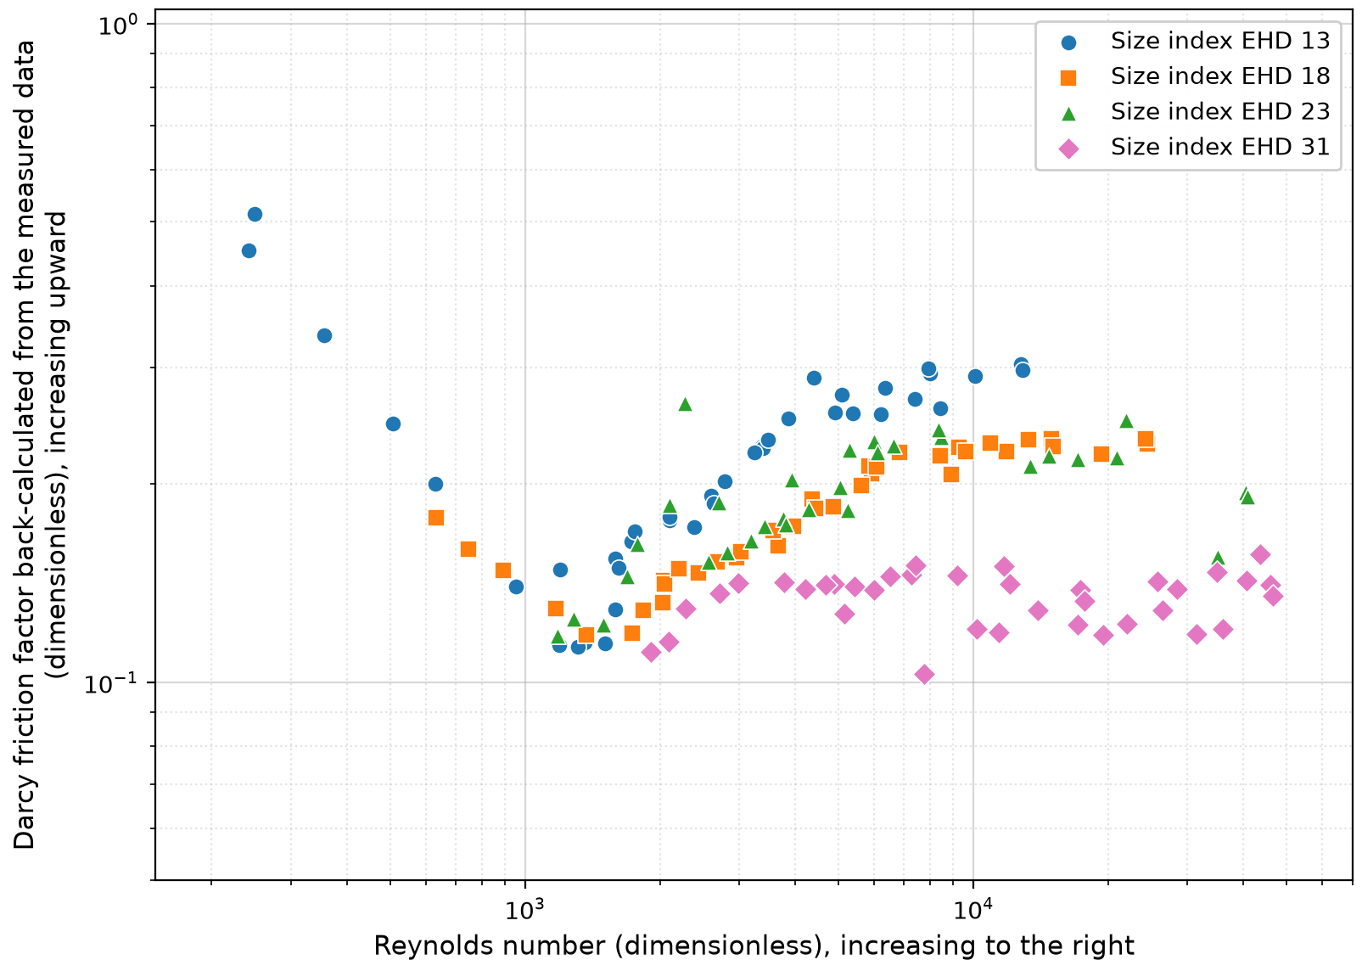
Figure 10 – Friction factor back-calculated from measured engineering flow data provided by Manufacturer C, all four sizes. Below the transition, the data appear to collapse onto a common line; the branches separate only in the turbulent range. Diameter basis: volume-equivalent diameter D_{eff} of the measured corrugation profile (EHD 13: 11.49 mm; EHD 18: 16.17 mm; EHD 23: 21.40 mm; EHD 31: 28.88 mm). The 3/4 in. test row at 41.5 in. w.c. is excluded as suspect.

Closure Family and the Hydrogen Operating Range
The measured points across all four sizes appear to trace a single laminar branch joined to a size-dependent high Reynolds number plateau. Where hydrogen sits against that behavior follows from the property ratios of §3.4.2. At equal appliance input hydrogen carries approximately 3.1 times the volumetric flow of natural gas but only about 0.49 times its Reynolds number, as established in §3.4.2, so re-expressing the Manufacturer C flow test conditions for hydrogen shifts every operating point substantially to the left. Re-expressed in this way, 70.0% of cells at EHD 13 fall below Re = 2300, together with 52.5% at EHD 18, 50.0% at EHD 23 and 21.6% at EHD 31, and the hydrogen Reynolds number reaches as low as 118 at the smallest size. A closure for CSST is not proposed in this report, because establishing and calibrating one requires the validation testing set out in §3.8. Because hydrogen moves a substantial share of the CSST operating range toward lower Reynolds numbers, hydrogen capacities cannot be obtained by applying a property multiplier to the existing natural-gas tables; flow measurements are required.

Hydrogen Sizing Equations and Applicability
Whether the Polyflo equation can be applied to hydrogen depends on whether its friction law holds at the Reynolds numbers hydrogen occupies in domestic service. §3.5.1 gives the RMS capacity deviation against GFE-Churchill for each Annex A pressure schedule, but an RMS figure over a whole table conceals where the disagreement sits. Tables 12, 13 and 14 resolve it cell by cell for natural gas at the pressure schedules of Tables A.1 (<1.75 kPa inlet / 125 Pa drop), A.3 (14 kPa inlet, 7 kPa drop) and A.7 (140 kPa inlet, 70 kPa drop) of CSA B149.1:25 Annex A, chosen to span the range from a table with a substantial laminar and transitional population to one that is fully turbulent throughout. Each cell gives the Reynolds number back-calculated from the GFE-Churchill capacity at that pipe size and length. L denotes laminar flow at Re below 2,300, T for transitional flow between 2,300 and 4,000, and U for turbulent flow above 4,000; an asterisk marks cells where Polyflo is non-conservative (it under-sizes pipes by over-predicting capacity). The fill color denotes the absolute percent difference between the published capacity and the GFE-Churchill capacity at the same cell: red for a difference of 10% or more, yellow between 5 and 10%, and green below 5%. Figure 11 maps the Reynolds spans those tables cover, for the two gases side by side.
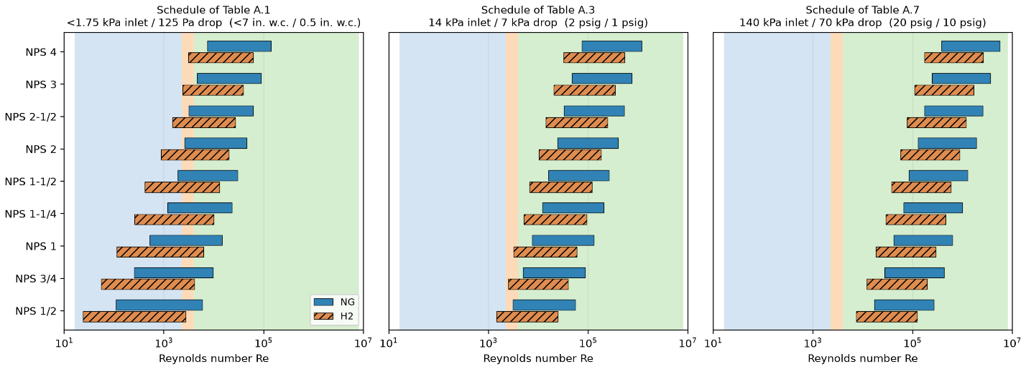
Figure 11 – Reynolds-number spans of the published schedules: for each pipe size, the range covered by the tabulated lengths (GFE-Churchill basis, §3.5.3) for natural gas and for hydrogen, over the laminar, transitional and turbulent bands, at the schedule conditions of Tables A.1, A.3 and A.7 of CSA B149.1:25 Annex A (fixed pressure drop per schedule). Hydrogen operates at roughly half the natural-gas Reynolds number and pushes the small sizes of the low-pressure schedule deep into the laminar range; at the schedule of Table A.7 both gases are fully turbulent throughout.
L (m) / NPS | 1/2 | 3/4 | 1 | 1-1/4 | 1-1/2 | 2 | 2-1/2 | 3 | 4
3 | 5933 U* | 9669 U | 14641 U | 23357 U | 30316 U | 46155 U | 62136 U | 89213 U | 139937 U
6 | 3994 T* | 6544 U* | 9951 U | 15941 U | 20734 U | 31666 U | 42716 U | 61472 U | 96674 U
9 | 3194 T* | 5193 U* | 7917 U | 12716 U | 16562 U | 25344 U | 34233 U | 49335 U | 77716 U
12 | 2847 T* | 4400 U* | 6722 U* | 10819 U | 14106 U | 21617 U | 29227 U | 42167 U | 66506 U
15 | 2663 T | 3868 T* | 5917 U* | 9539 U | 12446 U | 19097 U | 25840 U | 37312 U | 58907 U
18 | 2535 T | 3485 T* | 5329 U* | 8602 U | 11232 U | 17251 U | 23357 U | 33751 U | 53329 U
21 | 2434 T | 3209 T* | 4875 U* | 7879 U | 10295 U | 15825 U | 21439 U | 30999 U | 49016 U
24 | 2347 T | 3017 T* | 4513 U* | 7301 U | 9544 U | 14683 U | 19901 U | 28792 U | 45554 U
27 | 2260 L | 2885 T* | 4215 U* | 6825 U | 8926 U | 13742 U | 18634 U | 26972 U | 42699 U
30 | 2147 L | 2786 T | 3965 T* | 6425 U | 8406 U | 12950 U | 17567 U | 25439 U | 40292 U
35 | 1869 L | 2662 T | 3626 T* | 5880 U* | 7698 U | 11870 U | 16111 U | 23347 U | 37007 U
40 | 1636 L | 2567 T | 3363 T* | 5444 U* | 7131 U | 11005 U | 14945 U | 21670 U | 34372 U
45 | 1454 L | 2488 T | 3162 T* | 5085 U* | 6665 U | 10293 U | 13985 U | 20289 U | 32200 U
50 | 1309 L* | 2419 T | 3014 T* | 4784 U* | 6272 U | 9694 U | 13177 U | 19125 U | 30370 U
60 | 1090 L* | 2296 L | 2817 T* | 4302 U* | 5646 U* | 8736 U | 11884 U | 17263 U | 27440 U
70 | 935 L* | 2142 L | 2687 T | 3932 T* | 5163 U* | 7998 U | 10887 U | 15827 U | 25178 U
80 | 818 L* | 1901 L | 2589 T | 3639 T* | 4778 U* | 7408 U | 10090 U | 14677 U | 23365 U
90 | 727 L* | 1690 L | 2509 T | 3402 T* | 4461 U* | 6922 U | 9433 U | 13731 U | 21872 U
100 | 654 L* | 1521 L | 2440 T | 3214 T* | 4195 U* | 6514 U | 8881 U | 12934 U | 20616 U
125 | 523 L* | 1217 L* | 2288 L | 2910 T* | 3682 T* | 5725 U | 7813 U | 11392 U | 18182 U
150 | 436 L* | 1014 L* | 2081 L | 2738 T | 3320 T* | 5149 U* | 7034 U | 10266 U | 16402 U
175 | 374 L* | 869 L* | 1793 L | 2618 T | 3070 T* | 4706 U* | 6434 U | 9399 U | 15031 U
200 | 327 L* | 761 L* | 1569 L | 2525 T | 2904 T* | 4353 U* | 5955 U | 8705 U | 13933 U
250 | 262 L* | 608 L* | 1255 L* | 2379 T | 2699 T | 3820 T* | 5230 U | 7656 U | 12271 U
300 | 218 L* | 507 L* | 1046 L* | 2245 L | 2565 T | 3437 T* | 4702 U* | 6890 U | 11057 U
350 | 187 L* | 435 L* | 897 L* | 2036 L | 2461 T | 3162 T* | 4296 U* | 6301 U | 10122 U
400 | 164 L* | 380 L* | 785 L* | 1786 L | 2374 T | 2973 T* | 3972 T* | 5830 U | 9375 U
500 | 131 L* | 304 L* | 628 L* | 1429 L | 2197 L | 2747 T | 3488 T* | 5119 U | 8244 U
600 | 109 L* | 254 L* | 523 L* | 1191 L* | 1891 L | 2605 T | 3157 T* | 4601 U* | 7419 U
Table 12 – Reynolds numbers for natural gas back-calculated using the Churchill correlation at each pipe size and length under an inlet pressure below 1.75 kPa and a pressure drop of 125 Pa, matching Table A.1 of CSA B149.1:25. L: Re below 2,300; T: Re between 2,300 and 4,000; U: Re above 4,000.
At the pressure schedule of Table A.1, 20.3% of cells are laminar and a further 20.3% transitional, and the red cells concentrate in the laminar block at the small diameters and long lengths. The deviation there is not merely large but changes sign at the Reynolds number where the Polyflo power law crosses the laminar line in Figure 8. Below Re = 1361, the published capacity exceeds the GFE-Churchill capacity by 33% on average and by up to 75% at the smallest pipe and longest length. Between Re = 1361 and 2300, the sign reverses and Polyflo underpredicts by up to 23%. Both follow directly from Figure 8, where the Polyflo curve lies above the laminar line on one side of the crossover and below it on the other. At the largest diameter, the shortest lengths also exhibit deviations of around 11%, but with the opposite sign, because that pipe is the smoothest in the set and its Moody curve lies below the Polyflo curve rather than above it.
The same map follows for the pressure schedule of Table A.3, where nearly all cells are turbulent.
L (m) / NPS | 1/2 | 3/4 | 1 | 1-1/4 | 1-1/2 | 2 | 2-1/2 | 3 | 4
3 | 55089 U* | 87928 U* | 131084 U* | 205898 U* | 265156 U* | 399047 U | 533232 U | 759281 U | 1179972 U
6 | 38353 U* | 61348 U* | 91605 U | 144115 U | 185737 U | 279847 U | 374222 U | 533289 U | 829495 U
9 | 30973 U* | 49617 U | 74170 U | 116814 U | 150635 U | 227142 U | 303897 U | 433316 U | 674414 U
12 | 26590 U* | 42645 U | 63804 U | 100575 U | 129750 U | 195773 U | 262034 U | 373792 U | 582059 U
15 | 23608 U* | 37900 U | 56745 U | 89513 U | 115521 U | 174395 U | 233500 U | 333214 U | 519087 U
18 | 21414 U* | 34406 U | 51545 U | 81360 U | 105033 U | 158635 U | 212461 U | 303289 U | 472640 U
21 | 19713 U* | 31696 U | 47511 U | 75034 U | 96893 U | 146400 U | 196126 U | 280052 U | 436568 U
24 | 18345 U* | 29516 U | 44265 U | 69942 U | 90340 U | 136549 U | 182971 U | 261336 U | 407511 U
27 | 17214 U* | 27713 U | 41581 U | 65730 U | 84918 U | 128397 U | 172085 U | 245846 U | 383459 U
30 | 16260 U* | 26191 U | 39313 U | 62171 U | 80337 U | 121508 U | 162883 U | 232751 U | 363123 U
35 | 14955 U* | 24108 U | 36210 U | 57298 U | 74063 U | 112071 U | 150278 U | 214810 U | 335258 U
40 | 13906 U* | 22434 U | 33713 U | 53377 U | 69015 U | 104475 U | 140130 U | 200365 U | 312817 U
45 | 13039 U* | 21050 U | 31650 U | 50135 U | 64840 U | 98192 U | 131735 U | 188411 U | 294245 U
50 | 12308 U* | 19882 U | 29907 U | 47397 U | 61313 U | 92883 U | 124640 U | 178309 U | 278546 U
60 | 11135 U* | 18007 U | 27108 U | 42997 U | 55644 U | 84347 U | 113231 U | 162059 U | 253288 U
70 | 10227 U* | 16554 U | 24940 U | 39586 U | 51249 U | 77727 U | 104381 U | 149451 U | 233686 U
80 | 9498 U* | 15388 U | 23198 U | 36844 U | 47715 U | 72402 U | 97260 U | 139305 U | 217907 U
90 | 8897 U* | 14425 U | 21759 U | 34579 U | 44794 U | 67999 U | 91371 U | 130912 U | 204853 U
100 | 8390 U* | 13613 U | 20544 U | 32666 U | 42328 U | 64281 U | 86398 U | 123823 U | 193822 U
125 | 7406 U* | 12035 U | 18184 U | 28947 U | 37530 U | 57045 U | 76715 U | 110016 U | 172334 U
150 | 6685 U* | 10877 U | 16451 U | 26214 U | 34004 U | 51724 U | 69592 U | 99855 U | 156513 U
175 | 6128 U* | 9983 U | 15111 U | 24099 U | 31274 U | 47601 U | 64073 U | 91978 U | 144244 U
200 | 5682 U* | 9265 U | 14035 U | 22400 U | 29081 U | 44289 U | 59636 U | 85645 U | 134376 U
250 | 5005 U* | 8175 U* | 12400 U | 19816 U | 25743 U | 39244 U | 52877 U | 75992 U | 119329 U
300 | 4509 U* | 7376 U* | 11201 U | 17920 U | 23293 U | 35538 U | 47910 U | 68896 U | 108260 U
350 | 4127 U* | 6760 U* | 10275 U | 16454 U | 21398 U | 32671 U | 44065 U | 63400 U | 99684 U
400 | 3823 T* | 6266 U* | 9533 U | 15278 U | 19878 U | 30369 U | 40977 U | 58985 U | 92790 U
500 | 3373 T* | 5517 U* | 8406 U | 13492 U | 17566 U | 26867 U | 36277 U | 52262 U | 82289 U
600 | 3083 T* | 4970 U* | 7581 U | 12183 U | 15872 U | 24298 U | 32829 U | 47325 U | 74573 U
Table 13 – Reynolds numbers for natural gas back-calculated using the Churchill correlation at each pipe size and length under an inlet pressure of 14 kPa and a pressure drop of 7 kPa, matching Table A.3 of CSA B149.1:25. L: Re below 2,300; T: Re between 2,300 and 4,000; U: Re above 4,000.
The third map covers the highest published schedule, Table A.7, which is fully turbulent throughout.
L (m) / NPS | 1/2 | 3/4 | 1 | 1-1/4 | 1-1/2 | 2 | 2-1/2 | 3 | 4
3 | 268601 U* | 426482 U* | 633370 U* | 991150 U* | 1274041 U* | 1912259 U* | 2550996 U* | 3625763 U* | 5623422 U*
6 | 189059 U* | 300395 U* | 446345 U* | 698822 U* | 898496 U* | 1349058 U* | 1800066 U* | 2559063 U* | 3970030 U*
9 | 153846 U* | 244570 U* | 363531 U* | 569369 U* | 732184 U* | 1099628 U* | 1467482 U* | 2086608 U* | 3237693 U*
12 | 132867 U* | 211307 U* | 314184 U* | 492225 U* | 633072 U* | 950974 U* | 1269266 U* | 1805022 U* | 2801202 U*
15 | 118558 U* | 188617 U* | 280520 U* | 439594 U* | 565451 U* | 849550 U* | 1134022 U* | 1612890 U* | 2503367 U*
18 | 108001 U* | 171875 U* | 255678 U* | 400754 U* | 515548 U* | 774697 U* | 1034207 U* | 1471085 U* | 2283542 U*
21 | 99799 U* | 158867 U* | 236377 U* | 370575 U* | 476772 U* | 716531 U* | 956643 U* | 1360890 U* | 2112713 U*
24 | 93191 U* | 148386 U* | 220823 U* | 346254 U* | 445522 U* | 669654 U* | 894130 U* | 1272075 U* | 1975027 U*
27 | 87720 U* | 139706 U* | 207942 U* | 326113 U* | 419642 U* | 630830 U* | 842357 U* | 1198518 U* | 1860991 U*
30 | 83092 U* | 132366 U* | 197049 U* | 309078 U* | 397752 U* | 597992 U* | 798565 U* | 1136298 U* | 1764530 U*
35 | 76750 U* | 122304 U* | 182115 U* | 285723 U* | 367740 U* | 552968 U* | 738520 U* | 1050985 U* | 1632263 U*
40 | 71641 U* | 114197 U* | 170082 U* | 266902 U* | 343555 U* | 516684 U* | 690129 U* | 982228 U* | 1525661 U*
45 | 67411 U* | 107485 U* | 160118 U* | 251318 U* | 323528 U* | 486635 U* | 650054 U* | 925285 U* | 1437373 U*
50 | 63834 U* | 101809 U* | 151692 U* | 238138 U* | 306590 U* | 461221 U* | 616159 U* | 877121 U* | 1362694 U*
60 | 58077 U* | 92671 U* | 138126 U* | 216916 U* | 279316 U* | 420296 U* | 561575 U* | 799558 U* | 1242427 U*
70 | 53607 U* | 85575 U* | 127589 U* | 200431 U* | 258129 U* | 388502 U | 519167 U | 739293 U | 1148977 U
80 | 50007 U* | 79859 U* | 119101 U* | 187149 U* | 241057 U | 362882 U | 484993 U | 690728 U | 1073667 U
90 | 47027 U* | 75127 U* | 112074 U* | 176153 U | 226923 U | 341668 U | 456695 U | 650510 U | 1011298 U
100 | 44508 U* | 71127 U* | 106132 U* | 166854 U | 214970 U | 323728 U | 432762 U | 616496 U | 958547 U
125 | 39599 U* | 63327 U* | 94545 U | 148718 U | 191655 U | 288731 U | 386074 U | 550136 U | 855625 U
150 | 35980 U* | 57578 U* | 86002 U | 135343 U | 174459 U | 262915 U | 351631 U | 501177 U | 779685 U
175 | 33173 U* | 53115 U | 79369 U | 124957 U | 161106 U | 242865 U | 324878 U | 463144 U | 720688 U
200 | 30913 U* | 49522 U | 74028 U | 116592 U | 150349 U | 226712 U | 303324 U | 432502 U | 673150 U
250 | 27464 U* | 44036 U | 65873 U | 103816 U | 133919 U | 202035 U | 270392 U | 385677 U | 600501 U
300 | 24925 U* | 39996 U | 59863 U | 94399 U | 121806 U | 183839 U | 246106 U | 351141 U | 546909 U
350 | 22956 U* | 36861 U | 55199 U | 87089 U | 112403 U | 169711 U | 227247 U | 324320 U | 505283 U
400 | 21372 U* | 34339 U | 51446 U | 81204 U | 104831 U | 158333 U | 212057 U | 302715 U | 471749 U
500 | 18957 U* | 30491 U | 45718 U | 72220 U | 93272 U | 140957 U | 188857 U | 269711 U | 420514 U
600 | 17180 U* | 27659 U | 41500 U | 65603 U | 84754 U | 128151 U | 171756 U | 245378 U | 382732 U
Table 14 – Reynolds numbers for natural gas back-calculated using the Churchill correlation at each pipe size and length under an inlet pressure of 140 kPa and a pressure drop of 70 kPa, matching Table A.7 of CSA B149.1:25. L: Re below 2,300; T: Re between 2,300 and 4,000; U: Re above 4,000.
Turbulent flow by itself does not guarantee agreement with the GFE-Churchill computations. At the pressure schedule of Table A.3 only three cells fall below Re = 4000, yet the difference still reaches 11.3% at the longest length and largest diameter. Figure 8 accounts for this, as Moody friction is a collection of curves fanning out by relative roughness, whereas the Polyflo power law is a single curve running through the middle of them. At Reynolds numbers of order 10⁵ the roughest pipes lie above the Polyflo curve, thus Polyflo underpredicts friction and overpredicts capacity. The smoothest pipes lie below the Polyflo curve, so Polyflo overpredicts friction and underpredicts capacity there.
At the pressure schedule of Table A.7 every cell is turbulent, while the shortest length returns differences between 10.3% and 11.5% across all nine diameters at Reynolds numbers from 269,000 upwards. The mechanism differs at these far higher Reynolds numbers. Each Moody curve reaches a fully rough asymptote, the rough pipes early and the smooth ones later, whereas the Polyflo power law never asymptotes and continues to fall. In this region, the Polyflo curve drops below every Moody curve, underpredicts friction, thus overpredicts capacity at every diameter. The closest agreement occurs in a band immediately above the transition, between Re = 4,000 and 10,000, within which all nine pipe sizes lie inside 5% of the GFE-Churchill capacity when evaluated on unrounded capacities; on the published whole-kilowatt basis three cells breach the band through rounding alone.
The deviations maps of Tables 12 to 14 are computed for natural gas, and no hydrogen flow data exists against which to repeat them. They transfer to hydrogen nonetheless, because at matched Reynolds number and ε/D the capacity ratio between GFE-Churchill and Polyflo is independent of the working gas. Both closures share the same GFE pre-factor collecting all gas and pressure terms; when the ratio Q_{GFE} / Q_{Polyflo} is formed, this pre-factor cancels exactly, leaving (f_{Polyflo} / f_{GFE})^{0.5}. Since f_{Polyflo} depends only on Re and f_{GFE} depends only on Re and ε/D, the ratio is a function of (Re, ε/D) alone, regardless of which gas, pipe length, or pressure schedule produced the operating point. The gas-independence follows directly from Equation (7), which contains no gas properties. Table 15 verifies this numerically for natural gas, hydrogen, butane and propane at NPS 1, drawn from three different pressure schedules at lengths from 24 m to 600 m and Reynolds numbers within 2.3% of each other, all returning a difference of 3.3%.
Gas | Annex A table | L (m) | Re | GFE-Polyflo difference (%) | Re deviation from anchor (%)
Natural gas | A.5 | 250 | 23,914.50 | 3.2964 | 0
Hydrogen | A.4 | 24 | 23,481.60 | 3.2906 | 1.81
Butane | A.2 | 24 | 23,365.80 | 3.2888 | 2.29
Propane | A.4 | 600 | 24,079.40 | 3.2983 | 0.69
Table 15 – GFE-Churchill versus Polyflo capacity difference at approximately matched Reynolds number, NPS 1 Schedule 40 throughout, for four gases drawn from three different pressure schedules of CSA B149.1:25 Annex A. Natural gas at 250 m is the anchor.
The disagreement between the two closures therefore depends only on the Reynolds number and the relative roughness, not on the gas. Figure 12 shows this directly. Every cell from all seven pressure schedules is pooled onto one set of axes for each gas, and the points collapse onto nine curves indexed by pipe size alone; the schedule a cell came from is not recoverable from its position. The two subfigures carry the same nine curves in the same places, and differ only in which part of each curve the gas occupies. Figure 12 also locates where Polyflo works. All nine diameters lie within 5% only over a narrow range, from the transition at about Re = 4000 to roughly Re = 10⁴. Above that the larger diameters climb away from the smaller ones, reaching +11% near Re = 10⁵ before falling back, and the ½ in size crosses below -5% at about Re = 8.7 × 10⁴, and the next two sizes between Re = 2 × 10⁵ and 3 × 10⁵. Below the transition the behavior is less consistent: the spike to +23% at the laminar-to-transitional knee near Re ≈ 2,200 and the dive below the Polyflo/laminar crossing at Re = 1361 both lie entirely outside the yellow band. At equal energy delivery hydrogen runs at about 0.49 times the Reynolds number of natural gas, so hydrogen occupies these same curves further to the left. This helps explain why the RMS deviations in Table 9 increase from 15.6% and 11.1% for natural gas at the pressure schedules of Tables A.1 and A.2 to 28.5% and 21.7% for hydrogen. The increase reflects the shift of a greater number of cells below Re = 1361, where Polyflo tends to predict higher capacities than GFE-Churchill and may therefore provide less conservative capacity estimates. Figure 13 shows this trend across all seven schedules.
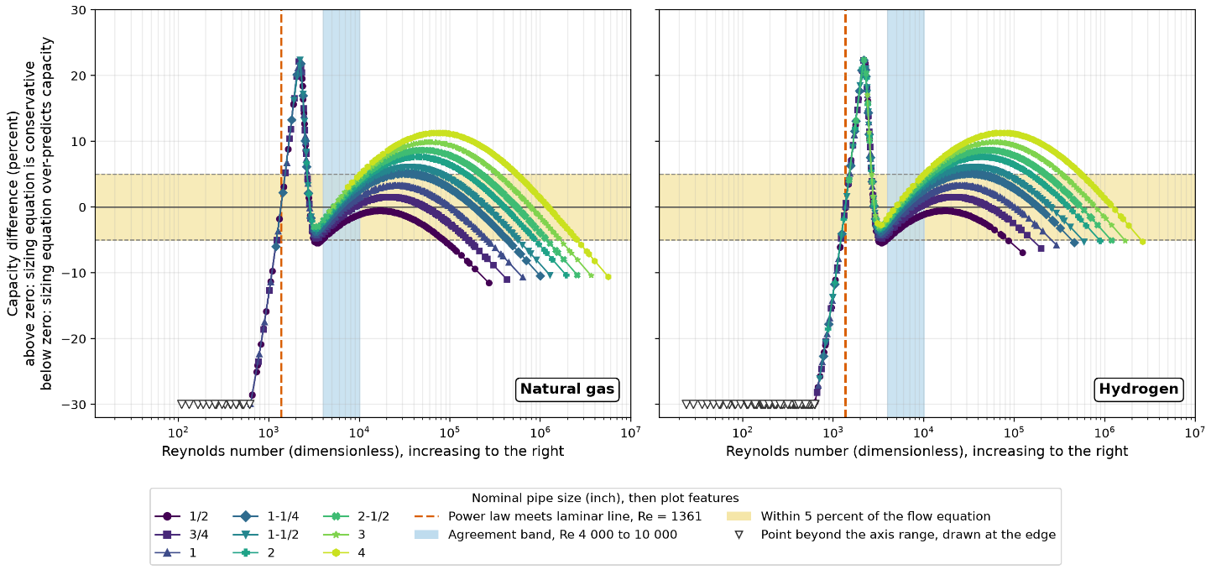
Figure 12 – Percent difference between the published Polyflo capacity and the GFE-Churchill capacity against Reynolds number. Points beyond ±30% are shown as open markers at the axis limit; the deepest laminar point reaches −84.4%. Capacities are unrounded; Figure 13 and Table 16 use capacities rounded to whole kW as published.
Figure 13 shows that a high share of cells inside the agreement range does not protect a schedule from non-conservatism, because the cells falling outside it can lie on either side. The pressure schedules of Tables A.1 and A.2 hold 25.3% and 24.9% of natural gas cells inside the range, the largest shares of any schedule, yet are the two worst performers, with the non-conservative cells averaging 15.0% and 9.4%. The reason is that these schedules also place 40.6% and 29.9% of their cells at or below the transition, where Polyflo lies beneath the laminar line and underpredicts friction. Their advantage inside the range is overwhelmed by their exposure below it.
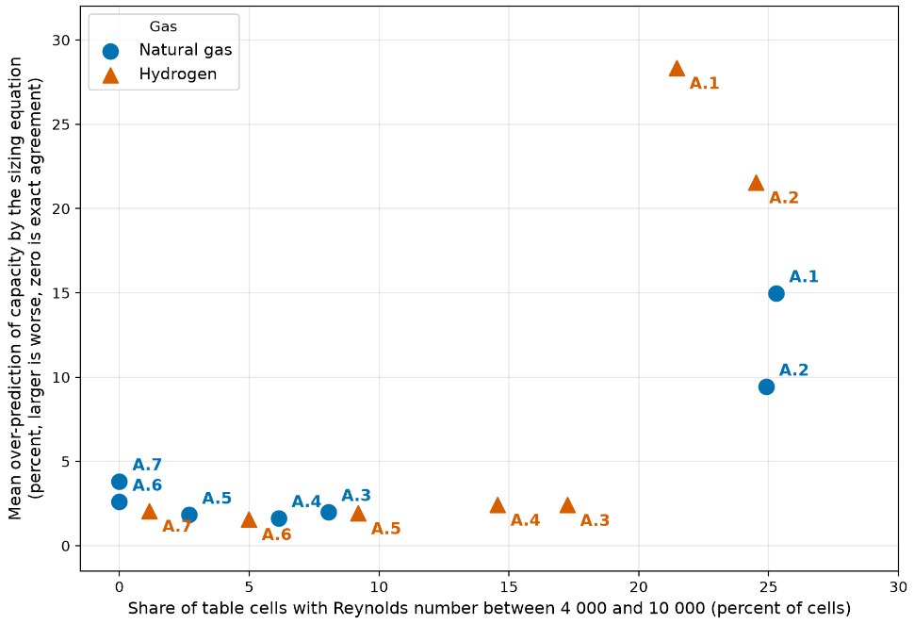
Figure 13 – Mean non-conservatism against the share of cells falling within Re = 4000 to 10000, for natural gas and hydrogen. Each point is one Annex A pressure schedule, colored by table, with marker area proportional to the share of cells non-conservative by more than 5%. Mean non-conservatism is plotted as positive magnitudes. Capacities are rounded to whole kW as published, the same basis as Table 16.
Raising the pressure schedule shifts Reynolds numbers higher, away from the laminar region, and the non-conservatism falls with it. From the schedule of Table A.3 onward no natural gas cell is laminar, and the mean non-conservatism drops from 9.4% at Table A.2 to 2.0% at Table A.3 and 1.6% at Table A.4, its best value. This improvement comes despite the share of cells inside the agreement range falling from 24.9% to 8.0% and then 6.1%, which confirms that the laminar exposure, not the share inside the range, is what governs the outcome. Beyond Table A.4 the trend reverses. The cells are now climbing past the upper edge of the agreement range rather than falling short of its lower edge, and the mean non-conservatism rises again to 1.8%, 2.6% and 3.8% at the schedules of Tables A.5, A.6 and A.7, with the share of affected cells rising much faster, from 23.0% to 37.9% and 62.1%. Above the range each Moody curve flattens toward its fully rough asymptote while the Polyflo power law continues to fall, so the two separate a second time. The deviations on this arm are shallow, never exceeding 11.5%, whereas those on the laminar arm reach 75%.
Hydrogen follows the same sequence displaced by about two pressure schedules, because it operates at roughly half the Reynolds number of natural gas at equal energy delivery. At the schedules of Tables A.1 and A.2 it is far worse than natural gas, with 41.8% and 31.0% of cells laminar against 20.3% and 12.3%, and the non-conservative cells averaging 28.3% and 21.6%. From Table A.3 to Table A.7, it is consistently better, holding a larger share of cells inside the agreement range at every one of those schedules, 17.2% against 8.0% at Table A.3 and 9.2% against 2.7% at Table A.5, because natural gas has already climbed past the range while hydrogen is still inside it. At the schedule of Table A.7, sizing with Polyflo produces natural gas capacities that exceed the Moody friction prediction (non-conservative) in 62.1% of cells, by up to 11.5%. At the same schedule, hydrogen capacities are non-conservative in 28.0% of cells, by up to 7.0%.
Polyflo is consequently not a suitable sizing basis for hydrogen across all flow regimes and pressure conditions in non-corrugated pipes.. Its use for hydrogen would be defensible only at the elevated-pressure schedules of Tables A.3 to A.7, where the worst overprediction for hydrogen is 7.0% and the hydrogen RMS difference does not exceed 6.7%. For natural gas the maximum deviation across those same schedules is 11.5%, at the schedule of Table A.7. Hydrogen’s worst case is not there, but at the low-pressure schedules of Tables A.1 and A.2, where 64.8% and 53.3% of hydrogen cells fall at or below the transition and the RMS differences are 28.5% and 21.7%. Since domestic service is predominantly low pressure, this excludes the majority of the hydrogen application range. The GFE closed under the Churchill correlation, that is Moody friction, carries no such calibrated band, requires only a known pipe roughness, and is the more widely used basis in industry, so it is an appropriate replacement, pending experimental confirmation. The capacities it returns are to be read together with the calculated flow regime for the cell rather than as stand-alone values. Table 16 gives the regime split and the extreme differences for each pressure schedule and gas.
Table | Gas | %Laminar | %Transitional | %Turbulent | RMS |diff%| | min diff% | max diff% | % non-conservative | % Re 4000-10000
A.1 | NG | 20.3 | 20.3 | 59.4 | 15.6 | -75.0 | 23.1 | 31.4 | 25.3
A.1 | H2 | 41.8 | 23.0 | 35.2 | 28.5 | -100.0 | 25.0 | 49.4 | 21.5
A.2 | NG | 12.3 | 17.6 | 70.1 | 11.1 | -60.0 | 23.1 | 25.7 | 24.9
A.2 | H2 | 31.0 | 22.2 | 46.7 | 21.7 | -80.0 | 25.0 | 40.6 | 24.5
A.3 | NG | 0.0 | 1.1 | 98.9 | 5.7 | -7.4 | 11.3 | 13.4 | 8.0
A.3 | H2 | 1.5 | 6.9 | 91.6 | 6.7 | -5.4 | 22.2 | 16.5 | 17.2
A.4 | NG | 0.0 | 0.4 | 99.6 | 5.4 | -5.4 | 11.2 | 15.3 | 6.1
A.4 | H2 | 0.8 | 5.4 | 93.9 | 6.7 | -6.5 | 23.1 | 15.7 | 14.6
A.5 | NG | 0.0 | 0.0 | 100.0 | 4.5 | -5.9 | 10.6 | 23.0 | 2.7
A.5 | H2 | 0.0 | 1.9 | 98.1 | 5.9 | -5.8 | 11.3 | 14.2 | 9.2
A.6 | NG | 0.0 | 0.0 | 100.0 | 3.9 | -8.5 | 9.2 | 37.9 | 0.0
A.6 | H2 | 0.0 | 0.0 | 100.0 | 5.1 | -4.3 | 11.1 | 16.5 | 5.0
A.7 | NG | 0.0 | 0.0 | 100.0 | 4.2 | -11.5 | 6.9 | 62.1 | 0.0
A.7 | H2 | 0.0 | 0.0 | 100.0 | 4.2 | -7.0 | 10.1 | 28.0 | 1.1
Table 16 – Fraction of operating points in each flow regime and the extreme signed capacity differences between Polyflo and GFE-Churchill, natural gas and hydrogen, Tables A.1 to A.7 of CSA B149.1:25 Annex A. Differences are computed from capacities rounded to whole kW as published. The hydrogen minimum of −100% at the schedules of Tables A.1 and A.2 is a rounding floor: capacities below 0.5 kW publish as zero.

Graph and Table Development
Section 3.5 established what the published sizing methods are, the conditions under which they apply where they are valid, and what could replace them where the conditions are not met. This section translates those findings into graphs and tables: first the graphing methodology by which CSST capacities are published (§3.6.1), then hydrogen sizing tables for smooth pipe built on Moody friction (§3.6.2), and an illustration of how these results may be incorporated into standards-related work (§3.6.3).

Applicability of CSA/ANSI LC 1 Graphing Methodology
CSA/ANSI LC 1:23 does not define a sizing equation for CSST. Manufacturers measure flow capacity at the lengths and pressure conditions prescribed by the standard, fit a pressure-gradient-versus-flow curve to the measurements, and designate the EHD rating by comparison of the fitted capacities against Tables 1 a) to 1 c) of the standard. The published sizing tables then extend that fit to lengths outside the tested range. The published sizing tables are therefore fitted extrapolations of test data, not evaluations of a flow equation.
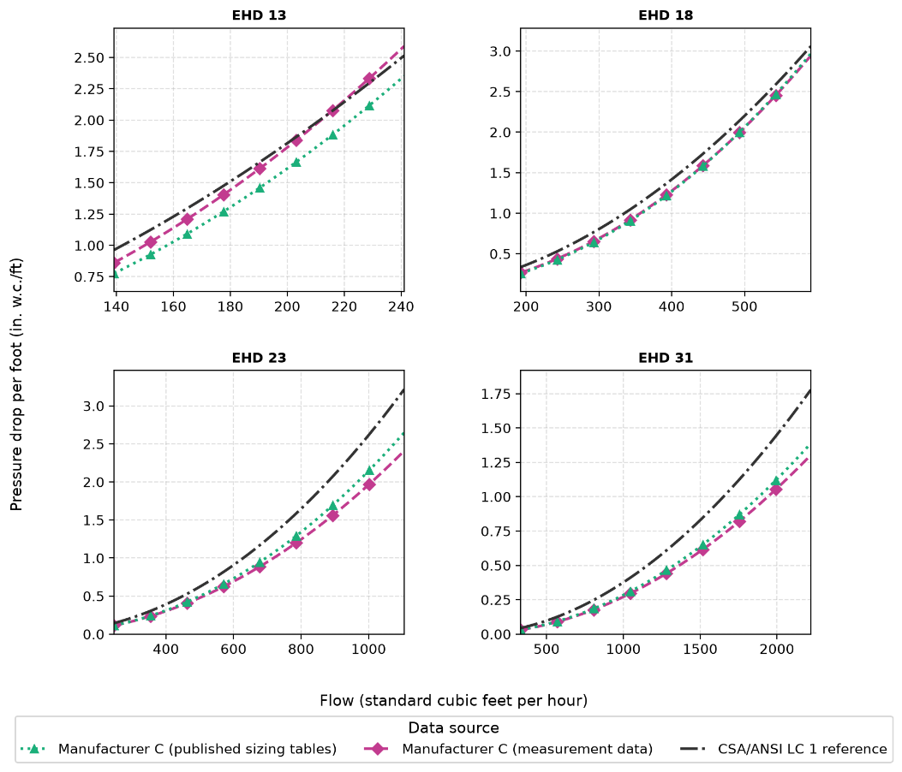
Figure 14 – Published pressure-gradient-versus-flow curves at equal EHD: Manufacturer C (published sizing tables) and Manufacturer C (measurement data) against the CSA/ANSI LC 1 reference, drawn over the flow range for which every governing source has data.
Figure 14 compares the published pressure-gradient curves at equal EHD. For each of the four sizes where Manufacturer C has both a published sizing table and independent measurement data, capacity meets or exceeds the CSA/ANSI LC 1 reference requires for that EHD, by margins of roughly 11-50% depending on size. The measurement data and the published table agree closely with each other and both sit consistently above the reference curve rather than scattered around it. The reference being met with this much margin, and consistently, indicates the CSA/ANSI LC 1 capacity tables reflect real, achievable tubing performance rather than a nominal or unverified target. This is consistent with Figure B.2 in Appendix B, where the friction factor back-calculated from the CSA/ANSI LC 1 tables follows a similar pattern against Reynolds number as Manufacturer C's own measurement data in §3.5.2.
Figure 15 extends the comparison to Manufacturer C’s full tubing range: EHD 13 (3/8 in.), 18 (1/2 in.), 23 (3/4 in.), 31 (1 in.), 39 (1¼ in.) and 62 (2 in.). The flow capacities are compared at a matched pressure gradient. At EHD 62, the largest size tabulated, published capacity falls below even the EHD 60 threshold and meets only the EHD 48 threshold. Under Clause 5.10.3.2 of CSA/ANSI LC 1:23, which assigns the largest designation whose tabulated capacity the measured curve meets or exceeds, EHD 48 is the nearest designation it still qualifies for.
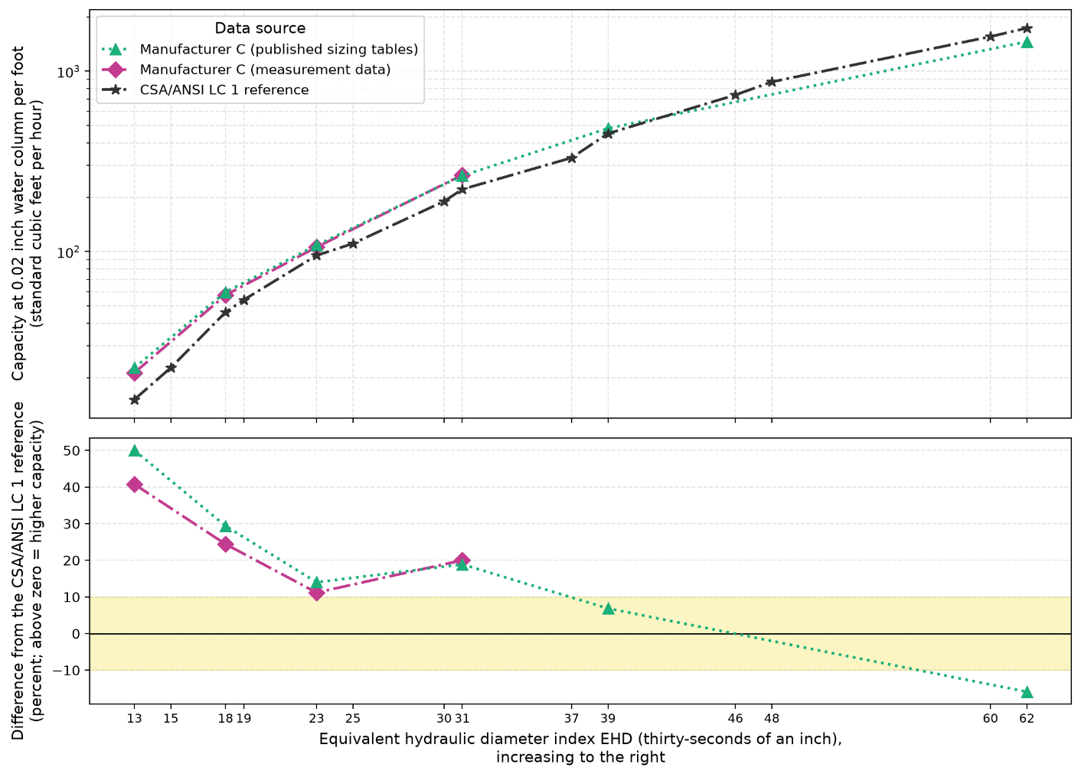
Figure 15 – Flow capacity at a matched pressure gradient versus EHD: Manufacturer C’s published sizing tables, Manufacturer C’s measurement data, and the CSA/ANSI LC 1 reference. Pressure gradient is tabulated pressure drop divided by bare tabulated length with no fitting allowance added; capacity read at a matched gradient of 0.02 inch water column per foot (16.3 Pa/m) by inverting a least-squares power-law fit to each source's own data, within its tested range, so no curve is extrapolated.
Tables 12 to 14 established that the operating envelope of the published schedules spans laminar, transitional and turbulent flow. Figure 10 shows the friction behavior changing across regimes. A single power-law fit of pressure gradient against flow has no laminar branch and cannot represent both regimes equally well. Hydrogen operates deeper in the low-Reynolds number range than natural gas does at equal energy delivery, roughly half the Reynolds number at the same delivered energy, so extending the existing fit into that range is not a sound basis for hydrogen sizing.

The CSA/ANSI LC 1 reference is stated for gas of relative density 0.60. Hydrogen's relative density is 0.0696, an order of magnitude lower, so there is no equivalent measured reference to test hydrogen against. Property-scaling or refitting the existing tables would assume the same friction relationship holds at hydrogen's properties and lower Reynolds numbers. That assumption cannot be confirmed without a dedicated measurement campaign, so it is not the right approach. Instead, the direct flow measurement that produced CSA/ANSI LC 1:23 Tables 1 a) to 1 c) should be repeated for hydrogen, at the lower Reynolds numbers it occupies, and used to build a hydrogen-specific EHD capacity scaling for CSST.

Hydrogen-specific or surrogate-gas flow testing within the LC 1 certification framework must deliver two things. The first is pressure drop against flow, measured per product at the certification lengths and conditions. The second is those same measurements carried down into the low-Reynolds number range hydrogen occupies, which lies below anything the present method is exercised at. A laboratory can deliver those two. From the standard itself, the capacities a product must meet to earn an EHD rating are tabulated for gas of relative density 0.60, so hydrogen acceptance capacities would have to be published before any hydrogen test result could be rated at all. CSA/ANSI LC 1’s applicable-fuels clause defines fuel gas as a commercially distributed gas used for combustion, such as natural gas, propane gas-air mixtures, or mixtures of these gases. Hydrogen is currently excluded from the standard as it falls outside that definition. This analysis shows the exclusion to be technically necessary rather than merely formal, as there is nothing at present for a hydrogen-tested curve to be judged against.

Hydrogen Sizing Graphs and Tables
For smooth (non-corrugated) pipe no such barrier exists. The General Flow Equation closed with the Churchill correlation (Moody friction with its laminar branch included) requires only the pipe bore, roughness and gas properties, and §3.5.3 established both its agreement with the published capacities in the turbulent band and its validity where Polyflo becomes less representative. Hydrogen sizing tables, scoped to a maximum of NPS 2, can be generated directly, with the flow regime evaluated cell by cell. These tables give the reference capacity on Moody friction, with no margin added. They are the benchmark against which a conservative sizing basis is calibrated in §3.7.3, not the proposed code provision itself.
L (m) / NPS  NG / H₂ (kW) |  |  | 1/2 |  |  | 3/4 |  |  | 1 |  | 1-1/4 |  |  | 1-1/2 |  | 2
3 |  |  | 46 / 42 T |  |  | 97 / 83 U |  |  | 182 / 162 U |  | 373 / 343 U |  |  | 559 / 522 U |  | 1077 / 1028 U
6 |  |  | 32 / 35 L |  |  | 66 / 59 T |  |  | 125 / 109 U |  | 257 / 231 U |  |  | 384 / 353 U |  | 740 / 697 U
9 |  |  | 25 / 24 L |  |  | 53 / 52 T |  |  | 100 / 86 T |  | 206 / 183 U |  |  | 309 / 280 U |  | 594 / 555 U
12 |  |  | 22 / 18 L |  |  | 46 / 48 T |  |  | 86 / 76 T |  | 176 / 155 U |  |  | 264 / 237 U |  | 509 / 471 U
15 |  |  | 19 / 15 L |  |  | 40 / 44 L |  |  | 76 / 70 T |  | 156 / 136 T |  |  | 234 / 208 U |  | 451 / 414 U
18 |  |  | 18 / 12 L |  |  | 37 / 38 L |  |  | 69 / 67 T |  | 142 / 122 T |  |  | 212 / 187 U |  | 409 / 373 U
21 |  |  | 16 / 10 L |  |  | 34 / 32 L |  |  | 63 / 64 T |  | 130 / 112 T |  |  | 195 / 171 U |  | 376 / 341 U
24 |  |  | 15 / 9 L |  |  | 31 / 28 L |  |  | 59 / 62 T |  | 121 / 105 T |  |  | 182 / 158 T |  | 350 / 316 U
27 |  |  | 14 / 8 L |  |  | 29 / 25 L |  |  | 55 / 60 L |  | 114 / 100 T |  |  | 170 / 148 T |  | 328 / 295 U
30 |  |  | 13 / 7 L |  |  | 28 / 23 L |  |  | 52 / 57 L |  | 107 / 96 T |  |  | 161 / 139 T |  | 310 / 278 U
35 |  |  | 12 / 6 L |  |  | 26 / 19 L |  |  | 48 / 51 L |  | 99 / 92 T |  |  | 148 / 128 T |  | 285 / 254 U
40 |  |  | 11 / 6 L |  |  | 24 / 17 L |  |  | 45 / 45 L |  | 92 / 89 T |  |  | 138 / 120 T |  | 265 / 235 U
45 |  |  | 11 / 5 L |  |  | 22 / 15 L |  |  | 42 / 40 L |  | 86 / 86 T |  |  | 129 / 115 T |  | 249 / 219 U
50 |  |  | 10 / 4 L |  |  | 21 / 14 L |  |  | 40 / 36 L |  | 81 / 83 T |  |  | 122 / 111 T |  | 235 / 206 U
60 |  |  | 9 / 4 L |  |  | 19 / 11 L |  |  | 36 / 30 L |  | 74 / 79 T |  |  | 111 / 105 T |  | 213 / 185 T
70 |  |  | 8 / 3 L |  |  | 18 / 10 L |  |  | 33 / 25 L |  | 68 / 74 L |  |  | 102 / 101 T |  | 196 / 170 T
80 |  |  | 8 / 3 L |  |  | 16 / 8 L |  |  | 31 / 22 L |  | 63 / 67 L |  |  | 95 / 97 T |  | 182 / 159 T
90 |  |  | 7 / 2 L |  |  | 15 / 8 L |  |  | 29 / 20 L |  | 59 / 59 L |  |  | 89 / 94 T |  | 171 / 151 T
100 |  |  | 7 / 2 L |  |  | 14 / 7 L |  |  | 27 / 18 L |  | 56 / 53 L |  |  | 84 / 91 L |  | 162 / 145 T
125 |  |  | 6 / 2 L |  |  | 13 / 5 L |  |  | 24 / 14 L |  | 50 / 43 L |  |  | 74 / 79 L |  | 143 / 135 T
150 |  |  | 6 / 1 L |  |  | 12 / 5 L |  |  | 22 / 12 L |  | 45 / 36 L |  |  | 67 / 66 L |  | 130 / 129 T
175 |  |  | 5 / 1 L |  |  | 11 / 4 L |  |  | 20 / 10 L |  | 41 / 30 L |  |  | 62 / 56 L |  | 119 / 124 T
200 |  |  | 5 / 1 L |  |  | 10 / 3 L |  |  | 19 / 9 L |  | 38 / 27 L |  |  | 58 / 49 L |  | 111 / 119 T
250 |  |  | 4 / 1 L |  |  | 9 / 3 L |  |  | 17 / 7 L |  | 34 / 21 L |  |  | 51 / 40 L |  | 98 / 107 L
300 |  |  | 4 / 1 L |  |  | 8 / 2 L |  |  | 15 / 6 L |  | 31 / 18 L |  |  | 46 / 33 L |  | 89 / 89 L
350 |  |  | 4 / 1 L |  |  | 7 / 2 L |  |  | 14 / 5 L |  | 28 / 15 L |  |  | 43 / 28 L |  | 82 / 77 L
400 |  |  | 3 / 1 L |  |  | 7 / 2 L |  |  | 13 / 4 L |  | 26 / 13 L |  |  | 40 / 25 L |  | 76 / 67 L
500 |  |  | 3 / 0 L |  |  | 6 / 1 L |  |  | 11 / 4 L |  | 23 / 11 L |  |  | 35 / 20 L |  | 68 / 54 L
600 |  |  | 3 / 0 L |  |  | 5 / 1 L |  |  | 10 / 3 L |  | 21 / 9 L |  |  | 32 / 16 L |  | 61 / 45 L
Table 17 – Flow capacity for the conditions of CSA B149.1:25 Table A.1 (<1.75 kPa inlet / 125 Pa drop): published natural-gas values and hydrogen values computed on the GFE-Churchill basis of §3.5.3. L = laminar, T = transitional, U = turbulent. Capacities below 0.5 kW publish as zero (rounding floor).
In the cells where both gases are fully turbulent, hydrogen delivers about nine-tenths of the published natural-gas capacity: across those 28 cells the ratio runs from 0.86 to 0.95 with a median of 0.90, and it approaches unity as the bore widens. The ratio falls away as runs lengthen and bores narrow. The median is 0.91 over the transitional hydrogen cells and 0.59 over the laminar ones, and down the smallest column; at NPS ½, for example, it drops from 0.91 at 3 m to 0.40 at 50 m and 0.25 at 300 m. The regime marking tracks that decay directly: 60.3% of the hydrogen cells are laminar against 36.2% for natural gas, and 47 cells that are turbulent for natural gas are transitional or laminar for hydrogen.
Zeros appear at two cells only, NPS 1/2 at 500 m and 600 m, where the hydrogen capacity falls below the whole-kilowatt rounding floor; they are a publication artifact, not a prediction of no flow. The region where §3.5.3 found Polyflo to become less representative, at and below the transition, does not shrink for hydrogen. It grows: every cell that is transitional for natural gas is laminar for hydrogen, and cells that are turbulent for natural gas become transitional or laminar for hydrogen. Figure 16 plots the ratio against run length for each size, with the hydrogen flow regime marked on every point. Table 18 maps the same ratio over the whole schedule, with each cell carrying its hydrogen flow regime. A cell reading 0.91 T means hydrogen carries 91% of the natural-gas capacity at that length and size, and runs transitional there. In practice, a designer sizing that run for hydrogen should expect roughly 91% of the pipe’s rated natural-gas capacity, so meeting the same demand may require the next larger pipe size or a shorter run. The transitional marking is a caution rather than a capacity penalty on its own: it means friction behavior at that cell is less certain than in the fully turbulent cells, so the capacity number carries less margin. This is a flag for where confirmation testing should concentrate, not a case for proposing a separate transitional sizing law here; §3.8 covers the testing program needed to close it.
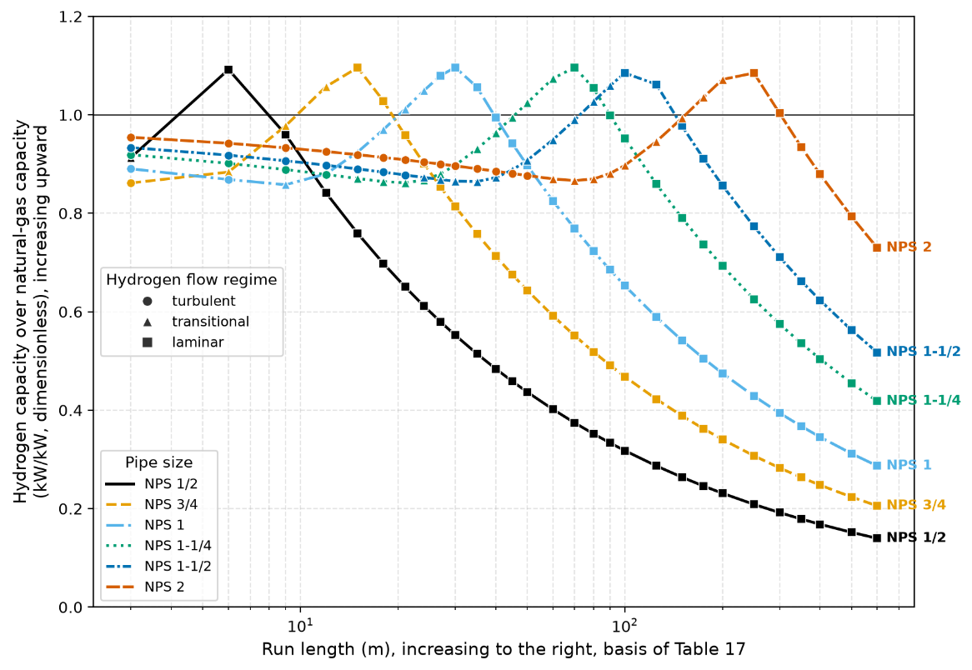
Figure 16 – Hydrogen capacity relative to the published natural-gas capacity against run length, for pipe sizes up to and including NPS 2, at the schedule conditions of Table A.1 (<1.75 kPa inlet / 125 Pa drop). Markers show the hydrogen flow regime. Whole-kilowatt rounding produces the visible steps at small capacities; hydrogen capacities rounded to zero are omitted.

L (m) / NPS |  | 1/2 |  | 3/4 |  | 1 | 1-1/4 |  | 1-1/2 |  | 2
3 |  | 0.91 T |  | 0.86 U |  | 0.89 U | 0.92 U |  | 0.93 U |  | 0.95 U
6 |  | 1.09 L |  | 0.88 T |  | 0.87 U | 0.90 U |  | 0.92 U |  | 0.94 U
9 |  | 0.96 L |  | 0.98 T |  | 0.86 T | 0.89 U |  | 0.91 U |  | 0.93 U
12 |  | 0.84 L |  | 1.06 T |  | 0.88 T | 0.88 U |  | 0.90 U |  | 0.93 U
15 |  | 0.76 L |  | 1.10 L |  | 0.92 T | 0.87 T |  | 0.89 U |  | 0.92 U
18 |  | 0.70 L |  | 1.03 L |  | 0.97 T | 0.86 T |  | 0.88 U |  | 0.91 U
21 |  | 0.65 L |  | 0.96 L |  | 1.01 T | 0.86 T |  | 0.88 U |  | 0.91 U
24 |  | 0.61 L |  | 0.90 L |  | 1.05 T | 0.87 T |  | 0.87 T |  | 0.90 U
27 |  | 0.58 L |  | 0.85 L |  | 1.08 L | 0.88 T |  | 0.87 T |  | 0.90 U
30 |  | 0.55 L |  | 0.81 L |  | 1.10 L | 0.90 T |  | 0.87 T |  | 0.90 U
35 |  | 0.51 L |  | 0.76 L |  | 1.06 L | 0.93 T |  | 0.86 T |  | 0.89 U
40 |  | 0.48 L |  | 0.71 L |  | 0.99 L | 0.96 T |  | 0.87 T |  | 0.89 U
45 |  | 0.46 L |  | 0.68 L |  | 0.94 L | 1.00 T |  | 0.89 T |  | 0.88 U
50 |  | 0.44 L |  | 0.64 L |  | 0.90 L | 1.02 T |  | 0.91 T |  | 0.88 U
60 |  | 0.40 L |  | 0.59 L |  | 0.83 L | 1.07 T |  | 0.95 T |  | 0.87 T
70 |  | 0.37 L |  | 0.55 L |  | 0.77 L | 1.10 L |  | 0.99 T |  | 0.87 T
80 |  | 0.35 L |  | 0.52 L |  | 0.72 L | 1.05 L |  | 1.03 T |  | 0.87 T
90 |  | 0.33 L |  | 0.49 L |  | 0.69 L | 1.00 L |  | 1.06 T |  | 0.88 T
100 |  | 0.32 L |  | 0.47 L |  | 0.65 L | 0.95 L |  | 1.08 L |  | 0.90 T
125 |  | 0.29 L |  | 0.42 L |  | 0.59 L | 0.86 L |  | 1.06 L |  | 0.95 T
150 |  | 0.26 L |  | 0.39 L |  | 0.54 L | 0.79 L |  | 0.98 L |  | 0.99 T
175 |  | 0.25 L |  | 0.36 L |  | 0.50 L | 0.74 L |  | 0.91 L |  | 1.04 T
200 |  | 0.23 L |  | 0.34 L |  | 0.47 L | 0.69 L |  | 0.86 L |  | 1.07 T
250 |  | 0.21 L |  | 0.31 L |  | 0.43 L | 0.63 L |  | 0.77 L |  | 1.08 L
300 |  | 0.19 L |  | 0.28 L |  | 0.39 L | 0.58 L |  | 0.71 L |  | 1.00 L
350 |  | 0.18 L |  | 0.26 L |  | 0.37 L | 0.54 L |  | 0.66 L |  | 0.93 L
400 |  | 0.17 L |  | 0.25 L |  | 0.35 L | 0.50 L |  | 0.62 L |  | 0.88 L
500 |  | 0.15 L |  | 0.22 L |  | 0.31 L | 0.45 L |  | 0.56 L |  | 0.79 L
600 |  | 0.14 L |  | 0.21 L |  | 0.29 L | 0.42 L |  | 0.52 L |  | 0.73 L
Capacity ratio below 0.50 0.50 to 0.74 0.75 to 0.89 0.90 to 0.99 1.00 to 1.04 1.05 or above
Table 18 – Hydrogen capacity relative to the natural gas basis at the conditions of CSA B149.1:25 Table A.1 (<1.75 kPa inlet / 125 Pa drop), by run and NPS, colored by capacity ratio. L for laminar below Re = 2,300, T for transitional to between Re = 2,300 and 4,000, U for turbulent above Re = 4,000. The numerator is the hydrogen capacity from GFE-Churchill and the denominator is the natural gas capacity from the Polyflo closed form on the same schedule, both unrounded.
The following worked example traces one representative cell of Table 17. The cell passes the low-Mach review: the Mach number is below 0.01 for both gases (Table 19).
Quantity | Natural gas | Hydrogen
Nominal pipe size (in) | 3/4 | 3/4
Internal diameter (in) | 0.824 | 0.824
Internal diameter (mm) | 20.93 | 20.93
Pipe roughness (mm) | 0.045 | 0.045
Run length (m) | 15 | 15
Fitting allowance factor F | 1.2 | 1.2
Effective length used (m) | 18.0 | 18.0
Inlet pressure (kPa absolute) | 101.4500 | 101.4500
Outlet pressure (kPa absolute) | 101.3250 | 101.3250
Pressure drop (Pa) | 125 | 125
Mean pressure per Menon [41] (kPa absolute) | 101.3875 | 101.3875
Relative density (air = 1) | 0.6 | 0.0696
Dynamic viscosity (Pa·s) | 1.200 × 10⁻⁵ | 8.760 × 10⁻⁶
Density at base conditions (kg/m³) | 0.7339 | 0.0851
Higher heating value (MJ/m³) | 37.259 | 12.100
Churchill friction factor (dimensionless) | 0.04338 | 0.03019
Reynolds number (dimensionless) | 3868 | 2163
Flow regime | transitional | laminar
Volumetric flow at base conditions (m³/h) | 3.743 | 13.173
Velocity at mean pressure (m/s) | 3.020 | 10.629
Speed of sound (m/s) | 425.3 | 1295.5
Mach number (dimensionless) | 0.00710 | 0.00820
Energy capacity, General Flow Equation with Churchill (kW) | 39 | 44
Energy capacity, published Polyflo sizing equation (kW) | 40 | 36
Difference, flow equation against sizing equation (percent) | −4.12 | +22.35
Table 19 – Worked example at one cell of Table 17: NPS 3/4 commercial steel, 15 m run, at the conditions of CSA B149.1:25 Table A.1 (<1.75 kPa inlet / 125 Pa drop). At this cell the hydrogen Reynolds number is 0.559 times the natural-gas value, the hydrogen volumetric flow 3.519 times, and the hydrogen energy capacity 1.14 times.
A separate applicability limit applies at high velocity, and it is independent of the friction question. The GFE carries the density change along the pipe through its P₁² − P₂² term, but it neglects the kinetic energy the gas gains as it expands and assumes the gas holds wall temperature throughout. Both assumptions weaken at the largest diameters and shortest lengths, where the gas moves fastest and has least time to equilibrate, so both are screened together against Mach 0.3. No cell of Table 17 approaches that limit. In simple terms, a cell in the tables is a valid hydraulic answer only if the gas is moving slowly enough for these two simplifications to hold; that condition is met everywhere in Table 17. This screening check only matters at higher operating pressures than the schedule shown here. At those higher-pressure schedules, the largest pipes carrying gas over the shortest runs push the flow fast enough to approach the Mach 0.3 limit, reaching as high as Mach 0.43 at the highest in-scope pressure schedule, Table A.5 (34 kPa inlet / 17 kPa drop, about 4.9 psig / 2.5 psi). When those higher-pressure tables are built, any cell that crosses Mach 0.3 must be flagged, or omitted from a future hydrogen sizing code with an explanation for the omission.
The same procedure generates the remaining sizing tables for pressure schedules A.2 to A.5 for steel; schedules A.6 (70 kPa inlet, 35 kPa drop) and A.7 (140 kPa inlet, 70 kPa drop) sit above the 10-psig scope of the study. The presentation here is limited to Table A.1. For non-corrugated tubing, a complete method is proposed and confirmation testing is recommended; for CSST the method awaits the test data set out in §3.6.1 and the program recommended in §3.8. Confirmation testing and standards acceptance remain necessary before the candidate tables can be presented as validated sizing provisions.

Designer-Ready Tools for Standards Inclusion
The transformation of §3.6.2 is mechanical once the method is fixed: the same process that turned Table A.1 into Table 17 carries over schedule by schedule, so Table 17's format could support future standardization efforts. The same format can carry the capacities of either sizing option in §3.7.3.

Sensitivity Analysis
This section tests how far the results of §3.5 and §3.6 depend on their inputs, and turns the outcome into a sizing basis. The inputs fall into two groups, shown side by side in Figure 17. The first group only changes the numbers in a table: the pipe roughness, the heating-value basis, the gas properties and the fitting allowance factor. The second group changes the flow regime a cell falls in, and with it whether Polyflo can be relied on there: the pressure schedule, the run length and the pipe size. Non-corrugated steel pipe and CSST are treated separately, since only the former has a sizing equation to test.
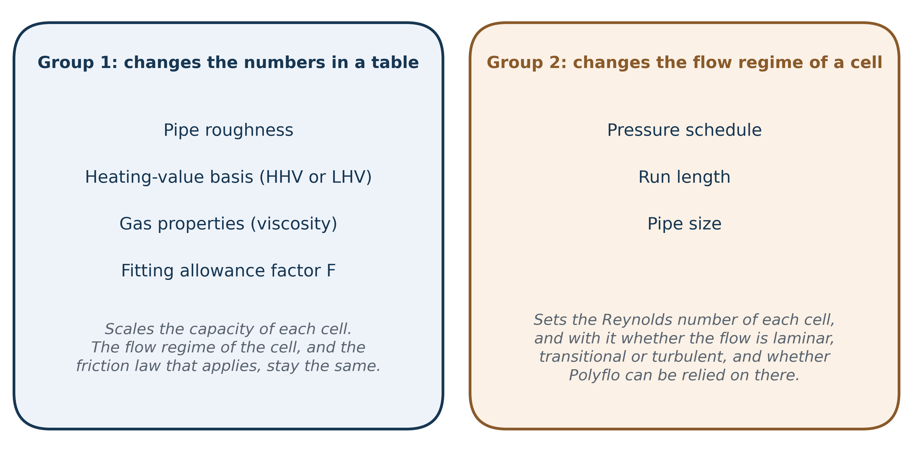
Figure 17 – The two groups of inputs examined in the sensitivity analysis. Inputs in the first group scale the capacity of a table cell; inputs in the second set its Reynolds number, and so its flow regime and the friction law that applies to it.

Identification of Critical Input Parameters
For non-corrugated steel pipe, seven inputs can change either the hydrogen capacity of a table cell or the flow regime the cell falls in. Each input is described below. Their effect on capacity is then quantified by changing them one at a time, starting from the conditions of CSA B149.1:25 Table A.1 (<1.75 kPa inlet / 125 Pa drop).
Pipe roughness affects friction only in turbulent flow. In laminar flow, the gas moves in ordered layers and the friction is set by viscous shear across the whole bore; the small roughness elements on the wall sit in slow-moving gas and do not change it, so the laminar friction factor (f = 64/Re) has no roughness term. In turbulent flow the slow-moving layer next to the wall is thin, the roughness elements protrude through it and add drag, and the friction factor rises with the relative roughness ε/D. Below Re = 1,361 the Polyflo line lies under the laminar line because it falls much more slowly with Reynolds number, with a slope of −0.152 on logarithmic axes against −1 for 64/Re. Polyflo therefore gives a lower friction factor, and so a higher capacity than Moody friction, at every Reynolds number below Re = 1,361 (§3.5.3), and since neither line has a roughness term it does so regardless of the pipe material. Above the transition, roughness sets how far the Churchill curves rise above the Polyflo line between about Re = 2,800 and 5,000, a region referred to below as the transition hump. The reference pipe roughness value is ε = 0.045 mm (0.0018 in.) for new commercial steel, with 0.09 mm (0.0035 in.) as the upper limit for commercial steel roughness; copper at 0.0015 mm serves as the smooth comparison.
As discussed in §3.1.3 and §3.4.1, hydrogen needs about 3.1 times the natural-gas volumetric flow to deliver the same energy on the HHV basis, and runs at about 0.49 times its Reynolds number; on the LHV basis the figures are 3.3 and 0.52. The basis matters in two different ways. For a given appliance load, the LHV basis calls for about 6% more hydrogen flow than the HHV basis, and so a Reynolds number about 6% higher, which can place a load just above Re = 1,361 or 2,300 on one basis and just below it on the other. In a sizing table the pressure drop is fixed instead, so the basis changes neither the volumetric flow of a cell nor its Reynolds number, only the energy rating assigned to it, which is 15.4% lower on the LHV basis.
The pressure schedule, the run length and the pipe size together set the Reynolds number of each cell, and the Reynolds number decides which regime the cell falls in. This is the largest driver of all, since Polyflo sits within ±5% of Moody friction only between about Re = 4,000 and 10,000 (§3.5.3). Table 16 gives the share of cells in each regime for every schedule: at the schedule of Table A.1, 41.8% of hydrogen cells are laminar, against 1.5% at the schedule of Table A.3. In-pipe velocity is set by the same three inputs, but it is not a friction input, and none of the installation codes limits it (§3.4.3), so it is reported here rather than applied as a limit. For a given Reynolds number the velocity follows from v = Re·μ/(ρ·D), with D the inside diameter for steel pipe and the volume-equivalent diameter D_{eff} for CSST (§3.5.2). Table 20 gives the hydrogen velocity at the two regime thresholds and at Re = 20,000 for each size. Velocity falls as the bore grows, so the smallest sizes run fastest: at Re = 20,000 hydrogen moves at about 130 m/s (427 ft/s) in NPS ½ and 39 m/s (129 ft/s) in NPS 2 at the pressure of Table A.1, and at 179 m/s (587 ft/s) in EHD 13 and 71 m/s (234 ft/s) in EHD 31. At the mean pressure of Table A.5 each value is about 20% lower, and the Mach number stays below 0.14 in every case.
Re = 20,000 bounds most of the hydrogen range. At the low-pressure schedules of Tables A.1 and A.2, hydrogen Reynolds numbers stay below about 11,000 and 16,000 for runs of 30 ft (9 m) and longer, with velocities up to 21 and 31 m/s (69 and 103 ft/s). For CSST, hydrogen delivering the same energy as the largest natural-gas flows measured by Manufacturer C runs at Re ≈ 6,300 for EHD 13 and up to about 22,800 for EHD 31 on the HHV basis, at up to about 80 m/s (262 ft/s). Only the elevated-pressure schedules of Tables A.3 to A.5 go further, in short runs of the larger steel sizes: 30 ft (9 m) of NPS 2 at the schedule of Table A.5 carries hydrogen at Re ≈ 1.9 × 10⁵ and about 300 m/s (980 ft/s), a Mach number of 0.23. Appendix C gives the range for each schedule, and the sizing options of §3.7.3 are checked over the whole of it.
Pipe | Diameter used (mm) | Re = 1,361, Table A.1 pressure | Re = 2,300, Table A.1 pressure | Re = 20,000, Table A.1 pressure | Re = 20,000, Table A.5 mean pressure
NPS ½ steel | 15.80 | 8.9 (29) | 15.0 (49) | 130 (427) | 104 (341)
NPS ¾ steel | 20.93 | 6.7 (22) | 11.3 (37) | 98.3 (322) | 78.4 (257)
NPS 1 steel | 26.64 | 5.3 (17) | 8.9 (29) | 77.2 (253) | 61.6 (202)
NPS 1¼ steel | 35.05 | 4.0 (13) | 6.7 (22) | 58.7 (193) | 46.8 (154)
NPS 1½ steel | 40.89 | 3.4 (11) | 5.8 (19) | 50.3 (165) | 40.1 (132)
NPS 2 steel | 52.50 | 2.7 (8.7) | 4.5 (15) | 39.2 (129) | 31.3 (103)
EHD 13 CSST | 11.49 (D_{eff}) | 12.2 (40) | 20.6 (68) | 179 (587) | 143 (469)
EHD 18 CSST | 16.17 (D_{eff}) | 8.7 (28) | 14.6 (48) | 127 (417) | 102 (333)
EHD 23 CSST | 21.40 (D_{eff}) | 6.5 (21) | 11.1 (36) | 96.1 (315) | 76.7 (252)
EHD 31 CSST | 28.88 (D_{eff}) | 4.8 (16) | 8.2 (27) | 71.2 (234) | 56.9 (187)
Table 20 – Hydrogen in-pipe velocity, m/s (ft/s), at the regime thresholds and at Re = 20,000, from v = Re·μ/(ρ·D) with μ = 8.76 × 10⁻⁶ Pa·s at 15.6 °C (60 °F). Mean pressures: 101.4 kPa absolute for Table A.1 and 127.0 kPa absolute for Table A.5 of CSA B149.1:25. Schedule 40 inside diameters for steel; D_{eff} of Manufacturer C for CSST.
The gas properties of hydrogen have a small effect. Its relative density is fixed by its molar mass, so it carries no uncertainty, and in laminar flow it does not enter the capacity at all. The laminar pressure drop depends on viscosity but not on density, so viscosity is the only gas property that matters there. Published viscosity values for hydrogen differ by a few percent between sources. A 5% change in viscosity changes the capacity of laminar cells by about 5%, and moves about 2% of cells across Re = 1,361.
The fitting allowance factor F, 1.2 or 1.0 depending on the schedule, lengthens the effective run and enters Polyflo and GFE-Churchill in the same way. Setting F = 1.0 at the schedule of Table A.1 raises hydrogen capacity by 20% in the laminar cells and by less in the turbulent ones, and moves 3.4% of cells above Re = 1,361.
For CSST, one input dominates: the assumed diameter. Moving from the nominal bore EHD·25.4/32 mm to D_{eff} changes the back-calculated friction factors by a factor of about 1.7 to 2.2, but leaves their trend unchanged (Appendix B.5).

One-at-a-Time Sensitivity of Hydrogen Capacity
Table 21 changes one input at a time from a hydrogen baseline at the schedule of Table A.1 (125 Pa drop, F = 1.2, ε = 0.045 mm, HHV), over NPS ½ to NPS 2 and all tabulated lengths, on the GFE-Churchill basis. At the baseline, 47.1% of cells lie below Re = 1,361 and 60.3% below Re = 2,300.
Input changed from the baseline | Median change in capacity (%) | Range of change (%) | Cells below Re = 1,361 (%) | Cells below Re = 2,300 (%)
Baseline: ε = 0.045 mm, F = 1.2, HHV | – | – | 47.1 | 60.3
Roughness 0.045 → 0.0015 mm (copper) | 0.0 | 0.0 to +4.2 | 47.1 | 60.3
Roughness 0.045 → 0.09 mm (upper value for commercial steel) | 0.0 | −3.3 to 0.0 | 47.1 | 60.3
Fitting factor F 1.2 → 1.0 | +20.0 | +5.0 to +20.0 | 43.7 | 56.9
Hydrogen viscosity −5% | +5.3 | −2.4 to +5.3 | 45.4 | 58.6
Hydrogen viscosity +5% | −4.8 | −4.8 to +2.3 | 49.4 | 62.6
Schedule of Table A.1 → Table A.2 (250 Pa drop) | +57.9 | +21.5 to +100 | 33.3 | 46.6
Schedule of Table A.1 → Table A.3 (14 kPa inlet, 7 kPa drop) | +915 | +659 to +6,080 | 0.0 | 2.3
Heating value HHV → LHV (energy rating only) | −15.4 | −15.4 | 47.1 | 60.3
Table 21 – One-at-a-time sensitivity of hydrogen capacity at the conditions of CSA B149.1:25 Table A.1 (<1.75 kPa inlet / 125 Pa drop), NPS ½ to NPS 2, all tabulated lengths, GFE-Churchill basis. Changes are relative to the baseline, cell by cell; the heating-value row changes the energy rating only.
The pressure schedule dominates. Doubling the allowable drop to the 250 Pa of Table A.2 raises capacity by 22 to 100%, and moving to the 14 kPa inlet of Table A.3 raises it roughly tenfold while taking almost every cell out of the laminar region. Among the inputs that only change numbers, the fitting factor and the heating-value basis have the largest effect, 15 to 20%. Roughness matters only in the turbulent cells, which are a minority at this schedule, so its median effect is zero and its largest effect 4.2% for copper and 3.3% for steel at 0.09 mm. A 5% uncertainty in hydrogen viscosity maps almost one to one onto laminar capacity.

Uncertainty and Robustness Analysis
The results of §3.5 and §3.6 rest on a reference model for non-corrugated pipe and on one measured dataset for CSST. This section sets out how far each can be relied on, citing the results already presented rather than repeating them.

Robustness of the GFE-Churchill Reference
GFE-Churchill is robust in two respects. It is gas-independent: at matched Reynolds number and relative roughness it returns the same capacity difference against Polyflo for natural gas, hydrogen, butane and propane, to within 0.01 percentage points (Table 15). It also needs only a pipe bore, a roughness and the gas properties, all of which are known for commercial steel.
Its weak point is the transition band between Re = 2,300 and 4,000. Churchill bridges the laminar and turbulent branches with a smooth interpolation, and other correlations do not agree with it there. Colebrook-White, for example, is a turbulent-flow correlation and is never applied below Re = 2,300; extended down from the turbulent range to Re = 2,300 purely for comparison, it returns a friction factor 55 to 61% higher than Churchill for NPS ½ to NPS 4 at ε = 0.045 mm. The transitional cells therefore carry the most uncertainty in the tables, as §3.6.2 already notes, and any deviation from GFE-Churchill found in this band is a deviation from an interpolation rather than from a settled friction law.

Where Polyflo Deviates from the Reference
Figures 12 and 13 and Table 16 locate the deviations of Polyflo from GFE-Churchill, and they fall into four bands. Below Re = 1,361 Polyflo lies beneath the laminar line and gives a higher capacity than Moody friction, by 33% on average in the natural-gas cells of Table A.1 below that point (§3.5.3). From Re = 1,361 to about 2,800 it lies above the Churchill curve and is conservative. In the transition hump, from about Re = 2,800 to 5,000, the Churchill friction curves rise above it and Polyflo’s capacity exceeds GFE-Churchill by up to about 6% at ε = 0.045 mm. The hump is a feature of the transition, not of roughness: even for a hydraulically smooth pipe it remains, at up to 2.3% in capacity. Above the hump, Polyflo is conservative for most sizes until Reynolds numbers of order 10⁵, where it falls below the asymptoting Churchill curves of the smaller and rougher pipes.
Hydrogen does reach the high-Reynolds band, but only at the elevated-pressure schedules, in short runs of the larger sizes (§3.7.1), and there the deviation stays small for commercial steel. Over the hydrogen cells of Tables A.1 to A.5 above Re = 10⁴, for runs of 30 ft (9 m) and longer, the largest deviation at ε = 0.045 mm is +1.1%, for NPS ½ at the schedule of Table A.5. At ε = 0.09 mm, it rises to +8.5% for the same size, which the rougher pipe also shows in the hump.
These bands set what a sizing basis for hydrogen has to handle. The first band holds the largest deviation and the largest share of hydrogen cells, since at the schedule of Table A.1 almost half of them lie below Re = 1,361 (Table 21). The transition hump is small, at most about 6% in capacity for new commercial steel, and lies where the reference itself is an interpolation. The high-Reynolds band matters only for the rougher and smaller pipes at the elevated-pressure schedules. A sizing basis for hydrogen therefore has to correct the first band, can treat the second as a question of margin, and has to be checked over the third.

Robustness of the CSST Evidence
The CSST evidence is weaker. It rests on a single dataset, the Manufacturer C measurements, which contain no hydrogen points. The published sizing table of Manufacturer C agrees with those measurements on average, with median differences within about 5% at every size, but not cell by cell, and it lies above them, on the non-conservative side, in about half of the matched cells. The largest excess is at EHD 13: up to 23% at the elevated-pressure conditions, and up to 69% at the lowest pressure drop over the longest runs, where the measured flows are smallest. For EHD 18, 23 and 31 the table lies within about 20% of the measurements. Hydrogen also moves 70.0, 52.5, 50.0 and 21.6% of the measured test conditions for EHD 13, 18, 23 and 31 below Re = 2,300 (§3.5.2), into the range where the measured friction behavior changes most.
No closure for CSST can therefore be justified from the present data. The measurements show a laminar branch joined to a plateau, but a single natural-gas dataset from one manufacturer cannot fix either branch well enough for sizing hydrogen. Since the measured data nonetheless give a clear trend of friction factor against Reynolds number, CFD is used in §3.8 to try to reproduce that trend independently, and a test program is proposed there to establish whether it holds in practice.

Parameter Ranking and Design Guidance
This section ranks the inputs of §3.7.1, sets out two options for sizing non-corrugated pipe in hydrogen service, and states the design values that go with them.

Ranking of the Input Parameters
Table 22 ranks the inputs by their influence on hydrogen sizing. The flow regime, set by the pressure schedule, the run length and the pipe size, comes first by a wide margin. The heating-value basis and the pipe roughness follow, then the fitting factor, and the gas properties come last. The fitting factor has a larger effect than roughness in Table 21, but it is fixed by the code for each schedule and so adds little uncertainty. Velocity is not ranked, since it follows from the flow rather than entering the friction factor.
Rank | Input | Effect on hydrogen capacity | Reason for the ranking
1 | Flow regime: pressure schedule, run length and pipe size | Capacity changes by a factor of 1.6 to 10 between the schedules of Tables A.1 to A.3; the share of cells below Re = 1,361 falls from 47% to zero | Decides whether a cell lies where Polyflo sits within ±5% of Moody friction
2 | Heating-value basis, HHV or LHV | Energy rating 15.4% lower on the LHV basis; at equal energy, Re is 0.49 or 0.52 times the natural-gas value | A choice of basis rather than a code value; moves loads near Re = 1,361 and 2,300
3 | Pipe roughness ε | 0 to −3.3% for 0.045 → 0.09 mm and 0 to +4.2% for 0.045 → 0.0015 mm at Table A.1; larger where more cells are turbulent | Varies within commercial steel; sets the size of the transition hump
4 | Fitting allowance factor F | +5 to +20% for F = 1.2 → 1.0 | Large effect, but fixed by the code for each schedule, so it adds little uncertainty
5 | Gas properties | About ±5% in laminar cells for ±5% in viscosity | Relative density is exact for pure hydrogen; viscosity varies by a few percent between sources
Table 22 – Input parameters ranked by their influence on hydrogen sizing, non-corrugated steel pipe. Effects are from Table 21 and §3.7.1.

Option A: Published Equation with a Laminar Branch
The first option keeps the Polyflo equation as published wherever it has served, and replaces it only where it departs furthest from pipe-flow physics. The installation codes have sized natural-gas piping with Polyflo for decades, and the conservatism built into the method has proved sufficient in service, even where it departs from Moody friction. Above Re = 1,361 the equation is therefore kept as published. Below Re = 1,361 it is replaced by the laminar friction factor, 64/Re: there the published equation gives capacities well above those of laminar flow, by a factor that reaches 6 at the lowest tabulated Reynolds numbers (§3.5.3). Hydrogen, at about half the Reynolds number of natural gas, places more of its cells in that range. The resulting friction law is
f=64Re, Re<1,3610.140370·Re-0.151571, Re≥1,361 (14)
Because the switch sits at the crossing, the law is continuous. Below Re = 1,361 the laminar capacity is the smaller of the two, and above it the Polyflo capacity is, so taking the smaller of the laminar capacity and the published Polyflo capacity for each cell applies the switch without computing the Reynolds number. With f = 64/Re the GFE solves in closed form, Q ∝ P12 - P22·D4μ·Tf·Leff, in which the relative density cancels, so no iteration and no roughness value are needed below the switch either. Figure 18 shows the resulting law against GFE-Churchill.
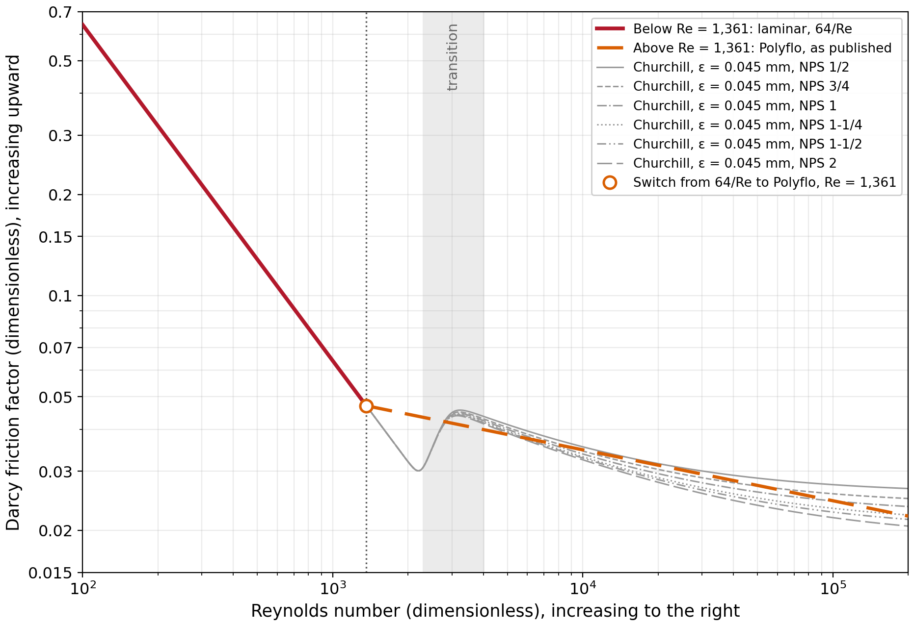
Figure 18 – Option A sizing law for non-corrugated pipe against the GFE-Churchill reference: the laminar line f = 64/Re below Re = 1,361 and the published Polyflo line above it. Gray curves: Churchill at ε = 0.045 mm for NPS ½ to NPS 2. Reynolds numbers up to 2 × 10⁵, the upper end of the hydrogen range (§3.7.1).
Compared with Moody friction, Option A gives more capacity only in the transition hump, where the Churchill curves rise above the Polyflo line, and, for the smaller and rougher pipes, at the highest Reynolds numbers. The hump starts at about Re = 2,800 and peaks near Re = 3,300 to 3,400. At ε = 0.045 mm the largest capacity deviation from GFE-Churchill at fixed pressure drop is +5.8% for NPS ½ and +3.4% for NPS 2. It falls back to zero by Re ≈ 5,400 for NPS 2 and Re ≈ 8,700 for NPS ¾, while for NPS ½ a residual below 1% remains above Re ≈ 10,600. At ε = 0.09 mm, the peak rises to 9.1% (Table C.2). Over the hydrogen cells of Tables A.1 to A.5 for runs of 30 ft (9 m) and longer, the worst cell is +5.8%, at the schedule of Table A.4, 150 m, NPS ½ and Re = 3,414.
A smoother pipe does not remove the hump, since the hump comes from the transition rather than from roughness. Figure 19 repeats Figure 18 at ε = 0.015 mm: the peak falls to between 2.7% (NPS 2) and 3.5% (NPS ½), and a hydraulically smooth pipe keeps a peak of 2.3%. Above the hump, Polyflo stays at or above the Churchill curves, and so conservative, up to Re = 20,000 for relative roughness ε/D up to 0.0027, which covers NPS ½ to NPS 2 up to ε = 0.042 mm, and up to Re = 2 × 10⁵ for ε/D up to 0.0012, or ε = 0.020 mm at NPS ½.
By calculation, then, Option A can give up to about 6% more capacity than Moody friction near the transition. How far this holds in practice is for CSA to judge: the codes have been applied for decades with the conservatism built into their method, the deviation lies in the band where no friction law is settled (§3.7.2), and it is small next to the laminar deviation that Option A removes.

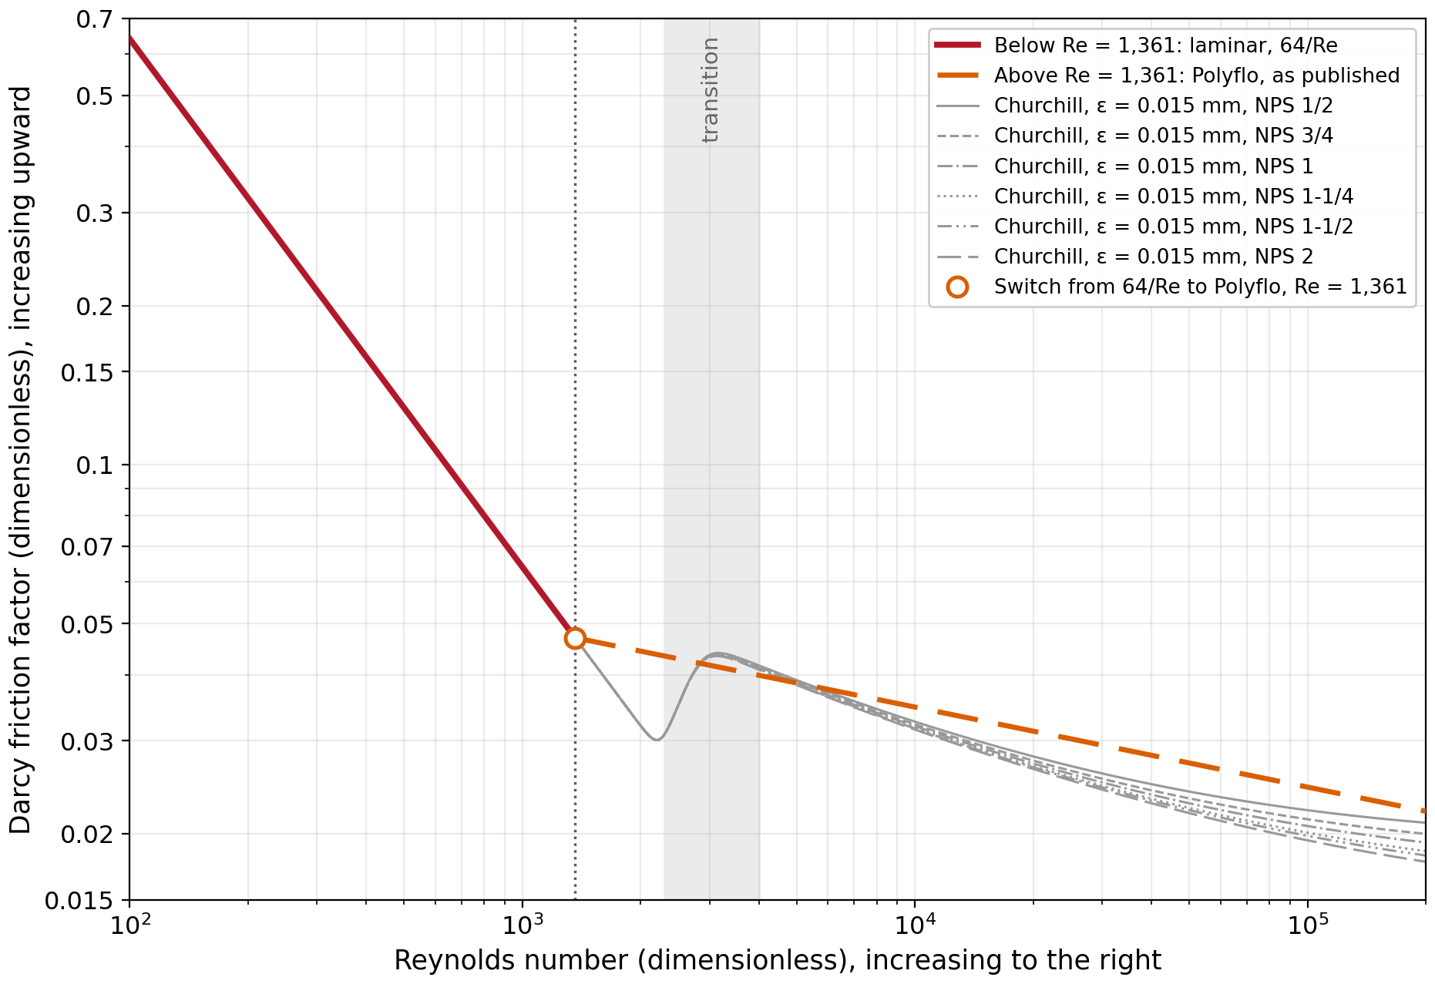
Figure 19 – Option A sizing law as in Figure 18, against Churchill at a lower roughness, ε = 0.015 mm, for NPS ½ to NPS 2. The transition hump remains.

Option B: Shifted Polyflo Friction Law
The second option also removes the transition hump. The Polyflo friction law is raised by a constant factor k,
f=k·0.140370·Re-0.151571, k=1.18 (15)
where k = 1.18 keeps the shifted line at or above the Churchill curves through the transition hump for steel at ε = 0.09 mm, the upper value for commercial steel; the exact value needed there is 1.174, rounded up. Below the point where the shifted line meets the laminar line, the laminar law applies:
f=max64Re, k·0.140370·Re-0.151571 (16)
The two lines meet at
Re*=1,361·k-1/(1-n)=1,361×1.18-1.179≈1,120 (17)
The shift enters the closed form of Polyflo only through a₀, so every published capacity above Re* is multiplied by a single factor,
QBQPolyflo=k-1/(2-n)=1.18-0.541≈0.914 (18)
In practice a table cell takes the smaller of the laminar capacity and 0.914 times the published Polyflo capacity, so a designer needs neither the Reynolds number nor a roughness value. Figure 20 shows the resulting law against the Churchill curves at ε = 0.09 mm.
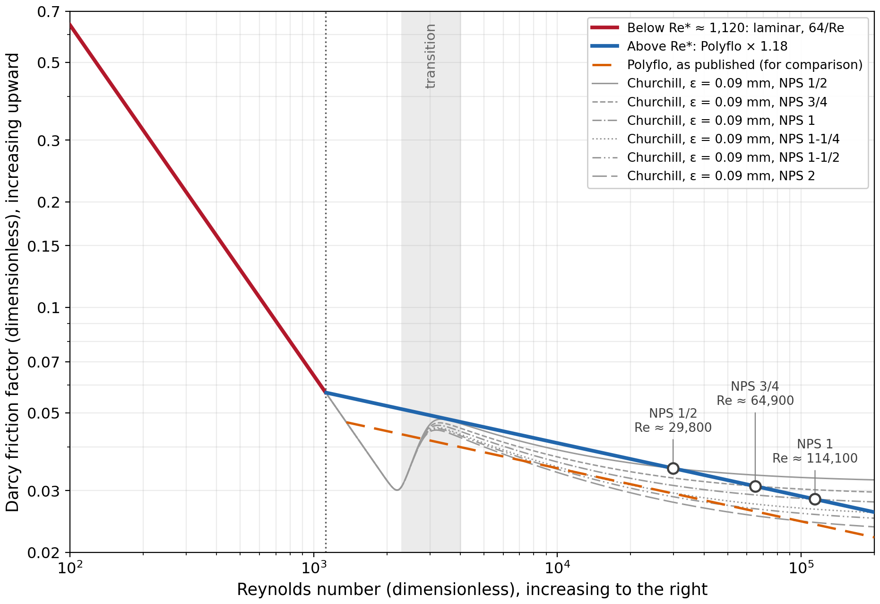
Figure 20 – Option B sizing law for non-corrugated pipe against the GFE-Churchill reference: the laminar line f = 64/Re below Re* ≈ 1,120 and the Polyflo line shifted upward by 1.18 above it, with the published Polyflo line for comparison. Gray curves: Churchill at ε = 0.09 mm for NPS ½ to NPS 2. Open circles mark where a Churchill curve rises above the shifted line. Reynolds numbers up to 2 × 10⁵.
Over every hydrogen cell of Tables A.1 to A.5 for runs of 30 ft (9 m) and longer, Option B is conservative against GFE-Churchill for NPS ½ to NPS 2 steel at any roughness up to 0.09 mm. At the highest Reynolds numbers a Churchill curve at 0.09 mm can still rise above the shifted line, from Re ≈ 29,800 for NPS ½, 64,900 for NPS ¾ and 114,000 for NPS 1 (Figure 20), but no hydrogen cell of these sizes reaches that point: their highest Reynolds numbers are about 26,000, 41,700 and 62,400 (Table C.2). Option B is also conservative for copper tubing from ¼ in. (7.7 mm inside diameter) upward and for smooth plastic pipe, up to Re = 2 × 10⁵.
Its limits have to be stated with it. It does not cover pipe rougher than ε = 0.09 mm, and it does not cover CSST, whose friction factors of about 0.1 to 0.3 are several times the smooth-pipe line (§3.5.2). It is proposed for hydrogen only: natural-gas cells at the elevated-pressure schedules reach Reynolds numbers above the limits given for ε = 0.09 mm.
Two options therefore follow from this work. The first keeps the sizing equation as published above Re = 1,361 and uses the laminar friction factor, 64/Re, below it. By calculation it can give up to about 6% more capacity than Moody friction near the transition, at Re ≈ 3,000 to 5,000, for commercial steel at 0.045 mm roughness; how far this academic finding holds in practice is for CSA to judge, given the service record of the current method. The second raises the Polyflo line by a factor of 1.18 from Re* ≈ 1,120, where it meets 64/Re. This gives a single law that is conservative relative to Moody friction for steel up to 0.09 mm roughness over every hydrogen cell of Tables A.1 to A.5, and for copper and plastic tubing. Neither option needs a roughness value to obtain the capacity, so either is as simple to apply as the current sizing method for natural gas. Neither applies to CSST, for which §3.8 sets out the testing needed.

Design Values
Two design values go with either option. The reference roughness for new commercial steel is ε = 0.045 mm, and Option B is checked up to 0.09 mm. The higher heating value is the default basis, as in the codes, with a check on the lower heating value where an appliance is rated on that basis. No velocity limit is set. None of the codes has one for natural gas, the 20 and 40 m/s values used for U.K. distribution mains address dust rather than any property of hydrogen (§3.4.3), and no hydrogen-specific value has yet been established; the velocities that go with the hydrogen range are given in Table 20 and Appendix C instead.

Model Validation and Recommendations for Laboratory Testing
The CFD model of §2.3 is run on the EHD 13 profile to test whether the friction trend back-calculated from the measurements in §3.5.2 can be reproduced independently. Figure 21 shows the geometry of the periodic unit cell and the mean velocity field it produces, and Figure 22 compares the friction factors with the measured data on the same diameter basis, D_{eff}.
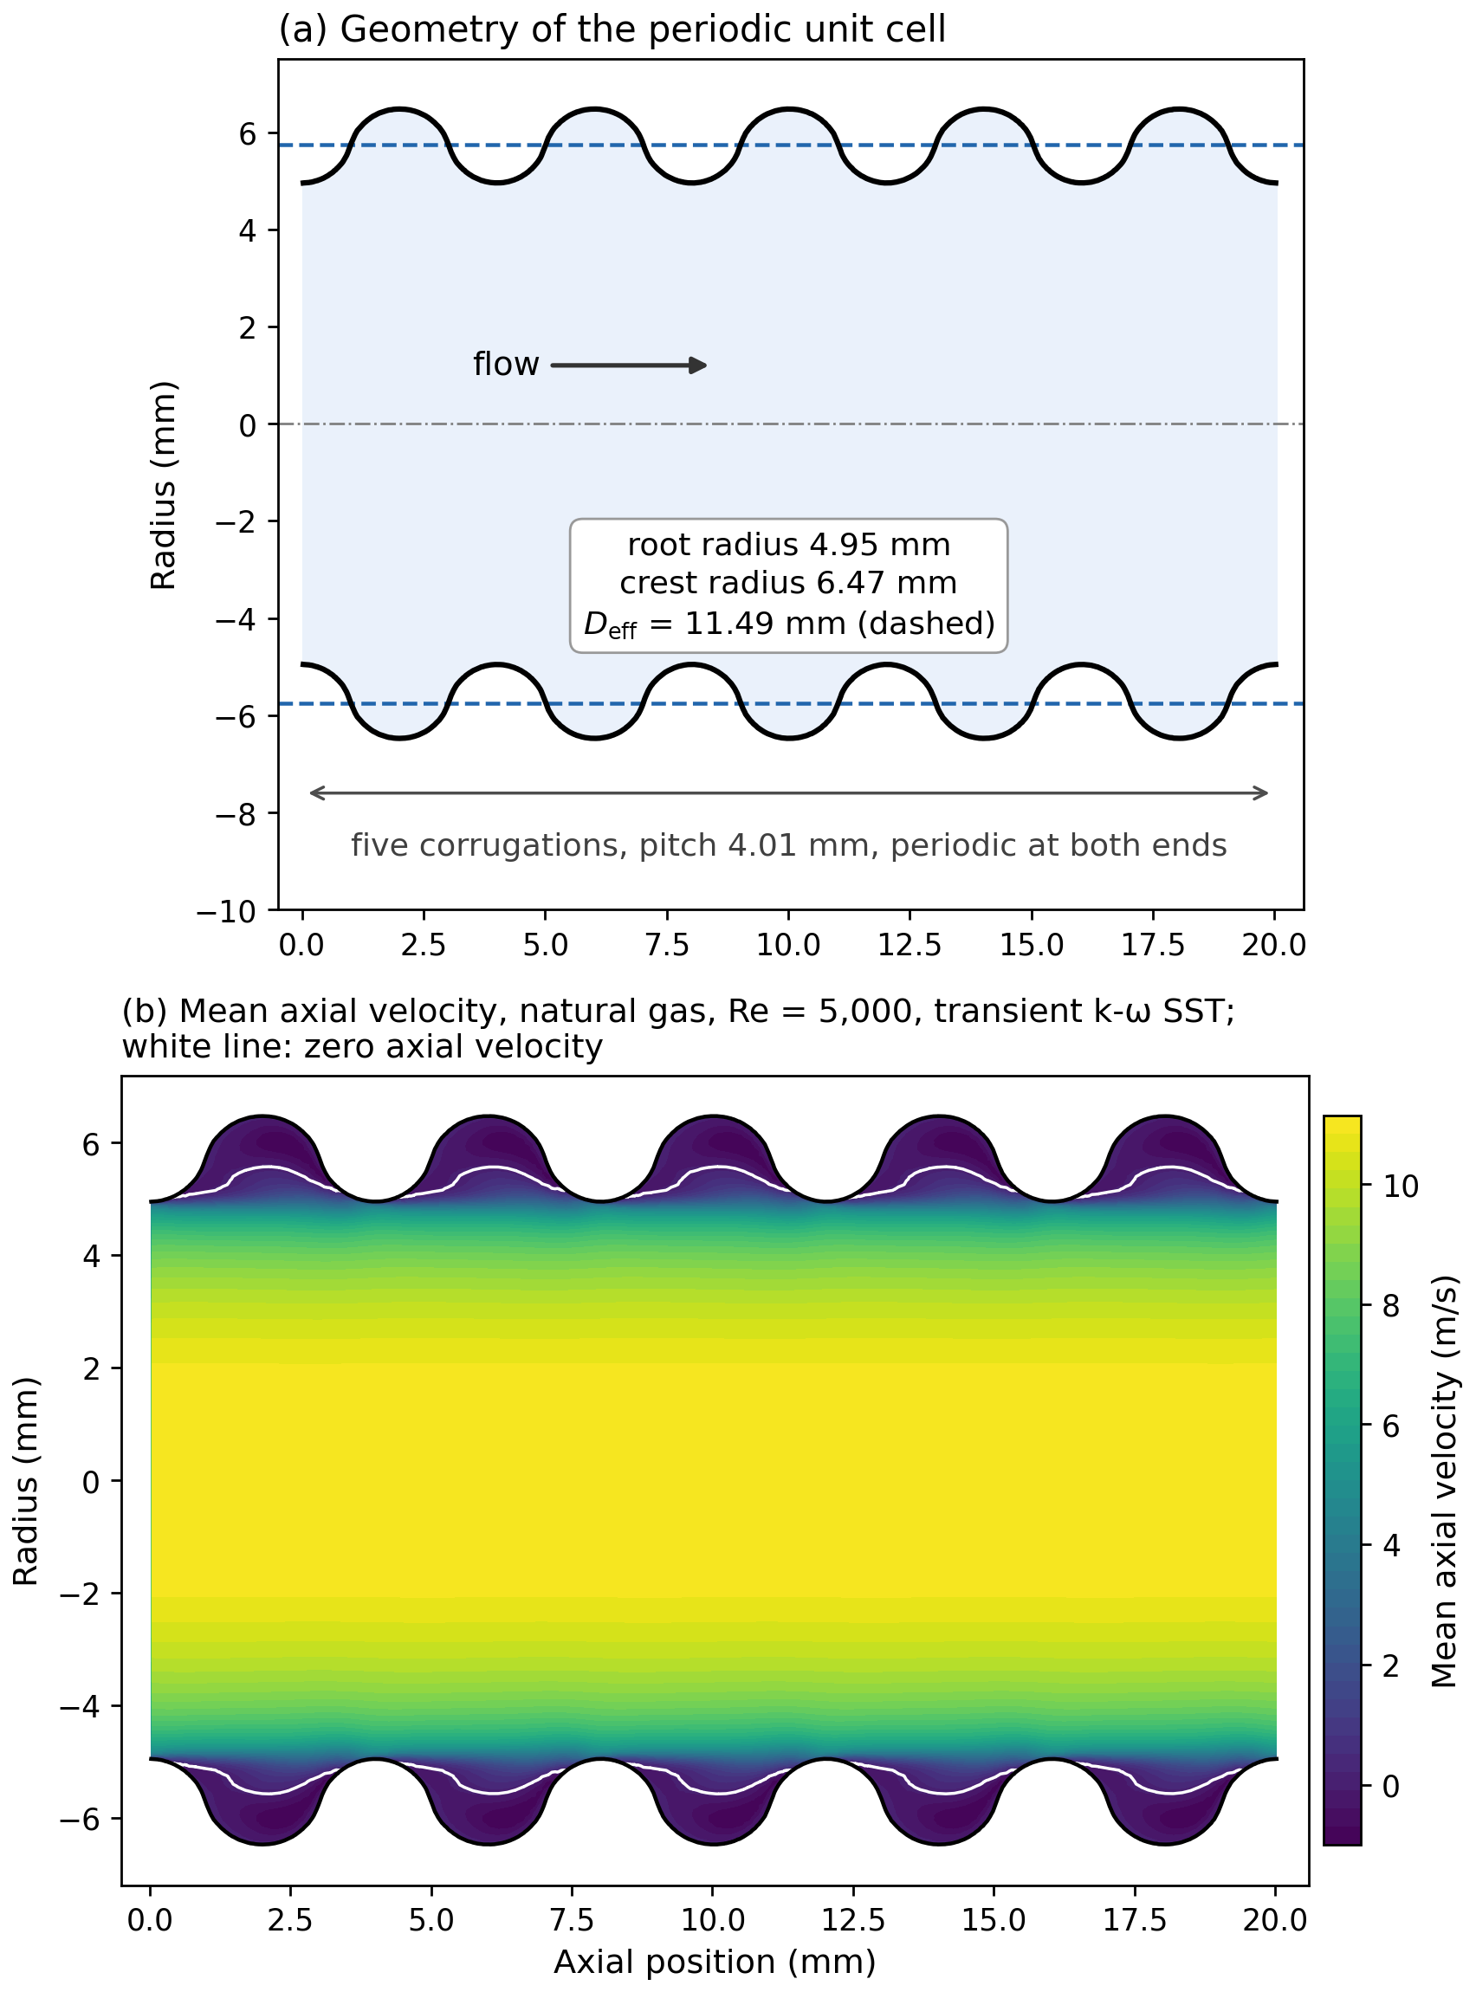
Figure 21 – CFD model of EHD 13: (a) the periodic unit cell of five corrugations, with the root and crest radii and the volume-equivalent diameter D_{eff} = 11.49 mm (dashed); (b) mean axial velocity on a longitudinal section at Re = 5,000, natural gas, transient k-ω SST model. The white line marks zero axial velocity, which bounds the slow recirculating flow in each corrugation groove.
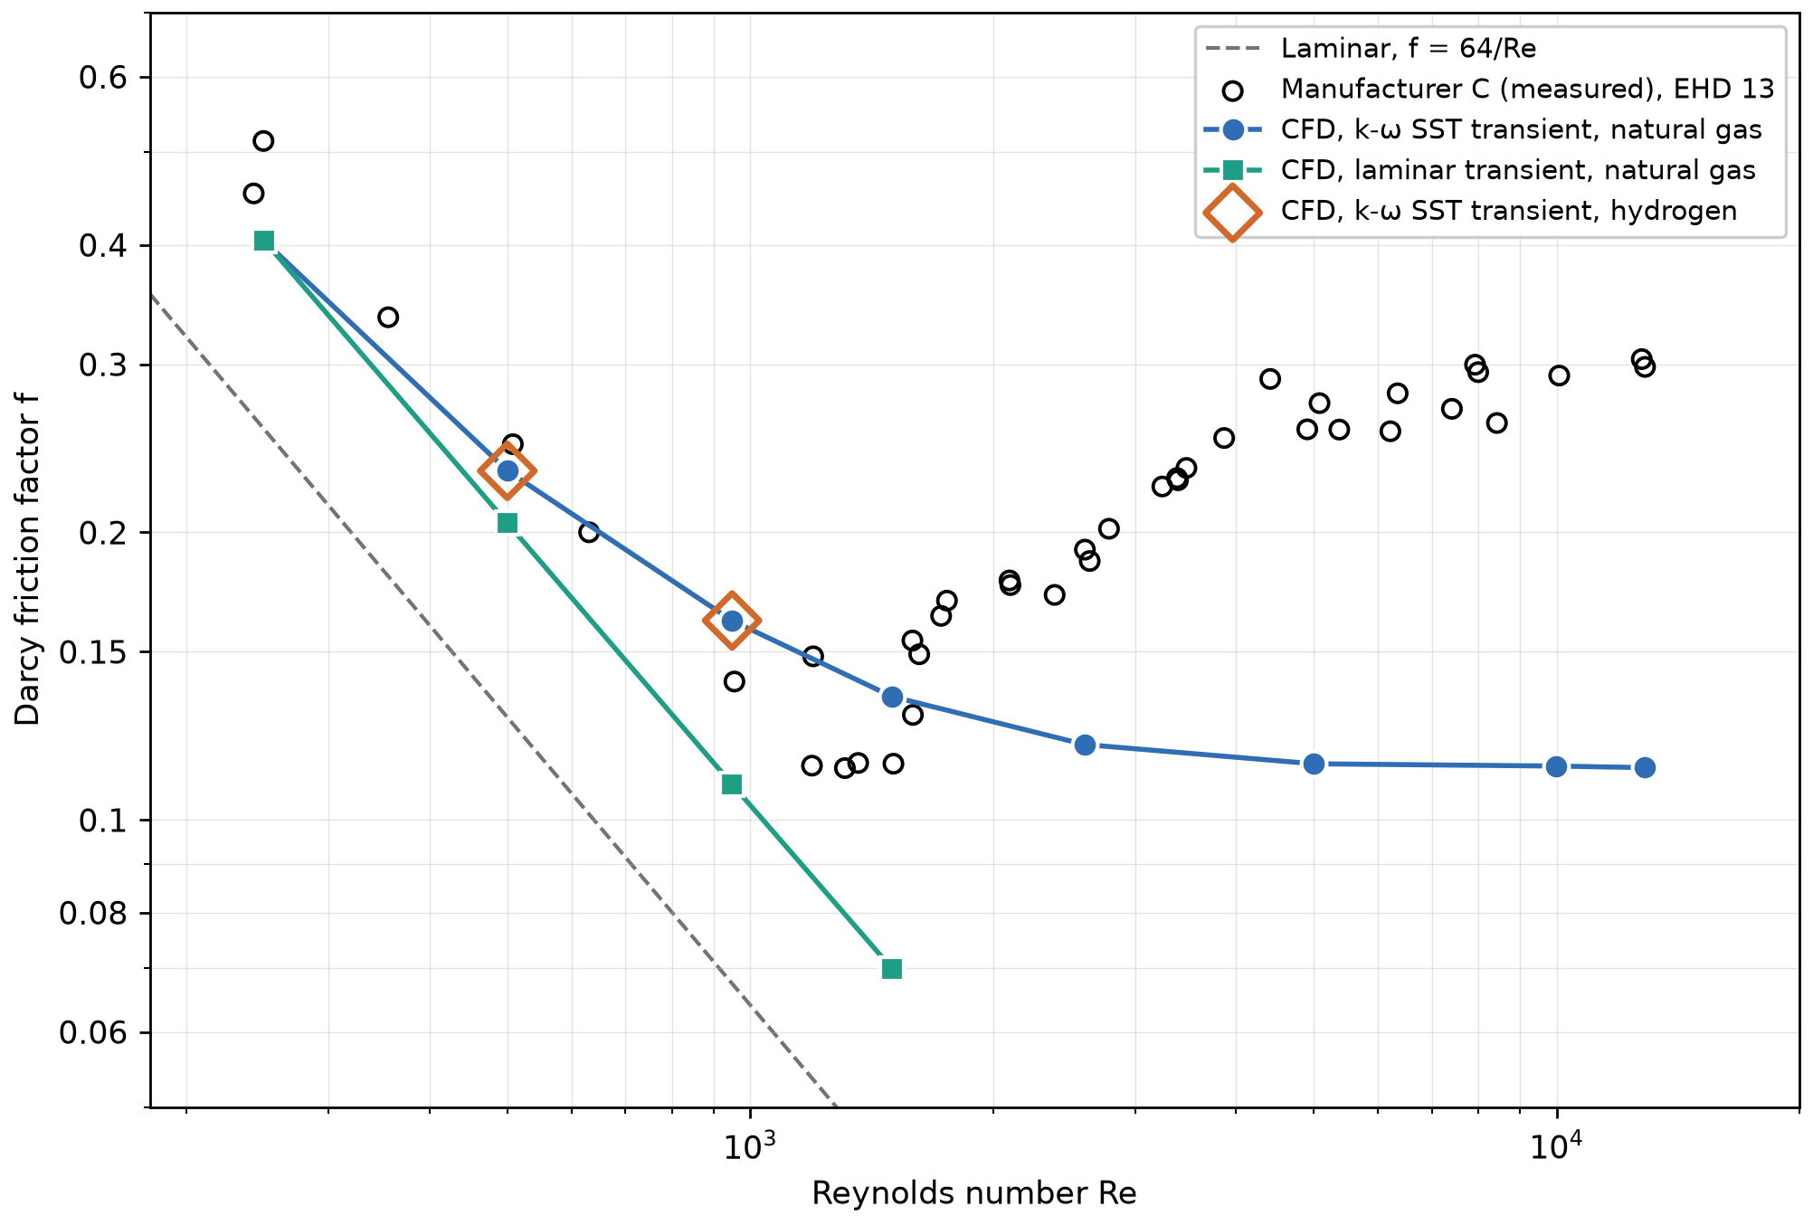
Figure 22 – Darcy friction factor against Reynolds number for EHD 13: Manufacturer C measurement data and the periodic CFD model (transient k-ω SST for natural gas and hydrogen, laminar model for natural gas), all on the volume-equivalent diameter D_{eff} = 11.49 mm. The laminar line f = 64/Re is shown for reference.
The k-ω SST results follow the measured data from Re = 250 to about 950, within about 20%, and reproduce their steep fall toward the laminar line. Hydrogen and natural gas give the same friction factor at matched Reynolds number, within 0.03% at Re = 500 and 950, which supports the gas independence assumed throughout §3.5. The laminar model agrees with k-ω SST at Re = 250 but falls below both it and the measurements from Re = 500. Above Re ≈ 1,500 the CFD no longer follows the measurements: the measured friction factor passes through a minimum near Re = 1,200 to 1,500 and then rises and begins to settle onto a plateau of about 0.28. The CFD results monotonically decrease, and level off at f ≈ 0.11 and stays there up to Re ≈ 12,900.
The trend of friction factor against Reynolds number measured for the CSST is therefore not reproduced by the CFD, and testing is required to confirm it. The tests below are designed for that purpose.

Critical Tests for Domestic-Scale Piping
Six tests are proposed, listed in Table 23. The first is the core of the program: it tests whether CSST friction depends only on the Reynolds number, which is the assumption that would allow hydrogen capacities to be derived from tests with helium and nitrogen, without hydrogen in the laboratory. The steel test checks the laminar law and the transition behavior on which the two sizing options of §3.7.3 differ, and the remaining tests supply what a hydrogen EHD rating and a hydrogen installation need beyond the friction factor.
Test | Specimen | Gas | What the test settles
T1 CSST friction against Re | Manufacturer C tubing, EHD 13, 18, 23 and 31, as tested in 1996 | Helium for the low-Re range; nitrogen for the high-Re range; overlap between the two | Whether CSST friction depends on Re only; the friction curve over the hydrogen range
T2 Repeat of the 1996 conditions | Same tubing as T1 | Natural gas, as in 1996 | Verifies the historical data and settles the suspect ¾ in. test row
T3 Steel confirmation | Schedule 40 steel, NPS ½, ¾ and 1 | Helium at low Re; nitrogen at high Re | The laminar law, the crossing at Re = 1,361, the size of the transition hump and the pipe roughness
T4 Hydrogen EHD reference capacities | CSST, EHD 13 to 31, at the LC 1 test lengths with four 90° bends and two end fittings | Helium; hydrogen capacities computed from the T1 friction curve | The reference capacities of a hydrogen EHD classification table
T5 Fitting losses | Elbows, tees and valves of NPS ½ to 1; CSST end fittings | Helium and nitrogen | Whether the fitting allowance used for natural gas holds at the Reynolds numbers of hydrogen
T6 Acoustic | CSST and steel runs with fittings | Helium | Fitting noise and the onset of CSST whistling against velocity (§3.4.4, §3.4.6), as the basis for any velocity limit for hydrogen
Table 23 – Proposed laboratory tests for domestic-scale piping.
Test T1 uses two gases because no single gas covers the whole range at moderate velocities. Helium, whose kinematic viscosity of about 1.1 × 10⁻⁴ m²/s is close to that of hydrogen, 1.0 × 10⁻⁴ m²/s, reaches the Reynolds numbers of hydrogen at the velocities hydrogen itself would have, while nitrogen, with a kinematic viscosity about eight times lower, reaches the upper end of the range at modest velocities. The two are run over a common band of Reynolds numbers, and the test passes if their friction curves agree there within the combined uncertainty. A pass means friction depends only on the Reynolds number, and hydrogen capacities can then be computed from the measured curve. Running the same EHD 13, 18, 23 and 31 tubing as the 1996 test ties the new data to the existing measurements, and test T2 checks those measurements directly.
Test T3 covers steel from the laminar range through the transition up to Re = 20,000, beyond which the turbulent friction of steel pipe is well established, with closely spaced points between Re = 1,000 and 5,000. It checks the laminar law and the crossing at Re = 1,361, and measures the size of the transition hump directly, which is where the two sizing options of §3.7.3 differ. The pipe roughness is fitted from the highest-Reynolds points and can be cross-checked with a profilometer.
Tests T4 to T6 follow from the first three. T4 repeats the LC 1 test lengths and conditions, including the allowance for four bends and two end fittings, so that a hydrogen CSST standard can carry a table of EHD reference capacities that any CSST intended for hydrogen would have to meet or exceed to be granted that EHD rating. T5 measures fitting losses at the Reynolds numbers hydrogen occupies, to check whether the fitting allowance used for natural gas also holds for hydrogen. T6 measures fitting noise and the onset of CSST whistling against velocity. No velocity limit has been established for hydrogen in domestic piping, and the values in use for natural-gas mains address dust rather than noise (§3.4.3), so T6 provides the data on which such a limit could be based.

Measurement Parameters and Acceptance Criteria
Each flow test measures the same core quantities: the differential pressure between taps, the volumetric flow rate at standard conditions, the inlet absolute pressure, the gas temperature and the gas purity, together with the tap spacing, the developed length upstream of the first tap and the inside diameter. The low-pressure schedules call for differential pressures of the order of 125 Pa, so a low-range transducer is needed alongside a high-range one. The friction factor is back-calculated with Equation (13), as for the Manufacturer C data in §3.5.2, and the Reynolds number follows from Re = ρvD/μ (§3.1.3), with the mean velocity v = 4Q/(πD²) taken at the mean pressure between the taps. Written in the measured quantities, Equation (13) gives f ∝ ΔP·D⁵/(ρ·L·Q²), so for independent errors the relative uncertainty in f is
uff=uρρ2+uΔPΔP2+5·uDD2+uLL2+2·uQQ21/2 (19)
where ρ is the gas density at the mean pressure between the taps, ΔP the differential pressure over the tap spacing L, Q the volumetric flow rate at the mean pressure and D the inside diameter. The diameter enters to the fifth power, so a 1% error in D alone gives a 5% error in f. The inside diameter of each steel specimen is therefore taken from the pipe dimensions and checked with a caliper or bore gauge at the specimen ends, and for CSST D_{eff} follows from the manufacturer's inside diameter and profile data, as in §3.5.2. Table 24 sets out the proposed acceptance criteria.
Criterion | Proposed acceptance value | Tests
Laminar friction factor | Within ±5% of 64/Re | T1, T3
Turbulent friction factor, steel | Within ±5% of Churchill with the fitted roughness | T3
Gas independence, CSST | The two gases' friction curves agree within their combined uncertainty over the overlap band | T1
Repeatability | Within 2% on repeated points | T1 to T5
Uncertainty in f | Within ±5% at 95% confidence (Equation (19)) | T1 to T5
Developed flow | Linear pressure gradient along at least three tap stations | T1, T3, T5
Incompressible conditions | Pressure drop between the outer taps below 10% of the absolute inlet pressure; Mach number below 0.3 | T1 to T6
Table 24 – Proposed acceptance criteria for the laboratory tests. All values are proposed and are to be confirmed with the testing laboratory.

Prioritized Test Matrix and Instrumentation
Table 25 orders the tests by priority, and Appendix D gives the full test matrix, with one row for each measurement point and the specimen, size, run length or tap spacing, gas, target Reynolds number, pressures, flow rate and velocity of each. Priority 1 is the CSST friction test and the repeat of the 1996 conditions at EHD 13 and 18, the two smallest sizes, where hydrogen moves the largest share of test conditions below Re = 2,300. Priority 2 is the same two tests at EHD 23 and 31, the steel confirmation and the hydrogen EHD reference capacities. Priority 3 covers fittings and acoustics.
Priority | Test | Specimen | Gas | Re range | Pressures | Points in Table D.3
1, then 2 | T1 | EHD 13 and 18, then 23 and 31 | He; N₂ | 250 to 25,000; overlap 1,000 to 5,000 | Outlet at atmospheric pressure; inlet up to about 19 kPa gauge | 71
1, then 2 | T2 | EHD 13 and 18, then 23 and 31 | NG | As in 1996 | 0.25 to 5 psig inlet; 0.5 to 96.9 in. w.c. drop | 140
2 | T3 | Steel NPS ½, ¾ and 1 | He; N₂ | 750 to 20,000; dense from 1,000 to 5,000 | Outlet at atmospheric pressure | 45
2 | T4 | EHD 13 to 31 at the LC 1 lengths | He | Set by the LC 1 conditions | 0.5 psig / 0.5 in. w.c.; 2.0 / 1.5 psi; 5.0 / 3.5 psi | 84
3 | T5 | Fittings NPS ½ to 1; CSST end fittings | He; N₂ | 1,000 to 20,000 | Outlet at atmospheric pressure | 64
3 | T6 | CSST and steel runs with fittings | He | Velocity 20 to 150 m/s | Outlet at atmospheric pressure | 38
Table 25 – Prioritized test program. Values are proposed; Appendix D gives the full test matrix and the detailed specifications.
The instrumentation follows from the quantities of §3.8.2. Appendix D states the range and the uncertainty each measurement needs and leaves the choice of instrument to the testing laboratory, which can then use equipment it already holds, calibrated for helium, nitrogen and natural gas.
The program is to be run by CSA and its partner laboratories, which hold the flow-test facilities it needs, with CSA owning the hydrogen reference capacities that result, since those capacities would become the reference for hydrogen EHD ratings under a new standard for sizing CSST to be used with hydrogen.

Integrated Gap Analysis and Recommendations
This chapter draws the results of Chapter 3 together. It sets out the chain of findings from the sizing equation to the recommended sizing options (§4.1), lists the gaps between the current standards and hydrogen service (§4.2), and closes with recommendations for each standard (§4.3).

Integrated Analysis
The three installation codes size non-corrugated pipe with the Polyflo equation, and this study shows that Polyflo is the General Flow Equation with one friction law hidden in its three published constants: f = 0.140370·Re^{−0.151571} (§3.5.1). Every published table in CSA B149.1:25 can be reproduced from that law, and the equation can be evaluated for any gas by entering its relative density and viscosity.
Compared with Moody friction, represented by the Churchill correlation, Polyflo stays close only between about Re = 4,000 and 10,000, where it is within ±5% (§3.5.3). Below Re = 1,361 it lies under the laminar line and gives a higher capacity than Moody friction, by 33% on average in the cells of the lowest natural-gas schedule that lie below it. Between Re = 1,361 and about 2,800 it is conservative, just above the transition it gives up to about 6% more capacity, and at Reynolds numbers of order 10⁵ it falls below the Churchill curves of the smaller and rougher pipes. Because the deviation depends only on the Reynolds number and the pipe roughness, it applies to hydrogen exactly as it does to natural gas.
Hydrogen runs at about half the Reynolds number of natural gas at equal energy delivery, so more of its cells fall in the region where Polyflo deviates most from Moody friction. At the low-pressure schedule of Table A.1, 41.8% of hydrogen cells are laminar against 20.3% for natural gas, and the RMS deviation from the reference rises from 15.6% to 28.5% (Tables 9 and 16). At the low-pressure schedules of Tables A.1 and A.2, hydrogen reaches at most Re ≈ 16,000 and 31 m/s (103 ft/s) in runs of 30 ft (9 m) and longer, and in CSST at the measured conditions about Re ≈ 23,000 and 80 m/s (262 ft/s). Only short runs of the larger sizes at the elevated-pressure schedules go further, up to Re ≈ 1.9 × 10⁵ and about 300 m/s (980 ft/s) for 30 ft of NPS 2 at the schedule of Table A.5 (§3.7.1). The laminar and transitional regions therefore dominate for hydrogen, and where hydrogen reaches the high-Reynolds band, Polyflo stays within about 1% of Moody friction for new commercial steel (§3.7.2). None of the codes limit velocity, and no hydrogen-specific limit has yet been set.
The remedy follows directly. Using 64/Re below Re = 1,361 and Polyflo as published above it removes the largest deviation from Moody friction and leaves, by calculation, up to about 6% near the transition (Option A). Where full conservatism relative to Moody friction is wanted, raising the Polyflo line by a factor of 1.18 removes that too, for steel, copper and plastic pipe, without a roughness value (Option B, §3.7.3).
CSST is a different case. No sizing equation exists for it, its published capacities are fitted certification curves, and its friction is dominated by form drag at the corrugations rather than by wall roughness (§3.5.2). The measured natural-gas data show a laminar branch joined to a size-dependent plateau, but the CFD of §3.8 reproduces only the laminar branch, so the trend is not confirmed by an independent method and no hydrogen closure can be proposed.
The operating effects discussed in §3.4 complete the picture. At equal energy input hydrogen raises the pressure drop by about 11 to 26% before friction changes (§3.4.2), raises fitting noise by 5 to 7 dB (§3.4.4) and raises in-pipe velocity about threefold (§3.4.1). A one-step pipe upsize brings all three back to or below the natural-gas baseline (§3.4.7), while raising the supply pressure removes the noise increase within the 5-psig indoor cap of the U.S. codes [33], [34] only on the HHV basis (§3.4.5).

Identified Gaps and Misalignments
Table 26 lists the gaps and misalignments between the current standards and 100% hydrogen domestic service, with the consequence of each and the part of this report that addresses it.
Gap | Standard and clause | Consequence for hydrogen | What closes it
Relative-density multipliers stop at S = 0.35 | CSA B149.1:25 Clause 6.3.6, Annex A.2.6, Table A.15 | The next-higher rule gives hydrogen (S = 0.0696) a multiplier of 1.31 against 2.94 from the table's own relationship, with no viscosity term | Direct substitution of hydrogen's S and μ (§3.5.1); hydrogen annex (§4.3)
Gas at S ≤ 0.70 may be sized from the natural-gas tables | NFPA 54 Annex B.3.4; IFGC Appendix A102.4 | Hydrogen is sent to the natural-gas tables unmodified | Outside the CSA Group standards (§3.3)
Polyflo is published without a derivation and has no laminar branch | CSA B149.1:25 Annex A.3.5; IFGC §402.4; NFPA 54 §6.4 | Capacity above that of laminar flow below Re = 1,361, where 47% of hydrogen cells lie at the schedule of Table A.1 (NPS ½ to 2) | Laminar branch with Option A or B (§3.7.3)
No hydrogen pressure-drop data at domestic sizes | None of the four documents; pilot programs cover blends or report no hydraulic data (§3.2) | Hydrogen sizing tables cannot be checked against measurement | Tests T1, T3 and T4 (§3.8)
No velocity limit | CSA B149.1:25 Clause 6.3 and Annex A; IFGC §402; NFPA 54 Chapter 6 (Appendix A, row 15) | Hydrogen reaches about 80 m/s in CSST and up to about 300 m/s in short steel runs at the elevated-pressure schedules; noise at these velocities is not quantified | Test T6 (§3.8)
5 psig indoor pressure cap | IFGC §402.7; NFPA 54 §5.5.1 | Raising supply pressure offsets the hydrogen noise increase only on the HHV basis (4.5 psig); the LHV basis needs 6.1 psig | One-step upsizing (§3.4.7)
Hydrogen excluded as a fuel; acceptance tables only for S = 0.60 | CSA/ANSI LC 1:23 Clauses 1.6 and 3; Tables 1 a) to 1 c) | No reference exists against which a CSST product could be rated for hydrogen | Hydrogen EHD reference capacities set by CSA from tests T1 and T4 (§3.8)
EHD 62 rating anomaly | CSA/ANSI LC 1:23 Clause 5.10.3.2 | The published EHD 62 capacity meets only the EHD 48 threshold (§3.6.1) | Enforce the capacity-floor rule of Clause 5.10.3.2
Gas dependence of CSST friction untested | CSA/ANSI LC 1:23 (not addressed) | Hydrogen capacities cannot be derived from natural-gas, nitrogen or helium tests until friction is shown to depend on Re alone | Test T1 (§3.8)
Table 26 – Gaps and misalignments between the current standards and 100% hydrogen domestic service.

Recommendations for Standards Development
The existing sizing equation can be retained for hydrogen with one change: below Re = 1,361, where it crosses the laminar line, capacities come from the laminar law f = 64/Re. Above that point the equation is used as published. Compared with Moody friction this leaves a small region near the transition, up to about 6% in capacity for commercial steel, where the equation gives more capacity, although this may not be non-conservative in practice, since the current method has been used for decades with the conservatism built into it. If CSA wants the law to be conservative over Moody friction everywhere, the alternative is to use 64/Re below Re* ≈ 1,120 and reduce every capacity above it by a single factor of 0.914. This works for steel, copper and plastic pipe without needing to know the pipe roughness value.
The recommendations for each CSA Group document are as follows.
- CSA B149.1: add a hydrogen annex that carries the laminar branch, with capacities from either option of §3.7.3, and state that the multipliers of Table A.15 do not apply to hydrogen.
- CSA/ANSI LC 1: set hydrogen EHD reference capacities through the tests of §3.8, with CSA owning the reference values; enforce the capacity-floor rule of Clause 5.10.3.2; and keep hydrogen outside the fuel-gas definition until those capacities exist. Neither sizing option applies to CSST.

Conclusions
The study leads to seven findings.
- The Polyflo equation used by CSA B149.1, the IFGC and NFPA 54 is the General Flow Equation with a single friction law, f = 0.140370·Re^{−0.151571}, hidden in its three published constants. The deviation of this law from Moody friction depends only on the Reynolds number and the pipe roughness, not on the gas, so the deviation found for natural gas applies to hydrogen unchanged.
- Hydrogen runs at about half the Reynolds number of natural gas at equal energy delivery, which pushes the low-pressure cells into the laminar region, where Polyflo gives a higher capacity than Moody friction.
- Using 64/Re below Re = 1,361 removes the largest deviation from Moody friction. What remains is, by calculation, up to about 6% in capacity near the transition. A single upward shift of the Polyflo line by a factor of 1.18 removes that too, for steel, copper and plastic pipe, without needing a roughness value.
- Hydrogen Reynolds numbers stay below about 2 × 10⁴ at the low-pressure schedules and in CSST, at velocities up to about 80 m/s. Short runs of the larger steel sizes at the elevated-pressure schedules reach Re ≈ 1.9 × 10⁵ and about 300 m/s, where Polyflo remains within about 1% of Moody friction for new commercial steel. No velocity limit exists for hydrogen in domestic piping.
- The existing natural-gas data from CSST Manufacturer C, back-calculated to a friction trend, and the CFD model tried here did not lead to a sizing equation or closure for CSST. Flow measurements are needed to establish one.
- No public measurements of hydrogen flow in domestic piping were found. The proposed test program uses helium, nitrogen and natural gas, and relies on friction depending only on the Reynolds number to carry the results over to hydrogen.
- The test program of §3.8 would confirm the laminar branch and the size of the transition hump for steel, establish whether CSST friction depends only on the Reynolds number, and give CSA the reference capacities a hydrogen EHD rating needs.

References
References follow the IEEE style with in-text citations numbered sequentially in square brackets, ordered by first appearance. Where possible, DOIs or URLs are provided.
[1] National Institute of Standards and Technology, "NIST Chemistry WebBook — thermophysical properties of fluid systems," U.S. Dept. of Commerce, Gaithersburg, MD, USA. [Online]. Available: https://webbook.nist.gov/chemistry/fluid/.
[2] J. W. Leachman, R. T. Jacobsen, S. G. Penoncello, and E. W. Lemmon, "Fundamental equations of state for parahydrogen, normal hydrogen, and orthohydrogen," J. Phys. Chem. Ref. Data, vol. 38, no. 3, pp. 721–748, 2009, doi: 10.1063/1.3160306.
[3] E. W. Lemmon, M. L. Huber, and M. O. McLinden, NIST Reference Fluid Thermodynamic and Transport Properties Database (REFPROP), Version 10.0, NIST Standard Reference Database 23, National Institute of Standards and Technology, Gaithersburg, MD, USA, 2018. [Online]. Available: https://www.nist.gov/srd/refprop.
[4] International Organization for Standardization, ISO/TR 15916:2015 Basic considerations for the safety of hydrogen systems. Geneva, Switzerland: ISO, 2015. [Online]. Available: https://www.iso.org/standard/56546.html.
[5] Pacific Northwest National Laboratory, "H2Tools — comparative properties of hydrogen and other fuels," [Online]. Available: https://h2tools.org/hyarc/hydrogen-data/comparative-properties-hydrogen-and-other-fuels.
[6] Kiwa N.V., "The properties of hydrogen," Kiwa Technology, Apeldoorn, Netherlands. [Online]. Available: https://www.kiwa.com/globalassets/netherlands/nieuws/documenten/infographic-properties-of-hydrogen.pdf.
[7] HyDeploy Consortium, "HyDeploy final report," Cadent Gas / Northern Gas Networks, U.K., 2018. [Online]. Available: https://hydeploy.co.uk/app/uploads/2018/02/21935_CADENT_HYDEPLOY_REPORT_v3.pdf.
[8] HyDeploy2 Consortium, "HyDeploy2 Winlaton final report," Cadent Gas / Northern Gas Networks, U.K., 2022.
[9] Arup, Progressive Energy, and Kiwa Gastec, "Hy4Heat — final report," U.K. BEIS, 2021. [Online]. Available: https://static1.squarespace.com/static/5b8eae345cfd799896a803f4/t/626aa96961a39b380f82717d/1651157358782/Final+Final+Report.pdf.
[10] Northern Gas Networks, "H21 — North of England and Teesside reports," U.K., 2018 and 2024. [Online]. Available: https://h21.green.
[11] Australian Hydrogen Centre, "100% hydrogen distribution networks: Victoria feasibility study," Australian Renewable Energy Agency, Australia, 2023. [Online]. Available: https://arena.gov.au/assets/2023/09/AHC-100-Hydrogen-Distribution-Networks-Victoria-Feasibility-Study.pdf.
[12] Australian Hydrogen Centre, "100% hydrogen distribution networks: South Australia feasibility study," Australian Renewable Energy Agency, Australia, 2023.
[13] Australian Hydrogen Centre, "10% hydrogen distribution networks: Victoria feasibility study," Australian Renewable Energy Agency, Australia, 2023.
[14] Australian Hydrogen Centre, "10% hydrogen distribution networks: South Australia feasibility study," Australian Renewable Energy Agency, Australia, 2023.
[15] HyDelta Consortium, "HyDelta Phase 1, 2, and 3 reports," TKI New Gas / DNV / Kiwa, Netherlands, 2020–2024. [Online]. Available: https://reports.hydelta.nl/technology-safety.
[16] Energie Südbayern and Bayernets, "H2Direkt project — Hohenwart hydrogen distribution loop summary," Germany, 2024.
[17] KU Leuven and WaterstofNet, "Hydrogen use in buildings — BatHyBuild project," KU Leuven, Belgium, 29 Apr. 2021. [Online]. Available: https://www.kuleuven.be/.
[18] THyGA Consortium, "Testing hydrogen admixture for gas applications — consolidated results," Engie Laborelec, EU, 2023.
[19] National Renewable Energy Laboratory and Sandia National Laboratories, "HyBlend and BlendPATH publications," NREL/TP-6A50 series, Golden, CO, USA, 2022–2024.
[20] ATCO Gas, "Fort Saskatchewan hydrogen home project," Alberta, Canada, 2022–2024.
[21] Enbridge Gas Inc., "Markham power-to-gas facility," Ontario, Canada, 2018–present.
[22] Southern California Gas Company, "[H2] Home demonstration project," California, USA, 2022–present.
[23] New York State Energy Research and Development Authority, "HyGrid — hydrogen injection into natural gas distribution," New York, USA, 2023–present.
[24] M. J. Lighthill, "On sound generated aerodynamically. I. General theory," Proc. Roy. Soc. London A, vol. 211, no. 1107, pp. 564–587, 1952, doi: 10.1098/rspa.1952.0060.
[25] M. P. Norton and D. G. Karczub, Fundamentals of Noise and Vibration Analysis for Engineers, 2nd ed. Cambridge, U.K.: Cambridge Univ. Press, 2003.
[26] M. E. Goldstein, Aeroacoustics. New York, NY, USA: McGraw-Hill, 1976.
[27] Verein Deutscher Ingenieure, VDI 3733:1996 Noise at pipes. Düsseldorf, Germany: VDI, 1996.
[28] L. F. Moody, "Friction factors for pipe flow," Trans. ASME, vol. 66, pp. 671–684, 1944.
[29] C. F. Colebrook, "Turbulent flow in pipes, with particular reference to the transition region between the smooth and rough pipe laws," J. Inst. Civ. Eng., vol. 11, no. 4, pp. 133–156, 1939, doi: 10.1680/ijoti.1939.13150.
[30] I. E. Idelchik, Handbook of Hydraulic Resistance, 4th ed. Mumbai, India: Begell House / Jaico, 2007.
[31] Omega Flex, Gastite, Titeflex, and Pro-Flex CSST manufacturer technical bulletins, "CSST capacity tables and whistling guidance," various editions, 2018–2025.
[32] CSA Group, CSA B149.1:25 Natural gas and propane installation code (amendments for hydrogen–natural-gas blends). Toronto, ON, Canada: CSA Group, 2025.
[33] International Code Council, International Fuel Gas Code 2021. Country Club Hills, IL, USA: ICC, 2021.
[34] National Fire Protection Association, NFPA 54-2015 National Fuel Gas Code. Quincy, MA, USA: NFPA, 2015.
[35] CSA Group, CSA/ANSI LC 1:23 / CSA 6.26:23 Fuel gas piping systems using corrugated stainless steel tubing. Toronto, ON, Canada: CSA Group, 2023.
[36] Bureau de normalisation du Québec, CAN/BNQ 1784-000:2022 Canadian hydrogen installation code. Québec, QC, Canada: BNQ, 2022. [Online]. Available: https://www.scc.ca/standardsdb/standards/4031502.
[37] American Society of Mechanical Engineers, ASME B31.12-2023 Hydrogen Piping and Pipelines. New York, NY, USA: ASME, 2023.
[38] C. San Marchi and B. P. Somerday, "Technical reference on hydrogen compatibility of materials," Sandia National Laboratories, Livermore, CA, USA, Rep. SAND2021-12478, 2021. [Online]. Available: https://www.sandia.gov/matlstechref/.
[39] B. C. Shebeko, Polyflo Flow Computer. Tulsa, OK, USA: Polyflo Pipeline Engineering, 1974.
[40] S. W. Churchill, “Friction-factor equation spans all fluid-flow regimes,” Chemical Engineering, vol. 84, no. 24, pp. 91–92, 1977.
[41] E. S. Menon, Gas Pipeline Hydraulics. Boca Raton, FL, USA: CRC Press, 2005.
[42] CSA Group, CSA Z662:23 Oil and gas pipeline systems. Toronto, ON, Canada: CSA Group, 2023.
[43] Deutscher Verein des Gas- und Wasserfaches, DVGW G 655 (M) Leitfaden H2-Ready Gasanwendung [Guideline for H2-ready gas applications]. Bonn, Germany: DVGW, 2025.
[44] Deutscher Verein des Gas- und Wasserfaches, DVGW G 260 (A) Gasbeschaffenheit [Gas quality]. Bonn, Germany: DVGW, 2021.
[45] Deutscher Verein des Gas- und Wasserfaches, DVGW G 600 (A) Technische Regel für Gasinstallationen, DVGW-TRGI 2018 [Technical rule for gas installations]. Bonn, Germany: DVGW, 2018.
[46] Koninklijk Nederlands Normalisatie-instituut, NEN 1078:2024 Voorziening voor gas met een werkdruk tot en met 500 mbar – Prestatie-eisen – Nieuwbouw [Supply for gas with an operating pressure up to and including 500 mbar – Performance requirements – New construction]. Delft, Netherlands: NEN, 2024.
[47] Koninklijk Nederlands Normalisatie-instituut, NPR 3378-3:2025 Praktijkrichtlijn gasinstallaties – Deel 3: Dimensionering gasleiding voor aardgas, propaan en waterstof met de grafiekmethode [Code of practice for gas installations – Part 3: Dimensioning of gas pipework for natural gas, propane and hydrogen by the graph method]. Delft, Netherlands: NEN, 2025.
[48] Institution of Gas Engineers and Managers, IGEM/H/2 Edition 2 Hydrogen enabling standard – Domestic. Kegworth, U.K.: IGEM, 2024.
[49] Institution of Gas Engineers and Managers, IGEM/UP/1B Edition 4 Tightness testing and direct purging of small liquefied petroleum gas/air, natural gas and liquefied petroleum gas installations. Kegworth, U.K.: IGEM, 2026.
[50] Institution of Gas Engineers and Managers, IGEM/H/3 Edition 2 Hydrogen enabling standard – Non-domestic. Kegworth, U.K.: IGEM, 2024.
[51] European Committee for Standardization, EN 15266:2024 Stainless steel pliable corrugated tubing kits for gas installation pipework with an operating pressure up to 0,2 MPa (2 bar). Brussels, Belgium: CEN, 2024.
[52] Asociación Española de Normalización, UNE-EN 15266:2025 Sistemas de tuberías corrugadas flexibles de acero inoxidable para conducción de gas con una presión en servicio inferior a 0,2 MPa (2 bar). Madrid, Spain: UNE, 2025.
[53] Standards Australia and Standards New Zealand, AS/NZS 5601.1:2022 Gas installations, Part 1: General installations. Sydney, NSW, Australia: Standards Australia, 2022.
[54] European Industrial Gases Association, IGC Doc 121/14 Hydrogen pipeline systems. Brussels, Belgium: EIGA, 2014.
[55] Institution of Gas Engineers and Managers, IGEM/TD/3 Edition 5 Steel and PE pipelines for gas distribution, Communication 1780. Kegworth, U.K.: IGEM, 2015, clause 5.3.5.
[56] SGN and DNV, "Velocity design with hydrogen," Strategic Innovation Fund Discovery project 10027185, Ofgem, U.K., 2022. [Online]. Available: https://smarter.energynetworks.org/projects/10027185/.
- Standards Cross-Reference Matrix
Table A-1 presents the standards cross-reference matrix in full detail. The matrix compares the four core North American documents examined in this study, specifically CSA B149.1:25, IFGC 2021, NFPA 54-2015, and CSA/ANSI LC 1:23 / CSA 6.26:23, on pressure-drop and sizing only. Each row addresses one topic area in pressure-drop and sizing; each cell carries a clause-cited extract or faithful paraphrase from the standard text. Where a cell quotes the standard exactly, the text is enclosed in quotation marks; other cells combine paraphrase, interpretation, and implications with a clause citation back to the source.
Table A-1 – Standards Cross-Reference Matrix: the four core North American documents examined in this study × fifteen topic rows on pressure-drop and sizing provisions. The Hydrogen-implication column states what the cell content means for the development of a 100% hydrogen domestic-sizing equation in this research.
# | Topic area | CSA B149.1:25 | IFGC 2021 | NFPA 54 (2015) | CSA/ANSI LC 1:23 / CSA 6.26:23 | Hydrogen implication
1 | Sizing-equation gateway clause (where in the standard the sizing rules live) | Clause 6.3 "Size". 6.3.2 governs systems ≤ 14 in w.c.; 6.3.3 governs > 14 in w.c. Both reference Annex A (NG / NG-H₂ blends) and Annex B (propane). Sizing tables and the calculation method are in Annex A (informative, written in mandatory language). | Section 402.3 "Sizing": gas piping shall be sized by (1) pipe-sizing tables or sizing equations in §402.4 or §402.5, (2) the manufacturer’s tables for a listed piping system, or (3) engineering methods. Equations 4-1 (low-P) and 4-2 (high-P) are in §402.4. | Section 5.4.3 lists three allowed methods: (1) pipe-sizing tables/equations in Chapter 6, (2) sizing tables in a listed manufacturer’s installation instructions, or (3) other approved engineering methods. Equations are in §6.4; original-form equations are in Annex B.5. | Clause 5.10 "Flow capacity and EHD". The product standard does not host a code-side sizing gateway clause; it sets minimum capacity acceptance criteria (Tables 1 a)–1 c)) that products must meet, and supplies the EHD index used by the installation codes (NFPA 54, IFGC) for system sizing. The manufacturer’s design and installation manual (Annex A) lists "3.2 Sizing methods and examples" as a mandatory subsection. | Three of the four standards (CSA B149.1:25, IFGC 2021 and NFPA 54-2015) put domestic-pipe sizing logic in one central clause referenced to a single gas (NG at SG 0.60). CSA/ANSI LC 1:23 hosts the EHD product-standard layer rather than a code-side sizing gateway. None of the four standards hosts a 100% hydrogen sizing gateway.
2 | Low-pressure sizing equation form: name + as-written equation + constants | Annex A.3.5 "Low pressure [less than 1.5 psig (10.3 kPa)]": Q = K₂ D^{2.623} · [ΔH / (Cr · L · F)]^{0.541} · (b·z). K₂ = 2313 imperial / 0.1509 SI. F = 1.2 (Tables A.1–A.4, A.8–A.11) or 1 (Tables A.5–A.7, A.12–A.14). Cr = K₃·S·T·(Z/S)^{0.152} = 0.6094 for NG; K₃ = 0.00354 imperial / 0.00638 SI; Z = 0.012 cP for NG. Footnote: "For further details on the formulas, refer to B.C. Shebeko, Polyflo Flow Computer, 1974". | Equation 4-1 (§402.4): D = Q^{0.381} / [19.17 · (ΔH / (Cr · L))^{0.206}]. Q in cfh @ 60 °F, 30 in Hg; ΔH in in w.c.; L equivalent length, ft. Cr from Table 402.4: 0.6094 for NG; 1.2462 for undiluted propane. Applies to smooth-wall pipe/tubing. | Equation 6.4.1 (rearranged Annex B.5b): D = Q^{0.381} / [19.17 · (ΔH / (Cr · L))^{0.206}]. Annex B.5 original form: Q = 2313 · D^{2.623} · [ΔH / (Cr · L)]^{0.541.} Cr from Table 6.4.2 (= 0.6094 NG; 1.2462 propane). "The Low-Pressure Formula is the standard flow formula located in Annex B but rearranged to solve for the pipe diameter" (A.6.4.1). | LC 1:23 does not state a low-pressure sizing equation; flow capacity is established empirically by test (Clause 5.10.2.2) and represented in EHD-indexed capacity tables. Table 1 a) (Clause 5.10.1) is the low-pressure acceptance table: "Minimum capacity of CSST in cubic feet per hour for gas pressure of 0.5 psig and a pressure drop of 0.5 in WC (based on 0.60 specific gravity gas)". | CSA, IFGC and NFPA 54 share one underlying Polyflo low-pressure form differing only in algebraic rearrangement. None of these forms exposes the gas property dependence except through the lumped Cr (a function of S, T, Z). For H₂ (S = 0.0696, μ ≈ 0.0088 cP), Cr must be rebuilt from first principles; not SG-multiplied. CSA/ANSI LC 1 supplies no equation; its EHD method is calibrated empirically on natural gas at SG = 0.60.
3 | High-pressure sizing equation form: name + as-written equation + constants | Annex A.3.5 "High pressure [1.5 psig (10.3 kPa) and above]": Q = K₁ D^{2.623} · [Cr · (P₁² − P₂²) · Y / (b · L · F)]^{0.541} · (b·z). K₁ = 2237 imperial / 0.3576 SI. Y = superexpansibility = 1/supercompressibility ≈ 1 for natural gas. Cr, F, b, z as for low-pressure. | Equation 4-2 (§402.4): D = Q^{0.381} / [18.93 · ((P₁² − P₂²) · Y / (Cr · L))^{0.206}]. P₁, P₂ in psia; Y from Table 402.4 (= 0.9992 NG; 0.9910 propane); Cr = 0.6094 NG / 1.2462 propane. Applies ≥ 1.5 psig. Also applies to noncorrugated stainless steel tubing per §402.5. | Equation 6.4.2 (rearranged Annex B.5a): D = Q^0.381 / [18.93 · ((P₁² − P₂²) · Y / (Cr · L))^{0.206}]. Original Annex B.5a: Q = 2237 · D^{2.623} · [Cr · (P₁²−P₂²) · Y / L]^{0.541}; alternate Q = 181.6 · [D⁵(P₁²−P₂²)Y / (Cr·fba·L)]^{0.5.} Cr, Y from Table 6.4.2. | No equation. Higher-pressure acceptance is empirical: Table 1 b) (gas pressure 2.0 psi / drop 1.5 psi) and Table 1 c) (gas pressure 5.0 psi / drop 3.5 psi), both "based on 0.60 specific gravity gas" (Clause 5.10.1). Clause 4.7 item (q): "For operating pressures above 5 psi (34.5 kPa), engineering guidance for sizing CSST systems shall be provided. The sizing data shall be provided in the form of actual test data, tables, graphs, or formulas for natural gas and propane as determined by the manufacturer". | The (P₁²−P₂²) compressible-flow structure is gas-property-agnostic; the gas-specific terms are Cr and Y. For H₂ at < 10 psig, Y ≈ 1 is a reasonable approximation, but Cr must be recomputed. None of the four standards provides a hydrogen-calibrated high-pressure form.
4 | Specific-gravity assumption (NG and propane) | Annex A.2.2: "The tables listed in this annex assume that a gas having a calorific value of 1000 Btu/ft³ (38 MJ/m³) and a relative density of 0.6 for natural gas will be used." Annex B (propane): based on propane of 1.52 relative density per Clause 6.3.6. Calorific value 1000 Btu/ft³ (38 MJ/m³) NG. | §402.4 Table 402.4 "Cr and Y Values for Natural Gas and Undiluted Propane at Standard Conditions": Cr(NG) = 0.6094 → implies S = 0.60; Cr(propane) = 1.2462 → implies S ≈ 1.50. Each pipe-sizing table prints "Specific Gravity: 0.60" (NG) or "1.50" (propane) in the header. | Table 6.4.2 (same as IFGC): Cr = 0.6094 (NG); Cr = 1.2462 (propane). Annex B.3.4 commentary: "Gas piping systems that are to be supplied with gas of a specific gravity of 0.70 or less can be sized directly from the tables." Each sizing table prints "Specific Gravity: 0.60" or "1.50". | All Tables 1 a), 1 b), 1 c) and Tables 4, 5, 6 are explicitly "based on 0.60 specific gravity gas" (Clauses 5.10.1, 5.10.3.2). Definition (Clause 3): "Fuel gas — a commercially distributed gas used for combustion including natural gas, propane gas-air mixtures, or mixtures of these gases." Hydrogen is not within the definition of fuel gas in this Standard. | S(H₂) = 0.0696. All four standards share an embedded calibration at S = 0.60 (NG) or S ≈ 1.50 (propane). NFPA 54’s own commentary states that gases with S ≤ 0.70 can be sized “directly from the tables”; H₂ (S = 0.0696) is about one-fifth of the lower SG bound of the multiplier table (0.35), well below the tabulated range.
5 | Cr / Y / friction-factor coefficients: values and source | Annex A.3.5: Cr = K₃·S·T·(Z/S)^{0.152} = 0.6094 for NG; K₃ = 0.00354 imperial / 0.00638 SI; S = 0.6; T = absolute temperature; Z = gas viscosity = 0.012 cP for NG. Y ≈ 1 "for intents and purposes". Fitting factor F = 1.2 (tables with allowance) or F = 1 (without). Footnote: B.C. Shebeko, Polyflo Flow Computer, 1974. | Table 402.4: Cr = 0.6094 (NG); 1.2462 (propane); Y = 0.9992 (NG); 0.9910 (propane). No friction-factor variable is exposed; friction is absorbed into the constants 19.17 and 18.93 in Eqs. 4-1 and 4-2. | Table 6.4.2 "Cr and Y for Natural Gas and Undiluted Propane at Standard Conditions": Cr = 0.6094 NG / 1.2462 propane; Y = 0.9992 NG / 0.9910 propane. Annex B.5 exposes fba = "base friction factor for air at 60 °F" (CF = 1 by definition; Cr is the gas-correction multiplier on fba). Source: AGA/Polyflo lineage (Annex B commentary). | LC 1:23 does not expose Cr, Y or friction factor. The empirical regression in Clause 5.10.3.2 is fitted as y = a x^b, where y is pressure drop and x is flow capacity ("factor of correlation shall be equal to or greater than 0.99"). All curves are fitted to natural-gas (or air-substitute) test data at SG = 0.60. | Cr is a packaged function of S, T and viscosity μ. In the CSA Annex A explanatory text the viscosity term appears with the symbol Z, which conflicts with Z used elsewhere in the report and in standard usage for the gas compressibility factor; in this matrix and in §3.1 the viscosity term is written as μ and Z is reserved for compressibility. Recomputing Cr for H₂ using CSA’s explicit formula and the Table 1 properties gives a Cr(H₂) / Cr(NG) ratio of approximately 0.154; i.e. Cr(H₂) is about 15% of Cr(NG), or roughly 6–7 times lower than Cr(NG) at 60 °F (imperial), not an order of magnitude smaller. The corresponding numerical calculation is reserved for the equation-development work in §3.5. The correct H₂ ratio in service also depends on Reynolds-regime placement. Y ≈ 1 for H₂ at < 10 psig is reasonable. None of the four standards exposes a friction-factor coefficient calibrated to hydrogen properties.
6 | Pressure envelope covered (inlet pressures of the tables/equations) | Tables in Annex A: < 7 in w.c. (A.1, A.8); 7–14 in w.c. (A.2, A.9); 2 psig (A.3, A.4, A.10, A.11); 5 psig (A.5, A.12); 10 psig (A.6, A.13); 20 psig (A.7, A.14). Calculation method (A.3.5) applies low-P (< 1.5 psig) and high-P (≥ 1.5 psig) equations across the full range. | §402.4 Eq. 4-1 governs < 1.5 psig; Eq. 4-2 governs ≥ 1.5 psig. §402.7: maximum operating pressure inside buildings = 5 psig (with listed exceptions). Sizing Tables 402.4(1)–(37) cover inlet pressures: < 2 psi (ΔP = 0.3, 0.5, 3.0, 6.0 in w.c.), 2 psi (ΔP = 1.0, 1.5 psi), 3 psi (ΔP = 2.0 psi), 5 psi (ΔP = 3.5 psi). | §6.4.1 governs < 1.5 psig; §6.4.2 governs ≥ 1.5 psig. Tables 6.2(a)–6.2(v) cover the same pressure/pressure-drop combinations as IFGC §402.4 (NFPA 54 is the source standard). §5.5.1: ≤ 5 psig inside buildings. | Clause 1.5: piping systems rated at (a) 5 psi (34.5 kPa) with max actual operating pressure not exceeding 6.5 psi, or (b) 25 psi (172.5 kPa) with max actual operating pressure not exceeding 30 psi. Acceptance tables fix discrete pressure/drop pairs: 0.5 psig / 0.5 in WC (Table 1 a); 2.0 psi / 1.5 psi (Table 1 b); 5.0 psi / 3.5 psi (Table 1 c). | All four documents cover the domestic envelope down to a few inches w.c., which spans the < 10 psig scope of this study. The equations are not pressure-restricted in form, but the underlying calibration (Cr, friction-factor lumping, EHD regression) is gas-specific.
7 | Allowable pressure-drop values (across the standard’s tables) | Clause 6.3.2 / Table 6.1: maximum allowable ΔP = 0.5 in w.c. (125 Pa) when supply < 7 in w.c.; = 1 in w.c. (250 Pa) when supply 7–14 in w.c. Annex A low-P tables built at 0.5 in w.c. (A.1, A.8) and 1 in w.c. (A.2, A.9); higher-pressure tables built at fractional drops of inlet (e.g., 17 kPa drop at 34 kPa inlet). | §402.6: "The design pressure loss in a piping system, from the point of delivery to the inlet connection of all appliances served, shall be such that the supply pressure at each appliance inlet is greater than or equal to the minimum pressure required by the appliance." Tabulated ΔP values: 0.3, 0.5, 1.0, 3.0, 6.0, 17 in w.c. for low-P tables; 1.0, 1.5, 2.0, 3.5 psi for higher-pressure tables. No single fixed cap. | Same structure as IFGC. §5.4.1 requires ΔP consistent with appliance minimum supply pressure (no fixed cap stated). Tables 6.2(a)–(v) provide the same drop options (0.3, 0.5, 3.0, 6.0 in w.c.; 1.0, 1.5, 2.0, 3.5 psi). | Clauses 5.10.1, 5.10.3.2: three explicit acceptance points: 0.5 in WC pressure drop at 0.5 psig inlet; 1.5 psi drop at 2.0 psi inlet; 3.5 psi drop at 5.0 psi inlet. These are the only drops at which CSST products must meet the minimum capacities. The standard does not set a system-level ΔP cap (that is the installation code’s responsibility). | Pressure-drop allowance is a system-design parameter, not gas-specific in itself, and so transfers cleanly to H₂. The table capacities (cfh) at a given ΔP are, however, gas-specific and must be regenerated for H₂.
8 | Diameter range of the tables | Annex A Sch 40 tables (A.1–A.7): NPS 1/2 to NPS 4 (lower-pressure) extending to larger sizes in higher-pressure tables. Copper-tubing tables (A.8–A.14): NPS 3/8 through NPS 1 nominal. Table A.16 lists fitting equivalent lengths from NPS 3/8 to NPS 12+. | Tables 402.4(1)–(8): NPS 1/2 to NPS 12 (actual ID 0.622 to 11.938 in). CSST tables 402.4(15)–(22): EHD 13 to EHD 62 (manufacturer-specific). Copper tubing 402.4(9)–(14): 3/8 through 2 in tube size. Polyethylene 402.4(35)–(37): IPS 1/2 to 4. | Tables 6.2(a)–6.2(v): NPS 1/2 to NPS 12 for Sch 40 metallic; 3/8 to NPS 2 for semi-rigid copper; EHD 13–62 for CSST; IPS 1/2 to 4 for PE. Same content as IFGC §402.4 tables. | Tables 1 a), 1 b), 1 c) and Tables 4, 5, 6: EHD designations 13, 15, 18, 19, 23, 25, 30, 31, 37, 39, 46, 48, 60, 62 (Clause 5.10.1 tables). The EHD is defined (Clause 3) as "a theoretical size that reflects the hydraulic performance of the tubing. It is not a true physical measurement." | Diameter range across the four standards covers the domestic envelope. Hydraulic behavior at small diameters and low pressures will differ for H₂ because Reynolds number / friction-factor regime shifts.
9 | Length range of the tables | Annex A Table A.1: 10 to 2000 ft (some tables extend further). Metric counterpart tables: similar range in meters. | Tables 402.4(1)–(8): 10 to 2000 ft. CSST tables 402.4(15)–(17): 5 to 300 ft. | Tables 6.2(a)–(v): 10 to 2000 ft for steel pipe; 5 to 300 ft for CSST tables. | Tables 1 a), 1 b), 1 c) (Clause 5.10.1): tubing length columns at 30, 50, 80, 100, 150, 200, 250 ft. Extended sizing-table set in the manufacturer’s design and installation manual (Annex A.7.1) covers the full range used by the installation codes. | Equivalent length appears linearly in the ΔH term of the low-P equation and is gas-independent. Length envelope transfers directly to H₂; only the cfh values change.
10 | Pipe materials addressed by the tables | Tables A.1–A.7: Schedule 40 steel pipe AND plastic pipe (combined) for NG / NG-H₂ blends. Tables A.8–A.14: copper tubing (Type K) for NG / NG-H₂ blends. CSST: 6.2.22 references CSA/ANSI LC 1/CSA 6.26; CSST is sized by manufacturer per 6.3.2(d). | Tables 402.4(1)–(8): Sch 40 metallic pipe (steel, NG). 402.4(9)–(14): semi-rigid copper tubing. 402.4(15)–(22): CSST (EHD-based). 402.4(23)–(34): same materials for propane. 402.4(35)–(37): polyethylene plastic pipe/tubing. | Tables 6.2(a)–(k): Sch 40 steel pipe, NG. 6.2(l)–(p): semi-rigid copper tubing. 6.2(q)–(s): CSST (EHD). 6.2(t)–(v): PE plastic. 6.3 series: same materials for propane. | Corrugated stainless steel tubing only. Clause 4.1.3 (Composition of materials): the CSST tubing is fabricated from austenitic stainless steel; specific composition requirements are set out in the standard. CSST scope is exclusive within this product standard (other materials are out of scope). | Materials of construction are out of the strict ΔP-and-sizing scope; the sizing equations themselves are written for smooth-wall pipe/tubing. CSST gets its own EHD-based tables which would also need H₂-specific re-derivation.
11 | CSST sizing method | Clause 6.2.22: "CSST and associated fittings shall comply with CSA/ANSI LC 1/CSA 6.26." Clauses 6.3.2(d) and 6.3.3(c): "for CSST, by the use of sizing methods and tables supplied by the manufacturer." No EHD-table reproduction in the code text. | §402.4 directs use of Tables 402.4(15)–(22), EHD-indexed. The note below Table 402.4(15) defines EHD. Equivalent fitting allowance: L = 1.3n. §402.3 item 2 invokes manufacturer’s instructions for a listed piping system. Reference: ANSI LC 1/CSA 6.26. | Tables 6.2(q)–(s) (NG) and 6.3(p)–(r) (propane): EHD-indexed capacity tables. Same L = 1.3n fitting allowance. CSST defined in Chapter 7 and §5.6.5; product standard ANSI LC 1/CSA 6.26. | This is the product standard for CSST. Clause 5.10.3.1: "The EHD for each tubing size shall be determined and assigned as specified in Clause 5.10.3.2." Clause 5.10.3.2 specifies the curve-fit method (y = a x^{b}, correlation ≥ 0.99) used to assign an EHD label to a tubing line by comparing measured flow capacity against the standard capacity tables (Tables 1 a)–c)). The flow tables include "losses for four 90° bends and two end fittings" by definition. | EHD itself is a hydraulic-equivalence parameter calibrated for NG at SG = 0.60 with empirical bend/end-fitting allowances. CSST capacities for H₂ cannot be obtained by SG multiplier; manufacturers would need H₂-specific certification within the LC 1 framework.
12 | "Other gases" / SG-multiplier provision (only mechanism that could mathematically extend the standard to H₂) | Clause 6.3.6: "Annex A is based on natural gas of 0.60 relative density. For gas having a relative density other than 0.60, the multipliers given in Table A.15 in Annex A shall be applied to the capacities listed." Table A.15 multipliers tabulated for S = 0.35 to 2.10. Clause A.2.6: "If the exact relative density does not appear in the table, the next higher value of relative density shown shall be chosen." | §A102.4 "Natural gas specific gravity": "Gas piping systems that are to be supplied with gas of a specific gravity of 0.70 or less can be sized directly from the tables ... unless the code official specifies that a gravity factor be applied." Table A102.4: multipliers for S = 0.35 to 2.10 (e.g., 0.35 → 1.31; 2.10 → 0.54). Multiplier applies to Tables 402.4(1)–(22). | Annex B.3.4: identical provision and identical Table B.3.4: multipliers for S = 0.35 to 2.10 (0.35 → 1.31; 2.10 → 0.54). "In case the exact specific gravity does not appear in the table, choose the next higher value specific gravity shown." | No SG-multiplier provision. LC 1:23 anchors its capacity tables (1 a)–1 c)) to SG = 0.60 and does not provide an extension mechanism to other gases. | S(H₂) = 0.0696 lies far below the lower bound of the SG-multiplier tables (S = 0.35) in all three North-American installation codes. The SG-multiplier mechanism cannot lawfully be extrapolated to H₂. CSA, IFGC and NFPA 54 SG tables share identical breakpoints and so share the identical extrapolation gap. CSA/ANSI LC 1 has no SG-multiplier provision at all.
13 | Explicit hydrogen mention or hydrogen-applicability statement | Yes, partial. Clauses 6.3.2 and 6.3.3 explicitly address "natural gas or hydrogen-natural gas blends" for Tables A.1, A.2, A.8, A.9 (and related). Clause 6.3.8.1: "Natural gas and hydrogen-natural gas blends threaded pipe and fittings less than NPS 1/2 ... shall be Schedule 80." B149.1:25 introduces blend coverage; the sizing tables themselves remain labeled for NG at SG 0.60. No coverage of 100% H₂. | No: explicitly out of scope of §402. Hydrogen is treated in a separate chapter: Chapter 7 "Gaseous Hydrogen Systems". Commentary at Chapter 7: "Chapter 7 is specific to gaseous hydrogen generation, storage, distribution and utilization systems". §402 sizing equations do not reference hydrogen. | No. §1.1.1.2(19): "Fuel gas systems using hydrogen as a fuel" are explicitly excluded from the scope. Commentary at §1.1.1.2(5) and (19) explicitly references NFPA 2 (Hydrogen Technologies Code). | No: explicitly out of scope. Clause 3 fuel-gas definition restricts the scope to natural gas, propane gas-air mixtures, or mixtures of these gases. Hydrogen is not within the definition; no hydrogen reference anywhere in the standard text. | Within the four standards, only CSA B149.1:25 mentions hydrogen at the sizing-clause level, and only as NG-blends, not 100% H₂. IFGC 2021 and NFPA 54-2015 explicitly exclude hydrogen from §402 / Chapter 6 scope. CSA/ANSI LC 1:23 is restricted to fuel gas as defined in Clause 3, which excludes hydrogen. The four standards collectively leave a < 10 psig 100% H₂ domestic-piping sizing gap.
14 | Equivalent length / fitting-loss treatment | Clause 6.3.7 + Table A.16 (imperial) / A.16b (metric). 90° threaded elbow k = 0.9 (L/D = 30); tee k = 1.8 (L/D = 60); globe valve k = 10 (L/D = 333). For copper/brass valves, increase equivalent length by 45% (Clause A.4). Fitting allowance built into select tables via F = 1.2; tables without F use Table A.16 directly. | §402.4 uses equivalent length L explicitly in Eqs. 4-1 and 4-2. Appendix A Table A102.2 provides k-factors and L/D ratios (45° ell k = 0.42, n = 14; 90° ell k = 0.90, n = 30; tee k = 1.80, n = 60), and equivalent lengths in feet for NPS 1/2 to NPS 18. "Allowance ... should be considered for any piping run with four or more fittings." | §6.1.2 "Branch length method" (and longest-length method) define L as actual length used with the tables. Annex B Table B.3.2 "Equivalent Lengths of Pipe Fittings and Valves" gives the same k-factors as IFGC Table A102.2. CSST footnote to each CSST table: L = 1.3n additional length per extra fitting. | Fittings are treated as part of the assembled product. The Tables 1 a)–1 c) include "losses for four 90° bends and two end fittings" baseline (notes below each table). Pressure-drop test method for additional bends in Clause 5.11.2.2: "the centres of the bends shall be spaced 7 ft (2.1 m) apart, starting 7 ft (2.1 m) from the end of the tubing." | Equivalent-length factors (k, L/D) are geometry-based and are gas-independent in the turbulent-rough regime in which gas-pipe sizing operates. They are reusable for H₂ in their geometric form, but the Reynolds-number regime check should be re-verified for H₂ at typical domestic flows.
15 | Velocity limits stated (noise/erosion caps; in-scope as a sizing constraint) | Not addressed. Clause 6.3 and Annex A do not specify a maximum gas velocity for sizing. | Not addressed. §402 sets sizing by appliance pressure requirement, not velocity. No noise- or erosion-based velocity cap. | Not addressed. Chapter 6 sets sizing by appliance pressure requirement, not velocity. Commentary discusses flue-gas velocity but not fuel-piping velocity limits. | Not addressed at fluid-velocity level. Flow capacity is the primary acceptance metric (cfh). | Absence of a velocity limit is consistent across all four standards. For H₂, density is about 9 times lower than NG, so for the same energy throughput volumetric flow rises about 3 times and velocity rises proportionally. A velocity check (the 20 to 40 m/s values often quoted apply to natural-gas distribution mains; see §3.4.3) is not a code requirement but is a practical design consideration the four standards do not address.
Sources convention. Every cell in this matrix is a primary extraction from the standard’s text as published: CSA B149.1:25, IFGC 2021, NFPA 54-2015 Handbook, and CSA/ANSI LC 1:23 / CSA 6.26:23. Cell content is a clause-cited extract or faithful paraphrase; quotation marks mark verbatim text.
- Hydrogen Sizing Equations – Detailed Derivations
§3.5.1 identifies the Polyflo equation as the General Flow Equation closed under a power-law friction assumption, and states that all three of its published constants follow from the single parameter n. This appendix carries out that derivation in full, defines every term entering it, and shows why the trends in the friction factors back-calculated in §3.5.2 do not depend on the diameter adopted for corrugated tubing.
  - Identifying the friction law
The Polyflo equation is usually presented as an empirical correlation with fixed exponents. It is not. The General Flow Equation gives Q ∝ f^{-1/2} · (ΔP²)^{1/2}. Substituting the power-law friction assumption f = a₀·Re^{-n} of Equation (7), with Re ∝ Q, gives f ∝ a₀·Q^{-n}, so
$Q ∝ a_{0}^{-1/2} · Q^{n/2} · {\left({ΔP}^{2}\right)}^{1/2}$ (B.1)
$Q^{1-n/2} ∝ a_{0}^{-1/2} · {\left({ΔP}^{2}\right)}^{1/2}$ (B.2)
$Q ∝ a_{0}^{-1/(2-n)} · {\left({ΔP}^{2}\right)}^{1/(2(1-n/2))}$ (B.3)
The exponent on ΔP² is 1/(2(1 − n/2)) = 1/(2 − n). Matching it to the published Polyflo pressure exponent of 0.541 gives 1/(2 − n) = 0.541, and therefore n = 2 − 1/0.541 = 0.151571.
With n fixed, a₀ is verified numerically rather than fitted. The published Polyflo capacities are converted to m³/day, the Reynolds number is computed from
$Re = \frac{4 · ρ_{std} · Q_{day}}{π · \left(D_{mm}/1000\right) · μ · 86400}$ (B.4)
and f is obtained from the General Flow Equation rearranged for friction. If the power-law assumption holds, a₀ = f·Re^{n} must be constant across every cell. It is: the value returns as a₀ = 0.140370 throughout Tables A.1 to A.7 of CSA B149.1:25 Annex A, which confirms the assumption and fixes the second constant.
  - Eliminating f and Re
Three relations are combined. The General Flow Equation,
$Q_{day} = 1.1494×{10}^{-3} · \left(\frac{T_{b}}{P_{b}}\right) · {\left[\frac{\left(P_{1}^{2} - P_{2}^{2}\right)}{S·T_{f}·L_{km}·f}\right]}^{1/2} · D_{mm}^{2.5}$ (B.5)
the Reynolds number, in which pressure cancels because Q is taken at standard conditions, so that ρ_{std} = S·P_{b}·1000 / (R_{air}·T_{b}) is used throughout,
$Re = \frac{4,000,000·S·P_{b}}{π·R_{air}·T_{b}·μ·86400} · \left(\frac{Q_{day}}{D_{mm}}\right)$ (B.6)
and the power-law friction assumption of Equation (7), f = a₀·Re^{-n}.
Step 1. Substitute the Reynolds number into the friction assumption. Replacing Re in f = a₀·Re^{-n} with Equation (B.6) and distributing the exponent −n across the product gives
$f = a_{0} · {\left[\frac{4,000,000·S·P_{b}}{π·R_{air}·T_{b}·μ·86400}\right]}^{-n} · D_{mm}^{n} · Q_{day}^{-n}$ (B.7)
Step 2. Raise the result to the power −1/2. Equation (B.5) contains f^{-1/2}, so the previous result is raised to that power and substituted:
$f^{-1/2} = a_{0}^{-1/2} · {\left[\frac{4,000,000·S·P_{b}}{π·R_{air}·T_{b}·μ·86400}\right]}^{n/2} · D_{mm}^{-n/2} · Q_{day}^{n/2}$ (B.8)
Step 3. Collect the diameter dependence. D_{mm} appears with exponent 2.5 from Equation (B.5) and −n/2 from the friction substitution, so the two combine as D_{mm}^{(2.5 − n/2)}. Writing the leading group of constants and gas properties as
$K = 1.1494×{10}^{-3} · \left(\frac{T_{b}}{P_{b}}\right) · a_{0}^{-1/2} · {\left[\frac{4,000,000·S·P_{b}}{π·R_{air}·T_{b}·μ·86400}\right]}^{n/2}$ (B.9)
the equation becomes
$Q_{day} = K · {\left[\frac{\left(P_{1}^{2} - P_{2}^{2}\right)}{S·T_{f}·L_{km}}\right]}^{1/2} · D_{mm}^{(2.5 - n/2)} · Q_{day}^{n/2}$ (B.10)
Step 4. Isolate the flow rate. Dividing through by Q_{day}^{n/2} and raising both sides to α = 1/(1 − n/2) = 2/(2 − n) gives
$Q_{day} = K^{α} · {\left[\frac{\left(P_{1}^{2} - P_{2}^{2}\right)}{S·T_{f}·L_{km}}\right]}^{α/2} · D_{mm}^{α(2.5 - n/2)}$ (B.11)
Step 5. Introduce the effective length. Pressure losses at fittings, valves, bends, tees, regulators and other inline components are carried by replacing the physical length L_{km} with the effective length L_{eff} = F·L_{km}, where F ≥ 1 is the fitting allowance factor. Making that substitution, and writing K out in full, recovers Equation (8) of §3.5.1 exactly.
Step 6. Evaluate the exponents. With n = 0.151571 and α = 2/(2 − n) = 1.08200, the exponent on the pressure term is α/2 = 1/(2 − n) = 0.5410 and the exponent on diameter is α(2.5 − n/2) = (5 − n)/(2 − n) = 2.6230. These are the two exponents published in the Polyflo equation, which confirms that the derived expression is its exact closed form under the same friction assumption. All three published constants are therefore expressions of n alone.
  - Parameter definitions
Table B.1 lists every term appearing in Equations (B.4) to (B.11), with the values used in this report. Three of them warrant a note. R_{air} = R_{universal}/M_{air} = 8314/28.97 = 287.05 J·kg⁻¹·K⁻¹ enters because relative density S is defined against air, so that ρ_{gas} = S·P_{b}·1000 / (R_{air}·T_{b}). The factor 86400 is a pure unit conversion, from m³/day to m³/s when forming the Reynolds number. And S appears twice, once inside the bracket through ρ_{std} and once explicitly in (S·T_{f})^{-α/2}: to change gas, substitute the new S in both places and the new μ inside the bracket, and no other term changes.
Symbol | Description | Value | Units
a₀ | Friction law prefactor | 0.140370 | –
n | Friction law exponent | 0.151571 | –
α | Derived exponent, 2/(2 − n) | 1.08200 | –
T_{b} | Base (standard) temperature | 288.6 | K
P_{b} | Base (standard) pressure | 101.325 | kPa
R_{air} | Specific gas constant, air | 287.05 | J·kg⁻¹·K⁻¹
86400 | Seconds per day | 86400 | s·day⁻¹
S | Relative density (air = 1) | Natural gas 0.60; hydrogen 0.0696 | –
μ | Dynamic viscosity | Natural gas 1.2 × 10⁻⁵; hydrogen 8.76 × 10⁻⁶ | Pa·s
T_{f} | Flowing gas temperature | = T_{b} = 288.6 | K
P₁ | Inlet pressure, absolute | Schedule-dependent | kPa
P₂ | Outlet pressure, absolute | Schedule-dependent | kPa
D_{mm} | Pipe internal diameter | Size-dependent | mm
L_{km} | Physical pipe length | Schedule-dependent | km
L_{eff} | Effective pipe length | = F · L_{km} | km
F | Fitting allowance factor | 1.0 or 1.2 | –
Table B.1 – Parameter definitions and values used with the General Flow Equation closed under the Polyflo friction law.
  - Flow and energy conversions
Equation (B.11) returns the standard volumetric flow rate Q_{day} in m³/day. Volumetric rates in other units follow by division, Q_{hour} = Q_{day}/24 in m³/h and Q_{s} = Q_{day}/86400 in m³/s. Thermal capacity follows from the calorific value:
$Q_{kW} = Q_{hour} · b · z = \left(\frac{Q_{day}}{24}\right) · b · z$ (B.12)
where b is the calorific value of the gas in MJ/m³ at standard conditions and z = 0.2778 kW·h/MJ converts MJ/h to kW. The value of b is gas-dependent and is taken on a higher heating value basis throughout, as §3.5.1 sets out.
  - Sensitivity of the back-calculated friction factor to the assumed diameter
The friction factors of §3.5.2 are back-calculated from a measured flow and a measured pressure drop, so the only assumed quantity entering them is the bore. Writing f = (ΔP/L)·D / (½ρV²) with V = 4Q/(πD²) gives f ∝ D⁵ at fixed flow, while Re = ρVD/μ gives Re ∝ D⁻¹. Rescaling the assumed diameter by a factor γ therefore multiplies f by γ⁵ and divides Re by γ. On logarithmic axes every measured point moves along a line of slope −5, and it does so in the same direction and by the same amount, so the rescaling translates the whole dataset without deforming it.
Figure B.1 shows this for the smallest tested size of Manufacturer C (measurement data). The nominal bore, D = EHD·25.4/32 mm, and a rescaled bore chosen to bring the low Reynolds number points onto f = 64/Re produce the same sub-transitional slope and the same plateau shape; only the vertical position changes. The laminar branch, the shallow minimum and the size-dependent plateau reported in §3.5.2 are therefore properties of the measurements, not of the diameter convention. The convention fixes where the curve sits, not what shape it has. The volume-equivalent diameter used in §3.5.2 corresponds to a rescaling of γ = 1.11 to 1.17 relative to the nominal bore EHD·25.4/32 mm across the four sizes.

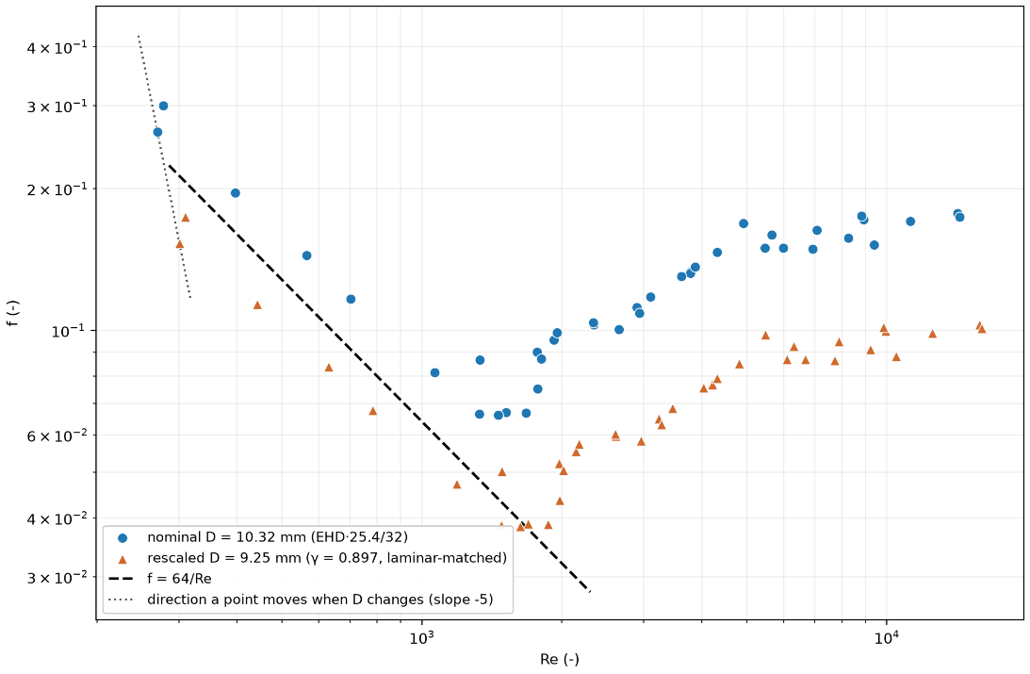
Figure B.1 – Back-calculated Darcy-Weisbach friction factor for the smallest tested EHD of Manufacturer C, plotted at the nominal bore D = EHD·25.4/32 mm and at a rescaled bore matched to the laminar line. Rescaling the assumed diameter moves every point along the slope −5 direction, preserving the shape of the data.
  - Back-calculated friction factors plotted over Re for CSA/ANSI LC 1:23
As mentioned in §3.5.2, the scatter of back-calculated Darcy-Weisbach friction factors observed for the tabulated CSA/ANSI LC 1:23 data shows a similar trend to that observed for Manufacturer C measurement data. In the laminar regime, the data appear to asymptote towards a single line; in the turbulent regime, the data reach a plateau or continue rising shortly after the transition regime. No measured profile is available for the CSA/ANSI LC 1 reference, so Figure B.2 is plotted on the nominal bore D = EHD·25.4/32 mm. Its friction values are therefore not on the same basis as Figure 10, and only the shapes should be compared.
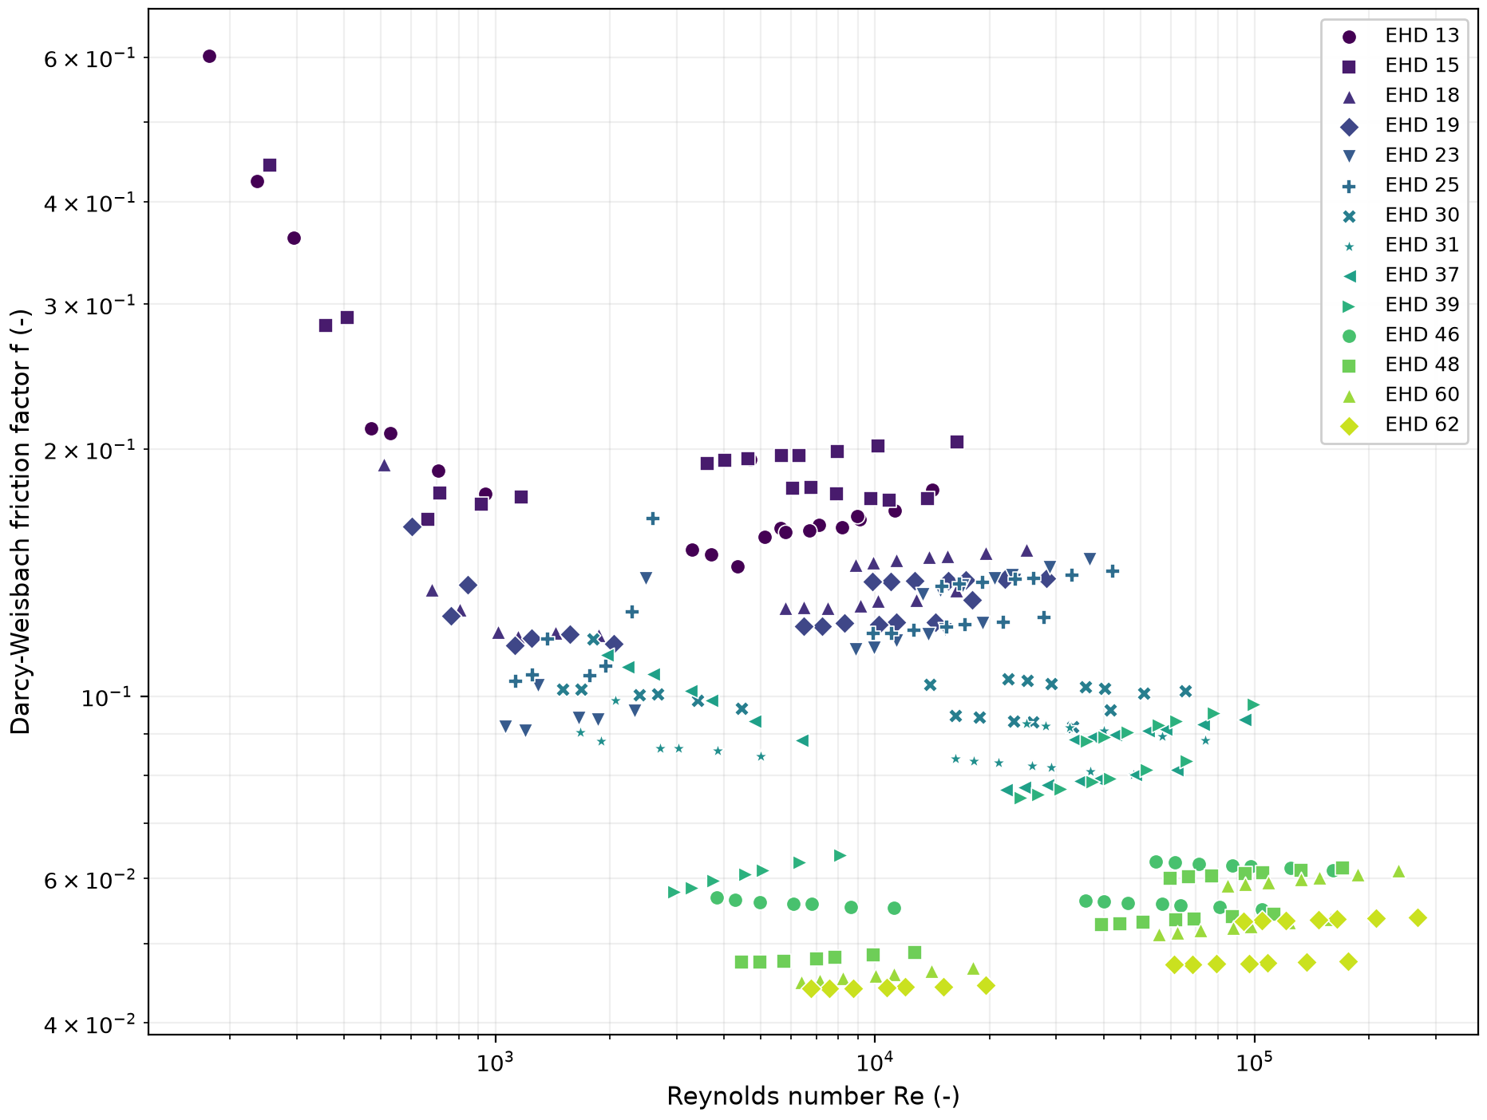
Figure B.2 – Back-calculated Darcy-Weisbach friction factor for CSA/ANSI LC 1:23 data from Tables 1a) to 1c), by EHD size, plotted against Reynolds number. The pattern reproduces that observed for the Manufacturer C measurement data in §3.5.2.
Gaps in the data appear because the points are drawn from three discrete pressure schedules (0.5 psig / 0.5 in WC, 2.0 psi / 1.5 psi, at 5.0 psi / 3.5 psi), an order of magnitude apart in inlet pressure between the lowest and highest. Sweeping intermediate pressure schedules would fill the gaps and provide a means to fit a closure to this data.
- Sensitivity Analysis – Supplementary Data
This appendix gives the hydrogen range and the sizing-option checks behind §3.7. Table C.1 gives, for each schedule of Tables A.1 to A.5, the highest hydrogen Reynolds number and velocity over NPS ½ to NPS 2 for runs of 30 ft (9 m) and longer, evaluated at the mean pressure on the GFE-Churchill basis, and the same quantities for CSST at the energy of the largest natural-gas flows measured by Manufacturer C. Table C.2 gives, for each size, the largest capacity deviation of Option A from GFE-Churchill and the Reynolds number above which Option B is no longer conservative, next to the highest hydrogen Reynolds number of that size.
Case | Highest hydrogen Re | Highest hydrogen velocity, m/s (ft/s) | Where | Cells above Re = 20,000 (%)
Table A.1 | 10,800 | 21.2 (69.6) | NPS 2, 9 m | 0
Table A.2 | 16,000 | 31.3 (103) | NPS 2, 9 m | 0
Table A.3 | 103,000 | 182 (598) | NPS 2, 9 m | 32.7
Table A.4 | 123,000 | 221 (726) | NPS 2, 9 m | 39.5
Table A.5 | 192,000 | 300 (983) | NPS 2, 9 m | 58.0
CSST EHD 13 | 6,300 | 47 (154) | Largest measured flow | –
CSST EHD 18 | 12,000 | 63 (208) | Largest measured flow | –
CSST EHD 23 | 20,000 | 80 (262) | Largest measured flow | –
CSST EHD 31 | 22,800 | 75 (247) | Largest measured flow | –
Table C.1 – Highest hydrogen Reynolds number and in-pipe velocity. Steel: NPS ½ to NPS 2, runs of 30 ft (9 m) and longer, CSA B149.1:25 Tables A.1 to A.5, mean pressure, GFE-Churchill at ε = 0.045 mm. CSST: Manufacturer C on D_{eff}, hydrogen at the energy of the largest measured natural-gas flow, HHV basis.
Both options are checked at fixed pressure drop, the basis of the sizing tables. The Option A peak lies near Re = 3,300 to 3,600 for every size and is the largest deviation up to the highest hydrogen Reynolds number of that size. Every Option B limit lies above the highest hydrogen Reynolds number of the same size, so Option B is conservative over all hydrogen cells at both roughness values. Copper tubing of ¼ to 1¼ in. at 0.0015 mm and smooth plastic pipe stay conservative under Option B up to Re = 2 × 10⁵.
Size | Highest hydrogen Re (runs of 30 ft and longer) | Option A largest deviation, ε = 0.045 mm (%) | Option A largest deviation, ε = 0.09 mm (%) | Option B conservative up to Re, ε = 0.045 mm | Option B conservative up to Re, ε = 0.09 mm
NPS ½ | 26,000 | +5.8 | +9.1 | 165,000 | 29,800
NPS ¾ | 41,700 | +5.0 | +7.5 | 290,000 | 64,900
NPS 1 | 62,400 | +4.4 | +6.4 | 458,000 | 114,000
NPS 1¼ | 98,400 | +3.9 | +5.5 | 750,000 | 204,000
NPS 1½ | 127,000 | +3.7 | +5.0 | 979,000 | 278,000
NPS 2 | 192,000 | +3.4 | +4.4 | 1,490,000 | 446,000
Table C.2 – Largest capacity deviation of Option A from GFE-Churchill up to the highest hydrogen Reynolds number of each size, and the Reynolds number above which Option B (k = 1.18) is no longer conservative, Schedule 40 steel. Positive deviations mean more capacity than Moody friction.
- Laboratory Test Plan – Detailed Specifications
This appendix gives the proposed specifications behind §3.8. All values are proposed and should be confirmed with the testing laboratory before the program starts.
  - Measurements
Table D.1 lists the measurements, with the range and the uncertainty each needs. The instruments are for the laboratory to choose. With the diameter known to 0.5% and the other quantities to the uncertainties listed, Equation (19) gives about ±3% in the friction factor, inside the ±5% criterion of Table 24.
Quantity | Proposed range | Required uncertainty | Note
Standard volumetric flow, low range | 1 to 100 std L/min (2 to 210 SCFH) | ±1% of reading | Calibrated for helium, nitrogen and natural gas
Standard volumetric flow, high range | 50 to 6,000 std L/min (110 to 12,700 SCFH) | ±1% of reading | As above
Differential pressure, low range | 0 to 1 kPa | ±0.25% of reading | Taps of T1, T3 and T5
Differential pressure, high range | 0 to 35 kPa | ±0.1% of full scale | Covers the LC 1 drops of T2 and T4
Inlet pressure | 80 to 200 kPa absolute | ±0.05% of full scale | –
Gas temperature | 0 to 40 °C | ±0.2 °C | At the inlet and between the taps
Gas purity | ≥ 99.99% (helium, nitrogen) | – | Supplier certificate; natural gas by analysis
Inside diameter | Specimen ends | ±0.5% | Caliper or bore gauge; manufacturer data for CSST
Sound | 30 to 120 dB | Class 1 (IEC 61672-1) | T6 only
Leak tightness | Each assembled specimen | – | Pressure decay or helium leak detector before testing
Table D.1 – Proposed measurements for the laboratory tests.
  - Test arrangement
Flow tests on straight specimens use a development length upstream of the first tap of at least the laminar entrance length, about 0.06·Re·D, and not less than 50 inside diameters, with at least 10 diameters downstream of the last tap. Pressure is measured at three or more tap stations, each a piezometer ring of four taps at 90°, so that a linear fall of pressure along the run can confirm developed flow. On CSST the taps are placed at the same phase of the corrugation at every station. Tap spacing is chosen so that the smallest differential pressure is at least 100 Pa. Table D.2 gives the proposed arrangement of each test.
Test | Arrangement
T1 | Straight runs of EHD 13, 18, 23 and 31 with three or more tap stations, outlet to atmosphere
T2 | The 1996 lengths of 30 to 240 ft, arranged as in the original test
T3 | Straight Schedule 40 steel, NPS ½, ¾ and 1, with three or more tap stations, outlet to atmosphere; three repeats at five of the points
T4 | LC 1 lengths of 30, 50, 80, 100, 150, 200 and 250 ft, with four 90° bends spaced 7 ft (2.1 m) apart and two end fittings
T5 | Single fittings between straight runs, with taps upstream and downstream
T6 | CSST and steel runs with fittings in an acoustically treated room, velocity stepped until tonal noise appears
Table D.2 – Proposed test arrangement.
  - Test matrix
Table D.3 gives the test matrix, one row per measurement point. Target Reynolds numbers are on the inside diameter for steel and on D_{eff} for CSST. Velocities and flows are planning values at 15.6 °C (60 °F) and atmospheric outlet pressure, from the gas properties of the NIST WebBook [1]; the expected differential pressures over the tap spacing are from the Manufacturer C friction trend for CSST and from Churchill at ε = 0.045 mm for steel. For T2 the flows are the 1996 values, and for T4 they are estimates from the same friction trend. The matrix is also supplied as a data file with the calculation scripts.
Point | Test | Priority | Specimen | Gas | Target Re | Run | Inlet (kPa gauge) | ΔP (Pa) | Flow, std L/min (SCFH) | Velocity (m/s)
1 | T1 | 1 | CSST, Manufacturer C, EHD 13 | He | 250 | 5 m | 0.13 | 117 | 15.5 (32.9) | 2.50
2 | T1 | 1 | CSST, Manufacturer C, EHD 13 | He | 500 | 3 m | 0.17 | 138 | 31.1 (65.8) | 4.99
3 | T1 | 1 | CSST, Manufacturer C, EHD 13 | He | 750 | 2 m | 0.19 | 142 | 46.6 (98.8) | 7.49
4 | T1 | 1 | CSST, Manufacturer C, EHD 13 | He | 1,000 | 2 m | 0.28 | 196 | 62.2 (132) | 9.99
5 | T1 | 1 | CSST, Manufacturer C, EHD 13 | He | 1,361 | 1 m | 0.32 | 156 | 84.6 (179) | 13.6
6 | T1 | 1 | CSST, Manufacturer C, EHD 13 | He | 1,750 | 0.5 m | 0.69 | 190 | 109 (230) | 17.5
7 | T1 | 1 | CSST, Manufacturer C, EHD 13 | He | 2,300 | 0.5 m | 0.80 | 336 | 143 (303) | 23.0
8 | T1 | 1 | CSST, Manufacturer C, EHD 13 | He | 3,000 | 0.5 m | 1.7 | 700 | 186 (395) | 30.0
9 | T1 | 1 | CSST, Manufacturer C, EHD 13 | He | 4,000 | 0.5 m | 3.6 | 1,530 | 249 (527) | 39.9
10 | T1 | 1 | CSST, Manufacturer C, EHD 13 | He | 5,000 | 0.5 m | 5.8 | 2,430 | 311 (658) | 49.9
11 | T1 | 1 | CSST, Manufacturer C, EHD 13 | N₂ | 1,000 | 10 m | 0.12 | 113 | 7.97 (16.9) | 1.28
12 | T1 | 1 | CSST, Manufacturer C, EHD 13 | N₂ | 1,361 | 10 m | 0.20 | 179 | 10.8 (23.0) | 1.74
13 | T1 | 1 | CSST, Manufacturer C, EHD 13 | N₂ | 1,750 | 3 m | 0.19 | 131 | 13.9 (29.5) | 2.24
14 | T1 | 1 | CSST, Manufacturer C, EHD 13 | N₂ | 2,300 | 2 m | 0.21 | 155 | 18.3 (38.8) | 2.94
15 | T1 | 1 | CSST, Manufacturer C, EHD 13 | N₂ | 3,000 | 1 m | 0.27 | 161 | 23.9 (50.6) | 3.84
16 | T1 | 1 | CSST, Manufacturer C, EHD 13 | N₂ | 4,000 | 0.5 m | 0.42 | 176 | 31.9 (67.5) | 5.12
17 | T1 | 1 | CSST, Manufacturer C, EHD 13 | N₂ | 5,000 | 0.5 m | 0.67 | 280 | 39.8 (84.4) | 6.40
18 | T1 | 1 | CSST, Manufacturer C, EHD 13 | N₂ | 7,500 | 0.5 m | 1.5 | 651 | 59.8 (127) | 9.60
19 | T1 | 1 | CSST, Manufacturer C, EHD 13 | N₂ | 10,000 | 0.5 m | 2.9 | 1,220 | 79.7 (169) | 12.8
20 | T1 | 1 | CSST, Manufacturer C, EHD 13 | N₂ | 15,000 | 0.5 m | 6.7 | 2,830 | 120 (253) | 19.2
21 | T1 | 1 | CSST, Manufacturer C, EHD 13 | N₂ | 20,000 | 0.5 m | 12 | 5,030 | 159 (338) | 25.6
22 | T1 | 1 | CSST, Manufacturer C, EHD 13 | N₂ | 25,000 | 0.5 m | 19 | 7,850 | 199 (422) | 32.0
23 | T1 | 1 | CSST, Manufacturer C, EHD 18 | He | 500 | 10 m | 0.16 | 148 | 43.7 (92.7) | 3.55
24 | T1 | 1 | CSST, Manufacturer C, EHD 18 | He | 750 | 5 m | 0.14 | 118 | 65.6 (139) | 5.32
25 | T1 | 1 | CSST, Manufacturer C, EHD 18 | He | 1,000 | 3 m | 0.15 | 111 | 87.5 (185) | 7.10
26 | T1 | 1 | CSST, Manufacturer C, EHD 18 | He | 1,361 | 2 m | 0.20 | 116 | 119 (252) | 9.66
27 | T1 | 1 | CSST, Manufacturer C, EHD 18 | He | 1,750 | 2 m | 0.38 | 194 | 153 (324) | 12.4
28 | T1 | 1 | CSST, Manufacturer C, EHD 18 | He | 2,300 | 0.5 m | 0.30 | 103 | 201 (426) | 16.3
29 | T1 | 1 | CSST, Manufacturer C, EHD 18 | He | 3,000 | 0.5 m | 0.55 | 185 | 262 (556) | 21.3
30 | T1 | 1 | CSST, Manufacturer C, EHD 18 | He | 4,000 | 0.5 m | 1.1 | 365 | 350 (741) | 28.4
31 | T1 | 1 | CSST, Manufacturer C, EHD 18 | He | 5,000 | 0.5 m | 1.8 | 616 | 437 (927) | 35.5
32 | T1 | 1 | CSST, Manufacturer C, EHD 18 | N₂ | 1,750 | 10 m | 0.13 | 112 | 19.6 (41.6) | 1.59
33 | T1 | 1 | CSST, Manufacturer C, EHD 18 | N₂ | 2,300 | 5 m | 0.14 | 118 | 25.8 (54.6) | 2.09
34 | T1 | 1 | CSST, Manufacturer C, EHD 18 | N₂ | 3,000 | 3 m | 0.17 | 128 | 33.6 (71.3) | 2.73
35 | T1 | 1 | CSST, Manufacturer C, EHD 18 | N₂ | 4,000 | 2 m | 0.25 | 168 | 44.8 (95.0) | 3.64
36 | T1 | 1 | CSST, Manufacturer C, EHD 18 | N₂ | 5,000 | 1 m | 0.28 | 142 | 56.1 (119) | 4.55
37 | T1 | 1 | CSST, Manufacturer C, EHD 18 | N₂ | 7,500 | 0.5 m | 0.56 | 189 | 84.1 (178) | 6.82
38 | T1 | 1 | CSST, Manufacturer C, EHD 18 | N₂ | 10,000 | 0.5 m | 1.0 | 342 | 112 (238) | 9.10
39 | T1 | 1 | CSST, Manufacturer C, EHD 18 | N₂ | 15,000 | 0.5 m | 2.3 | 793 | 168 (356) | 13.6
40 | T1 | 1 | CSST, Manufacturer C, EHD 18 | N₂ | 20,000 | 0.5 m | 4.0 | 1,350 | 224 (475) | 18.2
41 | T1 | 1 | CSST, Manufacturer C, EHD 18 | N₂ | 25,000 | 0.5 m | 6.4 | 2,180 | 280 (594) | 22.7
42 | T1 | 2 | CSST, Manufacturer C, EHD 23 | He | 750 | 10 m | 0.13 | 119 | 86.8 (184) | 4.02
43 | T1 | 2 | CSST, Manufacturer C, EHD 23 | He | 1,000 | 10 m | 0.18 | 158 | 116 (245) | 5.36
44 | T1 | 2 | CSST, Manufacturer C, EHD 23 | He | 1,361 | 5 m | 0.18 | 130 | 158 (334) | 7.30
45 | T1 | 2 | CSST, Manufacturer C, EHD 23 | He | 1,750 | 2 m | 0.24 | 109 | 203 (429) | 9.39
46 | T1 | 2 | CSST, Manufacturer C, EHD 23 | He | 2,300 | 1 m | 0.35 | 151 | 266 (564) | 12.3
47 | T1 | 2 | CSST, Manufacturer C, EHD 23 | He | 3,000 | 1 m | 0.37 | 164 | 347 (736) | 16.1
48 | T1 | 2 | CSST, Manufacturer C, EHD 23 | He | 4,000 | 0.5 m | 0.65 | 181 | 463 (981) | 21.5
49 | T1 | 2 | CSST, Manufacturer C, EHD 23 | He | 5,000 | 0.5 m | 1.00 | 280 | 579 (1,230) | 26.8
50 | T1 | 2 | CSST, Manufacturer C, EHD 23 | N₂ | 2,300 | 10 m | 0.20 | 174 | 34.1 (72.3) | 1.58
51 | T1 | 2 | CSST, Manufacturer C, EHD 23 | N₂ | 3,000 | 10 m | 0.21 | 189 | 44.5 (94.3) | 2.06
52 | T1 | 2 | CSST, Manufacturer C, EHD 23 | N₂ | 4,000 | 3 m | 0.18 | 125 | 59.3 (126) | 2.75
53 | T1 | 2 | CSST, Manufacturer C, EHD 23 | N₂ | 5,000 | 2 m | 0.21 | 129 | 74.2 (157) | 3.44
54 | T1 | 2 | CSST, Manufacturer C, EHD 23 | N₂ | 7,500 | 1 m | 0.40 | 173 | 111 (236) | 5.16
55 | T1 | 2 | CSST, Manufacturer C, EHD 23 | N₂ | 10,000 | 0.5 m | 0.53 | 148 | 148 (314) | 6.88
56 | T1 | 2 | CSST, Manufacturer C, EHD 23 | N₂ | 15,000 | 0.5 m | 1.2 | 324 | 223 (471) | 10.3
57 | T1 | 2 | CSST, Manufacturer C, EHD 23 | N₂ | 20,000 | 0.5 m | 2.0 | 572 | 297 (629) | 13.8
58 | T1 | 2 | CSST, Manufacturer C, EHD 23 | N₂ | 25,000 | 0.5 m | 3.2 | 891 | 371 (786) | 17.2
59 | T1 | 2 | CSST, Manufacturer C, EHD 31 | He | 1,361 | 10 m | 0.17 | 133 | 213 (450) | 5.41
60 | T1 | 2 | CSST, Manufacturer C, EHD 31 | He | 1,750 | 10 m | 0.23 | 172 | 273 (579) | 6.95
61 | T1 | 2 | CSST, Manufacturer C, EHD 31 | He | 2,300 | 5 m | 0.21 | 158 | 359 (761) | 9.14
62 | T1 | 2 | CSST, Manufacturer C, EHD 31 | He | 3,000 | 2 m | 0.22 | 117 | 469 (993) | 11.9
63 | T1 | 2 | CSST, Manufacturer C, EHD 31 | He | 4,000 | 1 m | 0.28 | 104 | 625 (1,320) | 15.9
64 | T1 | 2 | CSST, Manufacturer C, EHD 31 | He | 5,000 | 1 m | 0.43 | 156 | 781 (1,650) | 19.9
65 | T1 | 2 | CSST, Manufacturer C, EHD 31 | N₂ | 4,000 | 10 m | 0.14 | 119 | 80.1 (170) | 2.04
66 | T1 | 2 | CSST, Manufacturer C, EHD 31 | N₂ | 5,000 | 10 m | 0.21 | 179 | 100 (212) | 2.55
67 | T1 | 2 | CSST, Manufacturer C, EHD 31 | N₂ | 7,500 | 3 m | 0.19 | 123 | 150 (318) | 3.82
68 | T1 | 2 | CSST, Manufacturer C, EHD 31 | N₂ | 10,000 | 2 m | 0.25 | 132 | 200 (424) | 5.09
69 | T1 | 2 | CSST, Manufacturer C, EHD 31 | N₂ | 15,000 | 1 m | 0.41 | 151 | 300 (636) | 7.64
70 | T1 | 2 | CSST, Manufacturer C, EHD 31 | N₂ | 20,000 | 0.5 m | 0.56 | 126 | 400 (848) | 10.2
71 | T1 | 2 | CSST, Manufacturer C, EHD 31 | N₂ | 25,000 | 0.5 m | 1.0 | 230 | 501 (1,060) | 12.7
72 | T2 | 1 | CSST, Manufacturer C, EHD 13 | NG | 1,200 | 30 ft | 1.72 | 125 | 10.7 (22.7) | 1.69
73 | T2 | 1 | CSST, Manufacturer C, EHD 13 | NG | 956 | 50 ft | 1.72 | 125 | 8.55 (18.1) | 1.35
74 | T2 | 1 | CSST, Manufacturer C, EHD 13 | NG | 631 | 80 ft | 1.72 | 125 | 5.64 (12.0) | 0.892
75 | T2 | 1 | CSST, Manufacturer C, EHD 13 | NG | 508 | 100 ft | 1.72 | 125 | 4.54 (9.62) | 0.718
76 | T2 | 1 | CSST, Manufacturer C, EHD 13 | NG | 356 | 150 ft | 1.72 | 125 | 3.18 (6.74) | 0.503
77 | T2 | 1 | CSST, Manufacturer C, EHD 13 | NG | 249 | 200 ft | 1.72 | 125 | 2.23 (4.72) | 0.352
78 | T2 | 1 | CSST, Manufacturer C, EHD 13 | NG | 242 | 240 ft | 1.72 | 125 | 2.17 (4.59) | 0.342
79 | T2 | 1 | CSST, Manufacturer C, EHD 13 | NG | 2,600 | 30 ft | 2.48 | 747 | 23.3 (49.3) | 3.66
80 | T2 | 1 | CSST, Manufacturer C, EHD 13 | NG | 2,100 | 50 ft | 2.48 | 747 | 18.8 (39.8) | 2.96
81 | T2 | 1 | CSST, Manufacturer C, EHD 13 | NG | 1,720 | 80 ft | 2.48 | 747 | 15.4 (32.7) | 2.43
82 | T2 | 1 | CSST, Manufacturer C, EHD 13 | NG | 1,590 | 100 ft | 2.48 | 747 | 14.2 (30.1) | 2.24
83 | T2 | 1 | CSST, Manufacturer C, EHD 13 | NG | 1,500 | 150 ft | 2.48 | 747 | 13.5 (28.5) | 2.12
84 | T2 | 1 | CSST, Manufacturer C, EHD 13 | NG | 1,310 | 200 ft | 2.48 | 747 | 11.7 (24.8) | 1.84
85 | T2 | 1 | CSST, Manufacturer C, EHD 13 | NG | 1,190 | 240 ft | 2.48 | 747 | 10.7 (22.6) | 1.68
86 | T2 | 1 | CSST, Manufacturer C, EHD 13 | NG | 3,380 | 30 ft | 3.45 | 1,490 | 30.3 (64.1) | 4.74
87 | T2 | 1 | CSST, Manufacturer C, EHD 13 | NG | 2,790 | 50 ft | 3.45 | 1,490 | 24.9 (52.8) | 3.90
88 | T2 | 1 | CSST, Manufacturer C, EHD 13 | NG | 2,380 | 80 ft | 3.45 | 1,490 | 21.3 (45.2) | 3.34
89 | T2 | 1 | CSST, Manufacturer C, EHD 13 | NG | 2,100 | 100 ft | 3.45 | 1,490 | 18.7 (39.7) | 2.93
90 | T2 | 1 | CSST, Manufacturer C, EHD 13 | NG | 1,750 | 150 ft | 3.45 | 1,490 | 15.7 (33.2) | 2.45
91 | T2 | 1 | CSST, Manufacturer C, EHD 13 | NG | 1,620 | 200 ft | 3.45 | 1,490 | 14.5 (30.7) | 2.27
92 | T2 | 1 | CSST, Manufacturer C, EHD 13 | NG | 1,590 | 240 ft | 3.45 | 1,490 | 14.2 (30.1) | 2.23
93 | T2 | 1 | CSST, Manufacturer C, EHD 13 | NG | 7,990 | 30 ft | 13.8 | 10,300 | 71.5 (151) | 10.6
94 | T2 | 1 | CSST, Manufacturer C, EHD 13 | NG | 6,350 | 50 ft | 13.8 | 10,300 | 56.8 (120) | 8.41
95 | T2 | 1 | CSST, Manufacturer C, EHD 13 | NG | 5,080 | 80 ft | 13.8 | 10,300 | 45.4 (96.3) | 6.73
96 | T2 | 1 | CSST, Manufacturer C, EHD 13 | NG | 4,410 | 100 ft | 13.8 | 10,300 | 39.5 (83.6) | 5.85
97 | T2 | 1 | CSST, Manufacturer C, EHD 13 | NG | 3,870 | 150 ft | 13.8 | 10,300 | 34.6 (73.3) | 5.12
98 | T2 | 1 | CSST, Manufacturer C, EHD 13 | NG | 3,470 | 200 ft | 13.8 | 10,300 | 31.1 (65.8) | 4.60
99 | T2 | 1 | CSST, Manufacturer C, EHD 13 | NG | 3,240 | 240 ft | 13.8 | 10,300 | 29.0 (61.5) | 4.30
100 | T2 | 1 | CSST, Manufacturer C, EHD 13 | NG | 12,700 | 30 ft | 34.5 | 24,100 | 114 (242) | 15.0
101 | T2 | 1 | CSST, Manufacturer C, EHD 13 | NG | 10,100 | 50 ft | 34.5 | 24,100 | 90.1 (191) | 11.9
102 | T2 | 1 | CSST, Manufacturer C, EHD 13 | NG | 8,430 | 80 ft | 34.5 | 24,100 | 75.4 (160) | 9.92
103 | T2 | 1 | CSST, Manufacturer C, EHD 13 | NG | 7,410 | 100 ft | 34.5 | 24,100 | 66.3 (141) | 8.73
104 | T2 | 1 | CSST, Manufacturer C, EHD 13 | NG | 6,220 | 150 ft | 34.5 | 24,100 | 55.6 (118) | 7.32
105 | T2 | 1 | CSST, Manufacturer C, EHD 13 | NG | 5,380 | 200 ft | 34.5 | 24,100 | 48.1 (102) | 6.33
106 | T2 | 1 | CSST, Manufacturer C, EHD 13 | NG | 4,910 | 240 ft | 34.5 | 24,100 | 43.9 (93.0) | 5.77
107 | T2 | 1 | CSST, Manufacturer C, EHD 18 | NG | 2,040 | 30 ft | 1.72 | 125 | 25.6 (54.3) | 2.05
108 | T2 | 1 | CSST, Manufacturer C, EHD 18 | NG | 1,730 | 50 ft | 1.72 | 125 | 21.8 (46.1) | 1.74
109 | T2 | 1 | CSST, Manufacturer C, EHD 18 | NG | 1,370 | 80 ft | 1.72 | 125 | 17.2 (36.5) | 1.38
110 | T2 | 1 | CSST, Manufacturer C, EHD 18 | NG | 1,170 | 100 ft | 1.72 | 125 | 14.7 (31.2) | 1.18
111 | T2 | 1 | CSST, Manufacturer C, EHD 18 | NG | 895 | 150 ft | 1.72 | 125 | 11.3 (23.9) | 0.899
112 | T2 | 1 | CSST, Manufacturer C, EHD 18 | NG | 746 | 200 ft | 1.72 | 125 | 9.39 (19.9) | 0.750
113 | T2 | 1 | CSST, Manufacturer C, EHD 18 | NG | 633 | 250 ft | 1.72 | 125 | 7.96 (16.9) | 0.636
114 | T2 | 1 | CSST, Manufacturer C, EHD 18 | NG | 4,360 | 30 ft | 2.48 | 747 | 54.9 (116) | 4.37
115 | T2 | 1 | CSST, Manufacturer C, EHD 18 | NG | 3,670 | 50 ft | 2.48 | 747 | 46.2 (97.8) | 3.67
116 | T2 | 1 | CSST, Manufacturer C, EHD 18 | NG | 2,960 | 80 ft | 2.48 | 747 | 37.2 (78.9) | 2.96
117 | T2 | 1 | CSST, Manufacturer C, EHD 18 | NG | 2,670 | 100 ft | 2.48 | 747 | 33.6 (71.1) | 2.67
118 | T2 | 1 | CSST, Manufacturer C, EHD 18 | NG | 2,200 | 150 ft | 2.48 | 747 | 27.7 (58.8) | 2.21
119 | T2 | 1 | CSST, Manufacturer C, EHD 18 | NG | 2,020 | 200 ft | 2.48 | 747 | 25.5 (54.0) | 2.03
120 | T2 | 1 | CSST, Manufacturer C, EHD 18 | NG | 1,840 | 250 ft | 2.48 | 747 | 23.1 (49.0) | 1.84
121 | T2 | 1 | CSST, Manufacturer C, EHD 18 | NG | 5,920 | 30 ft | 3.45 | 1,490 | 74.5 (158) | 5.89
122 | T2 | 1 | CSST, Manufacturer C, EHD 18 | NG | 4,860 | 50 ft | 3.45 | 1,490 | 61.2 (130) | 4.84
123 | T2 | 1 | CSST, Manufacturer C, EHD 18 | NG | 3,980 | 80 ft | 3.45 | 1,490 | 50.0 (106) | 3.95
124 | T2 | 1 | CSST, Manufacturer C, EHD 18 | NG | 3,580 | 100 ft | 3.45 | 1,490 | 45.1 (95.5) | 3.56
125 | T2 | 1 | CSST, Manufacturer C, EHD 18 | NG | 3,030 | 150 ft | 3.45 | 1,490 | 38.2 (80.9) | 3.02
126 | T2 | 1 | CSST, Manufacturer C, EHD 18 | NG | 2,670 | 200 ft | 3.45 | 1,490 | 33.7 (71.3) | 2.66
127 | T2 | 1 | CSST, Manufacturer C, EHD 18 | NG | 2,440 | 250 ft | 3.45 | 1,490 | 30.7 (65.0) | 2.43
128 | T2 | 1 | CSST, Manufacturer C, EHD 18 | NG | 15,000 | 30 ft | 13.8 | 10,300 | 189 (400) | 14.1
129 | T2 | 1 | CSST, Manufacturer C, EHD 18 | NG | 11,800 | 50 ft | 13.8 | 10,300 | 149 (316) | 11.1
130 | T2 | 1 | CSST, Manufacturer C, EHD 18 | NG | 9,290 | 80 ft | 13.8 | 10,300 | 117 (248) | 8.75
131 | T2 | 1 | CSST, Manufacturer C, EHD 18 | NG | 8,440 | 100 ft | 13.8 | 10,300 | 106 (225) | 7.94
132 | T2 | 1 | CSST, Manufacturer C, EHD 18 | NG | 6,840 | 150 ft | 13.8 | 10,300 | 86.1 (183) | 6.44
133 | T2 | 1 | CSST, Manufacturer C, EHD 18 | NG | 6,080 | 200 ft | 13.8 | 10,300 | 76.6 (162) | 5.73
134 | T2 | 1 | CSST, Manufacturer C, EHD 18 | NG | 5,620 | 250 ft | 13.8 | 10,300 | 70.8 (150) | 5.29
135 | T2 | 1 | CSST, Manufacturer C, EHD 18 | NG | 24,500 | 30 ft | 34.5 | 24,100 | 308 (652) | 20.5
136 | T2 | 1 | CSST, Manufacturer C, EHD 18 | NG | 19,300 | 50 ft | 34.5 | 24,100 | 243 (514) | 16.1
137 | T2 | 1 | CSST, Manufacturer C, EHD 18 | NG | 15,000 | 80 ft | 34.5 | 24,100 | 189 (401) | 12.6
138 | T2 | 1 | CSST, Manufacturer C, EHD 18 | NG | 13,300 | 100 ft | 34.5 | 24,100 | 167 (354) | 11.1
139 | T2 | 1 | CSST, Manufacturer C, EHD 18 | NG | 10,900 | 150 ft | 34.5 | 24,100 | 138 (291) | 9.14
140 | T2 | 1 | CSST, Manufacturer C, EHD 18 | NG | 9,600 | 200 ft | 34.5 | 24,100 | 121 (256) | 8.03
141 | T2 | 1 | CSST, Manufacturer C, EHD 18 | NG | 8,940 | 250 ft | 34.5 | 24,100 | 112 (238) | 7.47
142 | T2 | 2 | CSST, Manufacturer C, EHD 23 | NG | 2,270 | 30 ft | 1.72 | 125 | 37.9 (80.2) | 1.73
143 | T2 | 2 | CSST, Manufacturer C, EHD 23 | NG | 2,100 | 50 ft | 1.72 | 125 | 35.0 (74.2) | 1.60
144 | T2 | 2 | CSST, Manufacturer C, EHD 23 | NG | 1,780 | 80 ft | 1.72 | 125 | 29.6 (62.8) | 1.35
145 | T2 | 2 | CSST, Manufacturer C, EHD 23 | NG | 1,690 | 100 ft | 1.72 | 125 | 28.1 (59.5) | 1.28
146 | T2 | 2 | CSST, Manufacturer C, EHD 23 | NG | 1,500 | 150 ft | 1.72 | 125 | 24.9 (52.8) | 1.14
147 | T2 | 2 | CSST, Manufacturer C, EHD 23 | NG | 1,280 | 200 ft | 1.72 | 125 | 21.4 (45.3) | 0.975
148 | T2 | 2 | CSST, Manufacturer C, EHD 23 | NG | 1,180 | 250 ft | 1.72 | 125 | 19.7 (41.8) | 0.899
149 | T2 | 2 | CSST, Manufacturer C, EHD 23 | NG | 6,000 | 30 ft | 2.48 | 747 | 100.0 (212) | 4.54
150 | T2 | 2 | CSST, Manufacturer C, EHD 23 | NG | 5,250 | 50 ft | 2.48 | 747 | 87.4 (185) | 3.97
151 | T2 | 2 | CSST, Manufacturer C, EHD 23 | NG | 3,930 | 80 ft | 2.48 | 747 | 65.5 (139) | 2.97
152 | T2 | 2 | CSST, Manufacturer C, EHD 23 | NG | 3,760 | 100 ft | 2.48 | 747 | 62.7 (133) | 2.85
153 | T2 | 2 | CSST, Manufacturer C, EHD 23 | NG | 3,200 | 150 ft | 2.48 | 747 | 53.2 (113) | 2.42
154 | T2 | 2 | CSST, Manufacturer C, EHD 23 | NG | 2,820 | 200 ft | 2.48 | 747 | 47.0 (99.7) | 2.14
155 | T2 | 2 | CSST, Manufacturer C, EHD 23 | NG | 2,570 | 250 ft | 2.48 | 747 | 42.8 (90.6) | 1.94
156 | T2 | 2 | CSST, Manufacturer C, EHD 23 | NG | 8,450 | 30 ft | 3.45 | 1,490 | 141 (298) | 6.36
157 | T2 | 2 | CSST, Manufacturer C, EHD 23 | NG | 6,650 | 50 ft | 3.45 | 1,490 | 111 (235) | 5.00
158 | T2 | 2 | CSST, Manufacturer C, EHD 23 | NG | 5,290 | 80 ft | 3.45 | 1,490 | 88.1 (187) | 3.98
159 | T2 | 2 | CSST, Manufacturer C, EHD 23 | NG | 5,050 | 100 ft | 3.45 | 1,490 | 84.1 (178) | 3.80
160 | T2 | 2 | CSST, Manufacturer C, EHD 23 | NG | 4,290 | 150 ft | 3.45 | 1,490 | 71.5 (151) | 3.23
161 | T2 | 2 | CSST, Manufacturer C, EHD 23 | NG | 3,810 | 200 ft | 3.45 | 1,490 | 63.5 (135) | 2.87
162 | T2 | 2 | CSST, Manufacturer C, EHD 23 | NG | 3,420 | 250 ft | 3.45 | 1,490 | 57.0 (121) | 2.57
163 | T2 | 2 | CSST, Manufacturer C, EHD 23 | NG | 24,900 | 30 ft | 13.8 | 10,300 | 415 (879) | 17.7
164 | T2 | 2 | CSST, Manufacturer C, EHD 23 | NG | 16,800 | 50 ft | 13.8 | 10,300 | 280 (592) | 11.9
165 | T2 | 2 | CSST, Manufacturer C, EHD 23 | NG | 13,300 | 80 ft | 13.8 | 10,300 | 222 (471) | 9.49
166 | T2 | 2 | CSST, Manufacturer C, EHD 23 | NG | 12,800 | 100 ft | 13.8 | 10,300 | 213 (451) | 9.10
167 | T2 | 2 | CSST, Manufacturer C, EHD 23 | NG | 10,600 | 150 ft | 13.8 | 10,300 | 176 (373) | 7.52
168 | T2 | 2 | CSST, Manufacturer C, EHD 23 | NG | 9,050 | 200 ft | 13.8 | 10,300 | 151 (319) | 6.43
169 | T2 | 2 | CSST, Manufacturer C, EHD 23 | NG | 4,290 | 250 ft | 13.8 | 10,300 | 71.4 (151) | 3.05
170 | T2 | 2 | CSST, Manufacturer C, EHD 23 | NG | 40,500 | 30 ft | 34.5 | 24,100 | 675 (1,430) | 25.6
171 | T2 | 2 | CSST, Manufacturer C, EHD 23 | NG | 35,100 | 50 ft | 34.5 | 24,100 | 585 (1,240) | 22.2
172 | T2 | 2 | CSST, Manufacturer C, EHD 23 | NG | 21,900 | 80 ft | 34.5 | 24,100 | 364 (771) | 13.8
173 | T2 | 2 | CSST, Manufacturer C, EHD 23 | NG | 20,900 | 100 ft | 34.5 | 24,100 | 348 (737) | 13.2
174 | T2 | 2 | CSST, Manufacturer C, EHD 23 | NG | 17,100 | 150 ft | 34.5 | 24,100 | 284 (603) | 10.8
175 | T2 | 2 | CSST, Manufacturer C, EHD 23 | NG | 14,700 | 200 ft | 34.5 | 24,100 | 245 (519) | 9.30
176 | T2 | 2 | CSST, Manufacturer C, EHD 23 | NG | 13,400 | 250 ft | 34.5 | 24,100 | 223 (473) | 8.47
177 | T2 | 2 | CSST, Manufacturer C, EHD 31 | NG | 4,890 | 30 ft | 1.72 | 125 | 110 (233) | 2.75
178 | T2 | 2 | CSST, Manufacturer C, EHD 31 | NG | 3,780 | 50 ft | 1.72 | 125 | 84.9 (180) | 2.12
179 | T2 | 2 | CSST, Manufacturer C, EHD 31 | NG | 2,990 | 80 ft | 1.72 | 125 | 67.3 (142) | 1.68
180 | T2 | 2 | CSST, Manufacturer C, EHD 31 | NG | 2,720 | 100 ft | 1.72 | 125 | 61.2 (130) | 1.53
181 | T2 | 2 | CSST, Manufacturer C, EHD 31 | NG | 2,280 | 150 ft | 1.72 | 125 | 51.3 (109) | 1.29
182 | T2 | 2 | CSST, Manufacturer C, EHD 31 | NG | 2,090 | 200 ft | 1.72 | 125 | 47.1 (99.7) | 1.18
183 | T2 | 2 | CSST, Manufacturer C, EHD 31 | NG | 1,910 | 250 ft | 1.72 | 125 | 42.9 (90.8) | 1.07
184 | T2 | 2 | CSST, Manufacturer C, EHD 31 | NG | 11,700 | 30 ft | 2.48 | 747 | 263 (557) | 6.56
185 | T2 | 2 | CSST, Manufacturer C, EHD 31 | NG | 9,210 | 50 ft | 2.48 | 747 | 207 (439) | 5.16
186 | T2 | 2 | CSST, Manufacturer C, EHD 31 | NG | 7,280 | 80 ft | 2.48 | 747 | 164 (347) | 4.08
187 | T2 | 2 | CSST, Manufacturer C, EHD 31 | NG | 6,530 | 100 ft | 2.48 | 747 | 147 (311) | 3.66
188 | T2 | 2 | CSST, Manufacturer C, EHD 31 | NG | 5,430 | 150 ft | 2.48 | 747 | 122 (259) | 3.04
189 | T2 | 2 | CSST, Manufacturer C, EHD 31 | NG | 4,690 | 200 ft | 2.48 | 747 | 105 (223) | 2.63
190 | T2 | 2 | CSST, Manufacturer C, EHD 31 | NG | 4,220 | 250 ft | 2.48 | 747 | 94.9 (201) | 2.37
191 | T2 | 2 | CSST, Manufacturer C, EHD 31 | NG | 17,300 | 30 ft | 3.45 | 1,490 | 389 (824) | 9.64
192 | T2 | 2 | CSST, Manufacturer C, EHD 31 | NG | 13,900 | 50 ft | 3.45 | 1,490 | 313 (662) | 7.75
193 | T2 | 2 | CSST, Manufacturer C, EHD 31 | NG | 11,400 | 80 ft | 3.45 | 1,490 | 256 (543) | 6.36
194 | T2 | 2 | CSST, Manufacturer C, EHD 31 | NG | 10,200 | 100 ft | 3.45 | 1,490 | 228 (484) | 5.66
195 | T2 | 2 | CSST, Manufacturer C, EHD 31 | NG | 7,420 | 150 ft | 3.45 | 1,490 | 167 (353) | 4.13
196 | T2 | 2 | CSST, Manufacturer C, EHD 31 | NG | 7,760 | 200 ft | 3.45 | 1,490 | 174 (370) | 4.32
197 | T2 | 2 | CSST, Manufacturer C, EHD 31 | NG | 6,000 | 250 ft | 3.45 | 1,490 | 135 (286) | 3.34
198 | T2 | 2 | CSST, Manufacturer C, EHD 31 | NG | 43,700 | 30 ft | 13.8 | 10,300 | 981 (2,080) | 23.0
199 | T2 | 2 | CSST, Manufacturer C, EHD 31 | NG | 34,900 | 50 ft | 13.8 | 10,300 | 784 (1,660) | 18.4
200 | T2 | 2 | CSST, Manufacturer C, EHD 31 | NG | 28,400 | 80 ft | 13.8 | 10,300 | 639 (1,350) | 15.0
201 | T2 | 2 | CSST, Manufacturer C, EHD 31 | NG | 26,400 | 100 ft | 13.8 | 10,300 | 593 (1,260) | 13.9
202 | T2 | 2 | CSST, Manufacturer C, EHD 31 | NG | 22,000 | 150 ft | 13.8 | 10,300 | 496 (1,050) | 11.6
203 | T2 | 2 | CSST, Manufacturer C, EHD 31 | NG | 19,500 | 200 ft | 13.8 | 10,300 | 438 (928) | 10.3
204 | T2 | 2 | CSST, Manufacturer C, EHD 31 | NG | 17,100 | 250 ft | 13.8 | 10,300 | 385 (815) | 9.02
205 | T2 | 2 | CSST, Manufacturer C, EHD 31 | NG | – | 30 ft | 34.5 | 24,100 | – (–) | –
206 | T2 | 2 | CSST, Manufacturer C, EHD 31 | NG | – | 50 ft | 34.5 | 24,100 | – (–) | –
207 | T2 | 2 | CSST, Manufacturer C, EHD 31 | NG | 46,600 | 80 ft | 34.5 | 24,100 | 1,050 (2,220) | 21.8
208 | T2 | 2 | CSST, Manufacturer C, EHD 31 | NG | 40,600 | 100 ft | 34.5 | 24,100 | 912 (1,930) | 19.0
209 | T2 | 2 | CSST, Manufacturer C, EHD 31 | NG | 36,100 | 150 ft | 34.5 | 24,100 | 811 (1,720) | 16.9
210 | T2 | 2 | CSST, Manufacturer C, EHD 31 | NG | 31,500 | 200 ft | 34.5 | 24,100 | 708 (1,500) | 14.8
211 | T2 | 2 | CSST, Manufacturer C, EHD 31 | NG | 25,700 | 250 ft | 34.5 | 24,100 | 578 (1,220) | 12.0
212 | T3 | 2 | Schedule 40 steel, NPS ½ | He | 750 | 10 m | 0.15 | 136 | 64.1 (136) | 5.45
213 | T3 | 2 | Schedule 40 steel, NPS ½ | He | 1,000 | 10 m | 0.20 | 181 | 85.4 (181) | 7.26
214 | T3 | 2 | Schedule 40 steel, NPS ½ | He | 1,200 | 5 m | 0.14 | 108 | 103 (217) | 8.72
215 | T3 | 2 | Schedule 40 steel, NPS ½ | He | 1,361 | 5 m | 0.16 | 123 | 116 (246) | 9.89
216 | T3 | 2 | Schedule 40 steel, NPS ½ | He | 1,500 | 5 m | 0.18 | 136 | 128 (272) | 10.9
217 | T3 | 2 | Schedule 40 steel, NPS ½ | He | 1,750 | 5 m | 0.22 | 158 | 150 (317) | 12.7
218 | T3 | 2 | Schedule 40 steel, NPS ½ | He | 2,000 | 3 m | 0.18 | 109 | 171 (362) | 14.5
219 | T3 | 2 | Schedule 40 steel, NPS ½ | He | 2,300 | 3 m | 0.18 | 138 | 197 (416) | 16.7
220 | T3 | 2 | Schedule 40 steel, NPS ½ | He | 2,600 | 2 m | 0.21 | 144 | 222 (471) | 18.9
221 | T3 | 2 | Schedule 40 steel, NPS ½ | He | 3,000 | 1 m | 0.22 | 114 | 256 (543) | 21.8
222 | T3 | 2 | Schedule 40 steel, NPS ½ | He | 4,000 | 1 m | 0.38 | 198 | 342 (724) | 29.1
223 | T3 | 2 | Schedule 40 steel, NPS ½ | He | 5,000 | 0.5 m | 0.42 | 146 | 427 (905) | 36.3
224 | T3 | 2 | Schedule 40 steel, NPS ½ | N₂ | 3,000 | 10 m | 0.14 | 131 | 32.9 (69.6) | 2.79
225 | T3 | 2 | Schedule 40 steel, NPS ½ | N₂ | 3,300 | 10 m | 0.18 | 161 | 36.1 (76.6) | 3.07
226 | T3 | 2 | Schedule 40 steel, NPS ½ | N₂ | 3,600 | 10 m | 0.21 | 189 | 39.4 (83.5) | 3.35
227 | T3 | 2 | Schedule 40 steel, NPS ½ | N₂ | 4,000 | 5 m | 0.14 | 114 | 43.8 (92.8) | 3.72
228 | T3 | 2 | Schedule 40 steel, NPS ½ | N₂ | 4,500 | 5 m | 0.17 | 139 | 49.3 (104) | 4.19
229 | T3 | 2 | Schedule 40 steel, NPS ½ | N₂ | 5,000 | 3 m | 0.13 | 101 | 54.8 (116) | 4.66
230 | T3 | 2 | Schedule 40 steel, NPS ½ | N₂ | 7,500 | 2 m | 0.20 | 137 | 82.1 (174) | 6.98
231 | T3 | 2 | Schedule 40 steel, NPS ½ | N₂ | 10,000 | 1 m | 0.22 | 115 | 110 (232) | 9.31
232 | T3 | 2 | Schedule 40 steel, NPS ½ | N₂ | 15,000 | 0.5 m | 0.35 | 121 | 164 (348) | 14.0
233 | T3 | 2 | Schedule 40 steel, NPS ½ | N₂ | 20,000 | 0.5 m | 0.59 | 205 | 219 (464) | 18.6
234 | T3 | 2 | Schedule 40 steel, NPS ¾ | He | 1,361 | 10 m | 0.13 | 106 | 154 (326) | 7.46
235 | T3 | 2 | Schedule 40 steel, NPS ¾ | He | 1,500 | 10 m | 0.14 | 117 | 170 (360) | 8.23
236 | T3 | 2 | Schedule 40 steel, NPS ¾ | He | 1,750 | 10 m | 0.17 | 136 | 198 (420) | 9.60
237 | T3 | 2 | Schedule 40 steel, NPS ¾ | He | 2,000 | 10 m | 0.20 | 156 | 226 (480) | 11.0
238 | T3 | 2 | Schedule 40 steel, NPS ¾ | He | 2,300 | 10 m | 0.22 | 198 | 260 (552) | 12.6
239 | T3 | 2 | Schedule 40 steel, NPS ¾ | He | 2,600 | 5 m | 0.19 | 155 | 294 (624) | 14.3
240 | T3 | 2 | Schedule 40 steel, NPS ¾ | He | 3,000 | 3 m | 0.21 | 146 | 340 (720) | 16.5
241 | T3 | 2 | Schedule 40 steel, NPS ¾ | He | 4,000 | 2 m | 0.27 | 167 | 453 (959) | 21.9
242 | T3 | 2 | Schedule 40 steel, NPS ¾ | He | 5,000 | 1 m | 0.28 | 123 | 566 (1,200) | 27.4
243 | T3 | 2 | Schedule 40 steel, NPS ¾ | N₂ | 4,500 | 10 m | 0.13 | 118 | 65.3 (138) | 3.16
244 | T3 | 2 | Schedule 40 steel, NPS ¾ | N₂ | 5,000 | 10 m | 0.16 | 141 | 72.5 (154) | 3.51
245 | T3 | 2 | Schedule 40 steel, NPS ¾ | N₂ | 7,500 | 5 m | 0.18 | 144 | 109 (231) | 5.27
246 | T3 | 2 | Schedule 40 steel, NPS ¾ | N₂ | 10,000 | 3 m | 0.20 | 144 | 145 (307) | 7.03
247 | T3 | 2 | Schedule 40 steel, NPS ¾ | N₂ | 15,000 | 1 m | 0.23 | 100 | 218 (461) | 10.5
248 | T3 | 2 | Schedule 40 steel, NPS ¾ | N₂ | 20,000 | 1 m | 0.38 | 170 | 290 (615) | 14.1
249 | T3 | 2 | Schedule 40 steel, NPS 1 | He | 2,600 | 10 m | 0.17 | 150 | 375 (794) | 11.2
250 | T3 | 2 | Schedule 40 steel, NPS 1 | He | 3,000 | 5 m | 0.15 | 117 | 432 (916) | 12.9
251 | T3 | 2 | Schedule 40 steel, NPS 1 | He | 4,000 | 3 m | 0.18 | 120 | 576 (1,220) | 17.2
252 | T3 | 2 | Schedule 40 steel, NPS 1 | He | 5,000 | 2 m | 0.21 | 118 | 721 (1,530) | 21.5
253 | T3 | 2 | Schedule 40 steel, NPS 1 | N₂ | 7,500 | 10 m | 0.16 | 137 | 139 (294) | 4.14
254 | T3 | 2 | Schedule 40 steel, NPS 1 | N₂ | 10,000 | 5 m | 0.15 | 114 | 185 (391) | 5.52
255 | T3 | 2 | Schedule 40 steel, NPS 1 | N₂ | 15,000 | 3 m | 0.22 | 142 | 277 (587) | 8.28
256 | T3 | 2 | Schedule 40 steel, NPS 1 | N₂ | 20,000 | 2 m | 0.29 | 160 | 369 (783) | 11.0
257 | T4 | 2 | CSST with four 90° bends and two end fittings, EHD 13 | He | 175 | 30 ft | 3.45 | 125 | 10.9 (23.0) | 1.69
258 | T4 | 2 | CSST with four 90° bends and two end fittings, EHD 13 | He | 105 | 50 ft | 3.45 | 125 | 6.53 (13.8) | 1.01
259 | T4 | 2 | CSST with four 90° bends and two end fittings, EHD 13 | He | 65.6 | 80 ft | 3.45 | 125 | 4.08 (8.64) | 0.634
260 | T4 | 2 | CSST with four 90° bends and two end fittings, EHD 13 | He | 52.5 | 100 ft | 3.45 | 125 | 3.26 (6.91) | 0.507
261 | T4 | 2 | CSST with four 90° bends and two end fittings, EHD 13 | He | 35.0 | 150 ft | 3.45 | 125 | 2.18 (4.61) | 0.338
262 | T4 | 2 | CSST with four 90° bends and two end fittings, EHD 13 | He | 26.2 | 200 ft | 3.45 | 125 | 1.63 (3.46) | 0.254
263 | T4 | 2 | CSST with four 90° bends and two end fittings, EHD 13 | He | 21.0 | 250 ft | 3.45 | 125 | 1.31 (2.77) | 0.203
264 | T4 | 2 | CSST with four 90° bends and two end fittings, EHD 13 | He | 2,860 | 30 ft | 13.8 | 10,300 | 177 (376) | 26.3
265 | T4 | 2 | CSST with four 90° bends and two end fittings, EHD 13 | He | 2,400 | 50 ft | 13.8 | 10,300 | 149 (317) | 22.1
266 | T4 | 2 | CSST with four 90° bends and two end fittings, EHD 13 | He | 1,900 | 80 ft | 13.8 | 10,300 | 118 (250) | 17.5
267 | T4 | 2 | CSST with four 90° bends and two end fittings, EHD 13 | He | 1,740 | 100 ft | 13.8 | 10,300 | 108 (229) | 16.0
268 | T4 | 2 | CSST with four 90° bends and two end fittings, EHD 13 | He | 1,560 | 150 ft | 13.8 | 10,300 | 96.8 (205) | 14.3
269 | T4 | 2 | CSST with four 90° bends and two end fittings, EHD 13 | He | 1,480 | 200 ft | 13.8 | 10,300 | 92.0 (195) | 13.6
270 | T4 | 2 | CSST with four 90° bends and two end fittings, EHD 13 | He | 1,210 | 250 ft | 13.8 | 10,300 | 75.4 (160) | 11.2
271 | T4 | 2 | CSST with four 90° bends and two end fittings, EHD 13 | He | 4,070 | 30 ft | 34.5 | 24,100 | 253 (536) | 33.3
272 | T4 | 2 | CSST with four 90° bends and two end fittings, EHD 13 | He | 3,400 | 50 ft | 34.5 | 24,100 | 211 (448) | 27.8
273 | T4 | 2 | CSST with four 90° bends and two end fittings, EHD 13 | He | 2,840 | 80 ft | 34.5 | 24,100 | 176 (374) | 23.2
274 | T4 | 2 | CSST with four 90° bends and two end fittings, EHD 13 | He | 2,650 | 100 ft | 34.5 | 24,100 | 165 (349) | 21.7
275 | T4 | 2 | CSST with four 90° bends and two end fittings, EHD 13 | He | 2,250 | 150 ft | 34.5 | 24,100 | 140 (296) | 18.4
276 | T4 | 2 | CSST with four 90° bends and two end fittings, EHD 13 | He | 1,940 | 200 ft | 34.5 | 24,100 | 121 (256) | 15.9
277 | T4 | 2 | CSST with four 90° bends and two end fittings, EHD 13 | He | 1,760 | 250 ft | 34.5 | 24,100 | 109 (232) | 14.4
278 | T4 | 2 | CSST with four 90° bends and two end fittings, EHD 18 | He | 476 | 30 ft | 3.45 | 125 | 41.6 (88.2) | 3.27
279 | T4 | 2 | CSST with four 90° bends and two end fittings, EHD 18 | He | 286 | 50 ft | 3.45 | 125 | 25.0 (52.9) | 1.96
280 | T4 | 2 | CSST with four 90° bends and two end fittings, EHD 18 | He | 179 | 80 ft | 3.45 | 125 | 15.6 (33.1) | 1.23
281 | T4 | 2 | CSST with four 90° bends and two end fittings, EHD 18 | He | 143 | 100 ft | 3.45 | 125 | 12.5 (26.5) | 0.981
282 | T4 | 2 | CSST with four 90° bends and two end fittings, EHD 18 | He | 95.2 | 150 ft | 3.45 | 125 | 8.33 (17.6) | 0.654
283 | T4 | 2 | CSST with four 90° bends and two end fittings, EHD 18 | He | 71.4 | 200 ft | 3.45 | 125 | 6.25 (13.2) | 0.490
284 | T4 | 2 | CSST with four 90° bends and two end fittings, EHD 18 | He | 57.1 | 250 ft | 3.45 | 125 | 5.00 (10.6) | 0.392
285 | T4 | 2 | CSST with four 90° bends and two end fittings, EHD 18 | He | 4,990 | 30 ft | 13.8 | 10,300 | 437 (925) | 32.7
286 | T4 | 2 | CSST with four 90° bends and two end fittings, EHD 18 | He | 4,010 | 50 ft | 13.8 | 10,300 | 351 (743) | 26.2
287 | T4 | 2 | CSST with four 90° bends and two end fittings, EHD 18 | He | 3,270 | 80 ft | 13.8 | 10,300 | 286 (606) | 21.4
288 | T4 | 2 | CSST with four 90° bends and two end fittings, EHD 18 | He | 2,990 | 100 ft | 13.8 | 10,300 | 262 (555) | 19.6
289 | T4 | 2 | CSST with four 90° bends and two end fittings, EHD 18 | He | 2,510 | 150 ft | 13.8 | 10,300 | 219 (465) | 16.4
290 | T4 | 2 | CSST with four 90° bends and two end fittings, EHD 18 | He | 2,180 | 200 ft | 13.8 | 10,300 | 190 (404) | 14.2
291 | T4 | 2 | CSST with four 90° bends and two end fittings, EHD 18 | He | 2,020 | 250 ft | 13.8 | 10,300 | 176 (374) | 13.2
292 | T4 | 2 | CSST with four 90° bends and two end fittings, EHD 18 | He | 7,420 | 30 ft | 34.5 | 24,100 | 649 (1,370) | 43.1
293 | T4 | 2 | CSST with four 90° bends and two end fittings, EHD 18 | He | 5,940 | 50 ft | 34.5 | 24,100 | 520 (1,100) | 34.5
294 | T4 | 2 | CSST with four 90° bends and two end fittings, EHD 18 | He | 4,960 | 80 ft | 34.5 | 24,100 | 434 (920) | 28.8
295 | T4 | 2 | CSST with four 90° bends and two end fittings, EHD 18 | He | 4,470 | 100 ft | 34.5 | 24,100 | 391 (828) | 26.0
296 | T4 | 2 | CSST with four 90° bends and two end fittings, EHD 18 | He | 3,830 | 150 ft | 34.5 | 24,100 | 335 (709) | 22.3
297 | T4 | 2 | CSST with four 90° bends and two end fittings, EHD 18 | He | 3,340 | 200 ft | 34.5 | 24,100 | 292 (618) | 19.4
298 | T4 | 2 | CSST with four 90° bends and two end fittings, EHD 18 | He | 3,050 | 250 ft | 34.5 | 24,100 | 266 (564) | 17.7
299 | T4 | 2 | CSST with four 90° bends and two end fittings, EHD 23 | He | 891 | 30 ft | 3.45 | 125 | 103 (218) | 4.62
300 | T4 | 2 | CSST with four 90° bends and two end fittings, EHD 23 | He | 534 | 50 ft | 3.45 | 125 | 61.9 (131) | 2.77
301 | T4 | 2 | CSST with four 90° bends and two end fittings, EHD 23 | He | 334 | 80 ft | 3.45 | 125 | 38.7 (81.9) | 1.73
302 | T4 | 2 | CSST with four 90° bends and two end fittings, EHD 23 | He | 267 | 100 ft | 3.45 | 125 | 30.9 (65.5) | 1.39
303 | T4 | 2 | CSST with four 90° bends and two end fittings, EHD 23 | He | 178 | 150 ft | 3.45 | 125 | 20.6 (43.7) | 0.925
304 | T4 | 2 | CSST with four 90° bends and two end fittings, EHD 23 | He | 134 | 200 ft | 3.45 | 125 | 15.5 (32.8) | 0.694
305 | T4 | 2 | CSST with four 90° bends and two end fittings, EHD 23 | He | 107 | 250 ft | 3.45 | 125 | 12.4 (26.2) | 0.555
306 | T4 | 2 | CSST with four 90° bends and two end fittings, EHD 23 | He | 6,850 | 30 ft | 13.8 | 10,300 | 793 (1,680) | 33.9
307 | T4 | 2 | CSST with four 90° bends and two end fittings, EHD 23 | He | 5,350 | 50 ft | 13.8 | 10,300 | 619 (1,310) | 26.5
308 | T4 | 2 | CSST with four 90° bends and two end fittings, EHD 23 | He | 4,620 | 80 ft | 13.8 | 10,300 | 535 (1,130) | 22.8
309 | T4 | 2 | CSST with four 90° bends and two end fittings, EHD 23 | He | 4,090 | 100 ft | 13.8 | 10,300 | 473 (1,000) | 20.2
310 | T4 | 2 | CSST with four 90° bends and two end fittings, EHD 23 | He | 3,520 | 150 ft | 13.8 | 10,300 | 408 (864) | 17.4
311 | T4 | 2 | CSST with four 90° bends and two end fittings, EHD 23 | He | 3,150 | 200 ft | 13.8 | 10,300 | 365 (773) | 15.6
312 | T4 | 2 | CSST with four 90° bends and two end fittings, EHD 23 | He | 2,680 | 250 ft | 13.8 | 10,300 | 310 (657) | 13.2
313 | T4 | 2 | CSST with four 90° bends and two end fittings, EHD 23 | He | 11,300 | 30 ft | 34.5 | 24,100 | 1,310 (2,780) | 49.8
314 | T4 | 2 | CSST with four 90° bends and two end fittings, EHD 23 | He | 8,500 | 50 ft | 34.5 | 24,100 | 984 (2,090) | 37.4
315 | T4 | 2 | CSST with four 90° bends and two end fittings, EHD 23 | He | 6,800 | 80 ft | 34.5 | 24,100 | 787 (1,670) | 29.9
316 | T4 | 2 | CSST with four 90° bends and two end fittings, EHD 23 | He | 6,160 | 100 ft | 34.5 | 24,100 | 713 (1,510) | 27.1
317 | T4 | 2 | CSST with four 90° bends and two end fittings, EHD 23 | He | 5,150 | 150 ft | 34.5 | 24,100 | 596 (1,260) | 22.6
318 | T4 | 2 | CSST with four 90° bends and two end fittings, EHD 23 | He | 4,710 | 200 ft | 34.5 | 24,100 | 546 (1,160) | 20.7
319 | T4 | 2 | CSST with four 90° bends and two end fittings, EHD 23 | He | 4,310 | 250 ft | 34.5 | 24,100 | 499 (1,060) | 18.9
320 | T4 | 2 | CSST with four 90° bends and two end fittings, EHD 31 | He | 1,440 | 30 ft | 3.45 | 125 | 224 (475) | 5.52
321 | T4 | 2 | CSST with four 90° bends and two end fittings, EHD 31 | He | 861 | 50 ft | 3.45 | 125 | 134 (285) | 3.31
322 | T4 | 2 | CSST with four 90° bends and two end fittings, EHD 31 | He | 538 | 80 ft | 3.45 | 125 | 84.1 (178) | 2.07
323 | T4 | 2 | CSST with four 90° bends and two end fittings, EHD 31 | He | 431 | 100 ft | 3.45 | 125 | 67.2 (142) | 1.66
324 | T4 | 2 | CSST with four 90° bends and two end fittings, EHD 31 | He | 287 | 150 ft | 3.45 | 125 | 44.8 (95.0) | 1.10
325 | T4 | 2 | CSST with four 90° bends and two end fittings, EHD 31 | He | 215 | 200 ft | 3.45 | 125 | 33.6 (71.2) | 0.828
326 | T4 | 2 | CSST with four 90° bends and two end fittings, EHD 31 | He | 172 | 250 ft | 3.45 | 125 | 26.9 (57.0) | 0.662
327 | T4 | 2 | CSST with four 90° bends and two end fittings, EHD 31 | He | 14,400 | 30 ft | 13.8 | 10,300 | 2,260 (4,780) | 52.9
328 | T4 | 2 | CSST with four 90° bends and two end fittings, EHD 31 | He | 11,400 | 50 ft | 13.8 | 10,300 | 1,780 (3,770) | 41.7
329 | T4 | 2 | CSST with four 90° bends and two end fittings, EHD 31 | He | 8,730 | 80 ft | 13.8 | 10,300 | 1,360 (2,890) | 32.0
330 | T4 | 2 | CSST with four 90° bends and two end fittings, EHD 31 | He | 7,340 | 100 ft | 13.8 | 10,300 | 1,150 (2,430) | 26.9
331 | T4 | 2 | CSST with four 90° bends and two end fittings, EHD 31 | He | 6,160 | 150 ft | 13.8 | 10,300 | 962 (2,040) | 22.6
332 | T4 | 2 | CSST with four 90° bends and two end fittings, EHD 31 | He | 5,380 | 200 ft | 13.8 | 10,300 | 841 (1,780) | 19.7
333 | T4 | 2 | CSST with four 90° bends and two end fittings, EHD 31 | He | 4,760 | 250 ft | 13.8 | 10,300 | 743 (1,580) | 17.4
334 | T4 | 2 | CSST with four 90° bends and two end fittings, EHD 31 | He | 23,200 | 30 ft | 34.5 | 24,100 | 3,630 (7,690) | 75.6
335 | T4 | 2 | CSST with four 90° bends and two end fittings, EHD 31 | He | 17,900 | 50 ft | 34.5 | 24,100 | 2,790 (5,920) | 58.2
336 | T4 | 2 | CSST with four 90° bends and two end fittings, EHD 31 | He | 14,300 | 80 ft | 34.5 | 24,100 | 2,240 (4,740) | 46.6
337 | T4 | 2 | CSST with four 90° bends and two end fittings, EHD 31 | He | 12,200 | 100 ft | 34.5 | 24,100 | 1,910 (4,050) | 39.8
338 | T4 | 2 | CSST with four 90° bends and two end fittings, EHD 31 | He | 10,800 | 150 ft | 34.5 | 24,100 | 1,690 (3,570) | 35.1
339 | T4 | 2 | CSST with four 90° bends and two end fittings, EHD 31 | He | 8,840 | 200 ft | 34.5 | 24,100 | 1,380 (2,930) | 28.8
340 | T4 | 2 | CSST with four 90° bends and two end fittings, EHD 31 | He | 8,360 | 250 ft | 34.5 | 24,100 | 1,310 (2,770) | 27.2
341 | T5 | 3 | 90° elbow, NPS ½ | He | 1,000 | – | – | – | 85.4 (181) | 7.26
342 | T5 | 3 | 90° elbow, NPS ½ | He | 3,000 | – | – | – | 256 (543) | 21.8
343 | T5 | 3 | 90° elbow, NPS ½ | N₂ | 10,000 | – | – | – | 110 (232) | 9.31
344 | T5 | 3 | 90° elbow, NPS ½ | N₂ | 20,000 | – | – | – | 219 (464) | 18.6
345 | T5 | 3 | Tee, run, NPS ½ | He | 1,000 | – | – | – | 85.4 (181) | 7.26
346 | T5 | 3 | Tee, run, NPS ½ | He | 3,000 | – | – | – | 256 (543) | 21.8
347 | T5 | 3 | Tee, run, NPS ½ | N₂ | 10,000 | – | – | – | 110 (232) | 9.31
348 | T5 | 3 | Tee, run, NPS ½ | N₂ | 20,000 | – | – | – | 219 (464) | 18.6
349 | T5 | 3 | Tee, branch, NPS ½ | He | 1,000 | – | – | – | 85.4 (181) | 7.26
350 | T5 | 3 | Tee, branch, NPS ½ | He | 3,000 | – | – | – | 256 (543) | 21.8
351 | T5 | 3 | Tee, branch, NPS ½ | N₂ | 10,000 | – | – | – | 110 (232) | 9.31
352 | T5 | 3 | Tee, branch, NPS ½ | N₂ | 20,000 | – | – | – | 219 (464) | 18.6
353 | T5 | 3 | Ball valve, NPS ½ | He | 1,000 | – | – | – | 85.4 (181) | 7.26
354 | T5 | 3 | Ball valve, NPS ½ | He | 3,000 | – | – | – | 256 (543) | 21.8
355 | T5 | 3 | Ball valve, NPS ½ | N₂ | 10,000 | – | – | – | 110 (232) | 9.31
356 | T5 | 3 | Ball valve, NPS ½ | N₂ | 20,000 | – | – | – | 219 (464) | 18.6
357 | T5 | 3 | 90° elbow, NPS ¾ | He | 1,000 | – | – | – | 113 (240) | 5.48
358 | T5 | 3 | 90° elbow, NPS ¾ | He | 3,000 | – | – | – | 340 (720) | 16.5
359 | T5 | 3 | 90° elbow, NPS ¾ | N₂ | 10,000 | – | – | – | 145 (307) | 7.03
360 | T5 | 3 | 90° elbow, NPS ¾ | N₂ | 20,000 | – | – | – | 290 (615) | 14.1
361 | T5 | 3 | Tee, run, NPS ¾ | He | 1,000 | – | – | – | 113 (240) | 5.48
362 | T5 | 3 | Tee, run, NPS ¾ | He | 3,000 | – | – | – | 340 (720) | 16.5
363 | T5 | 3 | Tee, run, NPS ¾ | N₂ | 10,000 | – | – | – | 145 (307) | 7.03
364 | T5 | 3 | Tee, run, NPS ¾ | N₂ | 20,000 | – | – | – | 290 (615) | 14.1
365 | T5 | 3 | Tee, branch, NPS ¾ | He | 1,000 | – | – | – | 113 (240) | 5.48
366 | T5 | 3 | Tee, branch, NPS ¾ | He | 3,000 | – | – | – | 340 (720) | 16.5
367 | T5 | 3 | Tee, branch, NPS ¾ | N₂ | 10,000 | – | – | – | 145 (307) | 7.03
368 | T5 | 3 | Tee, branch, NPS ¾ | N₂ | 20,000 | – | – | – | 290 (615) | 14.1
369 | T5 | 3 | Ball valve, NPS ¾ | He | 1,000 | – | – | – | 113 (240) | 5.48
370 | T5 | 3 | Ball valve, NPS ¾ | He | 3,000 | – | – | – | 340 (720) | 16.5
371 | T5 | 3 | Ball valve, NPS ¾ | N₂ | 10,000 | – | – | – | 145 (307) | 7.03
372 | T5 | 3 | Ball valve, NPS ¾ | N₂ | 20,000 | – | – | – | 290 (615) | 14.1
373 | T5 | 3 | 90° elbow, NPS 1 | He | 1,000 | – | – | – | 144 (305) | 4.31
374 | T5 | 3 | 90° elbow, NPS 1 | He | 3,000 | – | – | – | 432 (916) | 12.9
375 | T5 | 3 | 90° elbow, NPS 1 | N₂ | 10,000 | – | – | – | 185 (391) | 5.52
376 | T5 | 3 | 90° elbow, NPS 1 | N₂ | 20,000 | – | – | – | 369 (783) | 11.0
377 | T5 | 3 | Tee, run, NPS 1 | He | 1,000 | – | – | – | 144 (305) | 4.31
378 | T5 | 3 | Tee, run, NPS 1 | He | 3,000 | – | – | – | 432 (916) | 12.9
379 | T5 | 3 | Tee, run, NPS 1 | N₂ | 10,000 | – | – | – | 185 (391) | 5.52
380 | T5 | 3 | Tee, run, NPS 1 | N₂ | 20,000 | – | – | – | 369 (783) | 11.0
381 | T5 | 3 | Tee, branch, NPS 1 | He | 1,000 | – | – | – | 144 (305) | 4.31
382 | T5 | 3 | Tee, branch, NPS 1 | He | 3,000 | – | – | – | 432 (916) | 12.9
383 | T5 | 3 | Tee, branch, NPS 1 | N₂ | 10,000 | – | – | – | 185 (391) | 5.52
384 | T5 | 3 | Tee, branch, NPS 1 | N₂ | 20,000 | – | – | – | 369 (783) | 11.0
385 | T5 | 3 | Ball valve, NPS 1 | He | 1,000 | – | – | – | 144 (305) | 4.31
386 | T5 | 3 | Ball valve, NPS 1 | He | 3,000 | – | – | – | 432 (916) | 12.9
387 | T5 | 3 | Ball valve, NPS 1 | N₂ | 10,000 | – | – | – | 185 (391) | 5.52
388 | T5 | 3 | Ball valve, NPS 1 | N₂ | 20,000 | – | – | – | 369 (783) | 11.0
389 | T5 | 3 | End fittings, EHD 13 | He | 1,000 | – | – | – | 62.2 (132) | 9.99
390 | T5 | 3 | End fittings, EHD 13 | He | 3,000 | – | – | – | 186 (395) | 30.0
391 | T5 | 3 | End fittings, EHD 13 | N₂ | 10,000 | – | – | – | 79.7 (169) | 12.8
392 | T5 | 3 | End fittings, EHD 13 | N₂ | 20,000 | – | – | – | 159 (338) | 25.6
393 | T5 | 3 | End fittings, EHD 18 | He | 1,000 | – | – | – | 87.5 (185) | 7.10
394 | T5 | 3 | End fittings, EHD 18 | He | 3,000 | – | – | – | 262 (556) | 21.3
395 | T5 | 3 | End fittings, EHD 18 | N₂ | 10,000 | – | – | – | 112 (238) | 9.10
396 | T5 | 3 | End fittings, EHD 18 | N₂ | 20,000 | – | – | – | 224 (475) | 18.2
397 | T5 | 3 | End fittings, EHD 23 | He | 1,000 | – | – | – | 116 (245) | 5.36
398 | T5 | 3 | End fittings, EHD 23 | He | 3,000 | – | – | – | 347 (736) | 16.1
399 | T5 | 3 | End fittings, EHD 23 | N₂ | 10,000 | – | – | – | 148 (314) | 6.88
400 | T5 | 3 | End fittings, EHD 23 | N₂ | 20,000 | – | – | – | 297 (629) | 13.8
401 | T5 | 3 | End fittings, EHD 31 | He | 1,000 | – | – | – | 156 (331) | 3.97
402 | T5 | 3 | End fittings, EHD 31 | He | 3,000 | – | – | – | 469 (993) | 11.9
403 | T5 | 3 | End fittings, EHD 31 | N₂ | 10,000 | – | – | – | 200 (424) | 5.09
404 | T5 | 3 | End fittings, EHD 31 | N₂ | 20,000 | – | – | – | 400 (848) | 10.2
405 | T6 | 3 | CSST run with fittings, EHD 13 | He | 2,000 | – | – | – | 124 (264) | 20.0
406 | T6 | 3 | CSST run with fittings, EHD 13 | He | 4,010 | – | – | – | 249 (527) | 40.0
407 | T6 | 3 | CSST run with fittings, EHD 13 | He | 6,010 | – | – | – | 373 (791) | 60.0
408 | T6 | 3 | CSST run with fittings, EHD 13 | He | 8,010 | – | – | – | 498 (1,050) | 80.0
409 | T6 | 3 | CSST run with fittings, EHD 13 | He | 10,000 | – | – | – | 622 (1,320) | 100
410 | T6 | 3 | CSST run with fittings, EHD 18 | He | 2,820 | – | – | – | 246 (522) | 20.0
411 | T6 | 3 | CSST run with fittings, EHD 18 | He | 5,640 | – | – | – | 493 (1,040) | 40.0
412 | T6 | 3 | CSST run with fittings, EHD 18 | He | 8,450 | – | – | – | 739 (1,570) | 60.0
413 | T6 | 3 | CSST run with fittings, EHD 18 | He | 11,300 | – | – | – | 986 (2,090) | 80.0
414 | T6 | 3 | CSST run with fittings, EHD 18 | He | 14,100 | – | – | – | 1,230 (2,610) | 100
415 | T6 | 3 | CSST run with fittings, EHD 23 | He | 3,730 | – | – | – | 432 (914) | 20.0
416 | T6 | 3 | CSST run with fittings, EHD 23 | He | 7,460 | – | – | – | 863 (1,830) | 40.0
417 | T6 | 3 | CSST run with fittings, EHD 23 | He | 11,200 | – | – | – | 1,290 (2,740) | 60.0
418 | T6 | 3 | CSST run with fittings, EHD 23 | He | 14,900 | – | – | – | 1,730 (3,660) | 80.0
419 | T6 | 3 | CSST run with fittings, EHD 23 | He | 18,600 | – | – | – | 2,160 (4,570) | 100
420 | T6 | 3 | CSST run with fittings, EHD 31 | He | 5,030 | – | – | – | 786 (1,670) | 20.0
421 | T6 | 3 | CSST run with fittings, EHD 31 | He | 10,100 | – | – | – | 1,570 (3,330) | 40.0
422 | T6 | 3 | CSST run with fittings, EHD 31 | He | 15,100 | – | – | – | 2,360 (5,000) | 60.0
423 | T6 | 3 | CSST run with fittings, EHD 31 | He | 20,100 | – | – | – | 3,140 (6,660) | 80.0
424 | T6 | 3 | CSST run with fittings, EHD 31 | He | 25,200 | – | – | – | 3,930 (8,330) | 100
425 | T6 | 3 | Steel run with fittings, NPS ½ | He | 2,750 | – | – | – | 235 (498) | 20.0
426 | T6 | 3 | Steel run with fittings, NPS ½ | He | 5,510 | – | – | – | 470 (997) | 40.0
427 | T6 | 3 | Steel run with fittings, NPS ½ | He | 8,260 | – | – | – | 706 (1,500) | 60.0
428 | T6 | 3 | Steel run with fittings, NPS ½ | He | 11,000 | – | – | – | 941 (1,990) | 80.0
429 | T6 | 3 | Steel run with fittings, NPS ½ | He | 13,800 | – | – | – | 1,180 (2,490) | 100
430 | T6 | 3 | Steel run with fittings, NPS ½ | He | 20,600 | – | – | – | 1,760 (3,740) | 150
431 | T6 | 3 | Steel run with fittings, NPS ¾ | He | 3,650 | – | – | – | 413 (875) | 20.0
432 | T6 | 3 | Steel run with fittings, NPS ¾ | He | 7,290 | – | – | – | 826 (1,750) | 40.0
433 | T6 | 3 | Steel run with fittings, NPS ¾ | He | 10,900 | – | – | – | 1,240 (2,620) | 60.0
434 | T6 | 3 | Steel run with fittings, NPS ¾ | He | 14,600 | – | – | – | 1,650 (3,500) | 80.0
435 | T6 | 3 | Steel run with fittings, NPS ¾ | He | 18,200 | – | – | – | 2,060 (4,370) | 100
436 | T6 | 3 | Steel run with fittings, NPS ¾ | He | 27,400 | – | – | – | 3,100 (6,560) | 150
437 | T6 | 3 | Steel run with fittings, NPS 1 | He | 4,640 | – | – | – | 669 (1,420) | 20.0
438 | T6 | 3 | Steel run with fittings, NPS 1 | He | 9,290 | – | – | – | 1,340 (2,840) | 40.0
439 | T6 | 3 | Steel run with fittings, NPS 1 | He | 13,900 | – | – | – | 2,010 (4,250) | 60.0
440 | T6 | 3 | Steel run with fittings, NPS 1 | He | 18,600 | – | – | – | 2,680 (5,670) | 80.0
441 | T6 | 3 | Steel run with fittings, NPS 1 | He | 23,200 | – | – | – | 3,350 (7,090) | 100
442 | T6 | 3 | Steel run with fittings, NPS 1 | He | 34,800 | – | – | – | 5,020 (10,600) | 150
Table D.3 – Test matrix. Priority 1 points come first within each test. Run: run length in ft (T2, T4) or tap spacing in m (T1, T3). ΔP: pressure drop over the run or tap spacing.
  - Gas handling
No test uses hydrogen. Helium and nitrogen displace air, so the test area is ventilated and fitted with an oxygen-depletion monitor. Test T2 uses natural gas, as the 1996 test did, and needs ventilation to outdoors and combustible-gas detection. Each specimen is leak-checked before testing.

